World of Balance

Using Gamification to Teach Ecology Science

David Hoff
MS Project Advisor: Professor Ilmi Yoon
San Francisco, California
May 2017

World of Balance
Using Gamification to Teach Ecology Science

A project report submitted to the faculty of
San Francisco State University
In partial fulfillment of
The Requirements for
The Degree of

Master of Science
In
Computer Science

David Hoff

San Francisco, California

May 10, 2017

Copyright by

David Hoff

2017

CERTIFICATION OF APPROVAL
I certify that I have read World of Balance: Using Gamification to Teach Ecology Science by David Hoff, and that in my opinion his work meets the criteria for approving a project report submitted in partial fulfillment of the requirements for the degree: Master of Science in Computer Science.

Ilmi Yoon
Professor of Computer Science

______________________________________

Anagha Kulkarni
Assistant Professor of Computer Science

______________________________________
Table of Contents

Acknowledgements 7
Abstract 8
Chapter 1: Introduction 9
1.1 Motivation 10
Chapter 2: Overview 11
2.1 Player Interactions 14
2.2 Project Scope 14
Chapter 3: Design 15
3.1 Client-Server Architecture 15
3.2 Ecosystem Simulation 16
3.3 Multiplayer Convergence 17
3.3.1 Game Origin – Single Player Convergence 17
3.3.2 Game Overview 18
3.3.3 Joining in the Lobby 22
3.4 Ecosystem Display in Lobby 24
3.5 Ecosystem Graph 25
3.6 Bar Graph Enhancements 26
3.7 Shop Purchase 27
3.8 Shop Owned 28
3.9 Website Enhancements 30
Chapter 4: Implementation 40
4.1 Ecosystem Simulation 40
4.2 Multiplayer Convergence 44
4.2.1 New Protocols 44
4.3 MultiplayerGames 66
4.4 Ecosystem Display in Lobby 70
4.5 Ecosystem Graph 78
4.6 BarGraph Enhancements 85
4.7 Shop Purchase 90
4.8 Shop Owned 94
4.9 Windows Executable Creation 98
4.10 Server Deployment 99
Chapter 5: Results 103
5.1 Testing 103
5.2 Testing Protocols 104
5.2.1 Multiplayer Convergence Testing Protocol 104
5.2.2 Ecosystem Graph Testing Protocol 106
5.2.3 Shop Purchase Testing Protocol 106
5.2.4 Shop Owned Testing Protocol 107
5.3 Major Accomplishments 108
Chapter 6: Conclusion 109
6.1 Learning 110
6.2 References 112

Acknowledgements

Ilmi Yoon, Ph.D.: Professor Yoon has been my guide and helper even before attending SFSU. When considering whether to go back and pursue as MS degree, she graciously agreed to talk with me about the program. Also, I found her CSC413 class to be one of the most helpful and educational classes I have taken. The design of the class and projects were optimized to advance programming skills. Her CSC413 class is a great asset for the computer science students. Professor Yoon has great vision for World of Balance and that has been a constant help for me throughout this project. Her greater objective of teaching science while entertaining is a great goal.

Anagha Kulkarni, Ph.D.: I have taken two classes from Dr. Kulkarni and she kindly agreed to be the 2nd chair on my committee. I have found Dr. Kulkarni to be very committed to her students’ education through her careful and thorough development of lecture material and also for her excellent lectures. She was also very helpful in project completion through availability to answer questions. She is a great asset to SFSU.

Jens Vanderhaeghe: I enjoyed working with Jens and found him to be very helpful. I was new to Git and he was very patient and very eager to help with training on using Git. His work in developing Travis was an inspiration.

Ben Saylor: I have found Ben to be very helpful, supportive and friendly. Ben always maintains a very good and productive attitude. His website is very informative and helpful.

Hunvil Rodriguez: I have never met Hunvil personally, but she has answered several emails. In answering the emails she researched the questions and provided useful answers. This was particularly impressive as the most recent email was more than 1 year after she graduated. Most importantly, her MS project report was very helpful in understanding the server and in getting the ecosystem simulations to start working. This document helped more than any other document in accomplishing this task.

Abstract

Development work on World of Balance:
Using Gamification to teach Ecology Science

David Hoff
San Francisco, California
May, 2017

World of Balance (WoB) is an ecology science teaching tool designed into a client-server game environment. This project is focused on several key components; development of a multiplayer version of the Convergence game, game Lobby enhancements to increase user capability and enjoyment, website improvements and development of ecosystem simulation for the game server. The multiplayer Convergence game allows gamers to play together and earn credits based upon how well they perform in competition with each other. Preview, opponent monitor and tracking features have been added. Nine new protocols were developed to facilitate all of the activity of the game, including player interactions. A new player-matching scheme was developed to match up to 5 players in the Lobby. Also, game parameters are specified in the Lobby, which is new to this game package. As part of this project, the website was also updated to add the new games and update the content of existing games. Automatic, periodic ecosystem simulation is fundamental to the World of Balance environment. Through this, each player’s ecosystem progresses in time. This progression helps teach ecology and ecosystem science principles to students which is a major objective of the World of Balance project. The continually changing ecosystems also increase the excitement of the World of Balance environment. The ecosystem simulation was part of an earlier version of World of Balance but was lost. As part of this project that capability was added anew. The objective of these efforts is to forward World of Balance that it may contribute to the advancement of science teaching through gamification.

Key Words: gamification, ecology, science, ecosystem

I certify that the Abstract is a correct representation of the content of this thesis.

__________________________________________ _______________
Chair, Thesis Committee Date

Chapter 1: Introduction

The World of Balance (WoB) environment has been in development under Dr. Yoon’s supervision for a number of years. CS Graduate students, as part of their Master’s project, and also students of the CSC 631/831 classes over the years have contributed. This MS project is also about forwarding World of Balance.

World of Balance contributes to the worldwide effort to use Gamification to advance both the teaching of science and science itself. Dr. Yoon and her WoB team have made contributions to this effort. Interesting games have been developed and these games are structured around the player’s regularly changing ecosystem. The player is drawn in by the fun and excitement of the games and ecosystem progression. However, the end goal is to teach the player about science and specifically about ecology. Also, another goal is eventually to advance science through properly designed games that serve as a way to solve scientific problems.

This MS project has several main components. The largest component is the development of the Multiplayer Convergence game. This game was created in the Spring 2016 CSC 631/831 class. However, a central goal of this project was to make that game production worthy and to document the game to enable the next team to support and advance the game. Another important goal of this project is to make the Lobby fully functional and connected into the server. A significant goal is also to make player ecosystems progress over time through periodic simulation. These goals together have an overriding objective which is to prepare WoB for regular use by players. This is an objective driven forward by Dr. Yoon and has been the center part of this MS project.

The WoB project is an ongoing project focused on a high objective. Each team and student that works on it helps to advance that ultimate objective. This MS project has moved the WoB project forward a part also. Since others will come after and continue to move World of Balance forward, it is important that the software engineering work on this MS project be documented to help those future workers to efficiently receive the “baton” and advance it forward. Providing explanation of the software developed is the first goal of this document.

The teaching of science to the next generation and the advancement of science will help society immensely. This is the overall objective of the World of Balance project.

1.1 Motivation

Science education is very important to our future. The work of scientists has resulted in many benefits to mankind as well as helping with his very survival. One area of scientific work that has been making great progress in recent years is the area of ecosystem simulation: The ability to simulate an ecosystem of various species and predict by computer how that ecosystem will progress over time. [1,2,3,4,5] One post graduate student modeled the ecosystem of Lake Constance and by adjusting simulation parameters was able to match empirical data very closely. [3] With this technology it is now possible to build a game that teaches about ecosystems using simulated ecosystem progression over time. The success of ecosystem simulation was a key motivation to Dr. Yoon to develop World of Balance. World of Balance is designed to use the latest methodologies for simulating ecosystems to create a realistic ecosystem progression over time. This is the basis for a gaming environment that is both interesting and educational.
This is where the principle of Gamification enters. World of Balance is designed to attract game players, especially young people. The interesting games are the attraction. The hub for these games is the Lobby which incorporates progressing ecosystems, driven by periodic simulations. The interesting games also incorporate principles of ecology science to further educate people. The result is that people are entertained and also educated through the process known as Gamification. Great strides have been made in employing Gamification as this principle has been applied in a variety of ways. [7,8,9,10,11]. World of Balance is an on-going project in development with this important objective. The goal of this CSC 895 Project has been to advance World of Balance.
The scope of this project has been carefully designed to accomplish the goals of advancing World of Balance and the education of people using the principles of Gamification. The new Multiplayer Convergence game takes the excellent learning features of the existing Convergence game and adds interesting multiplayer competition to pull people into the game so that they can be educated. Continually progressing ecosystems will teach players about ecosystem dynamics while making World of Balance more interesting, which forwards both of the project goals. In addition, enabling the Lobby functionality is necessary for the player to receive feedback from the game and to learn. This is a key feature to make World of Balance ready for expanded use by players outside of the development team. Finally, to introduce World of Balance to a larger audience the website must be current and correct. Without the proper website, other researchers and players may not even investigate World of Balance further. These elements comprise the scope of this project and achieve the goals stated herein.

Chapter 2: Overview

Central to World of Balance, and the starting place for any session, is the Lobby. The player first enters the Lobby by logging in or, for the first time, by registering. After registering, the player will login with her new account.

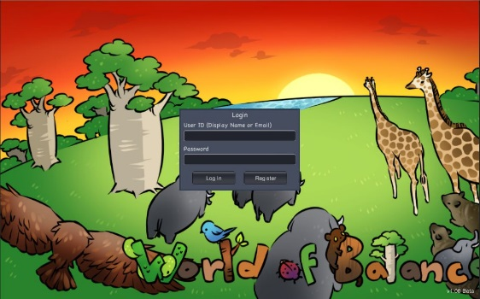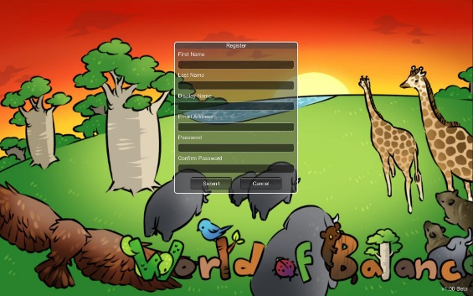

After logging in the player is brought into the Lobby. Here, the player can see her species on one of her tiles and the species of other players on their own tiles.

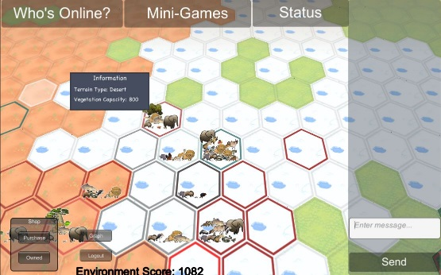

The player can take a variety of actions from the Lobby. This project includes modifications done to many of these features so they are discussed in more detail in this document. The actions include:

1. Send and receive messages with other players using the message panel in the right side of the image above.

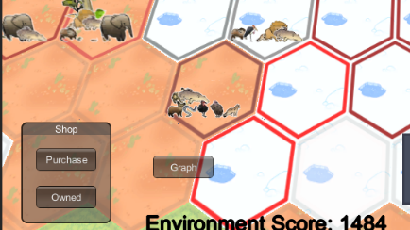
2. Buying species for one’s ecosystem using the shop. The shop buttons are shown below.

3. Viewing species and their biomass amounts already owned.

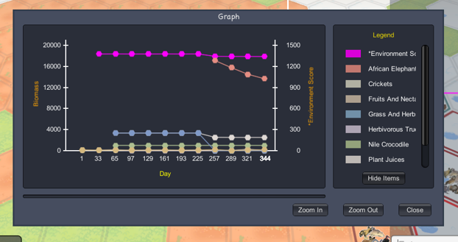
4. Viewing how the biomass of one’s ecosystem has changed over time using the Ecosystem graph

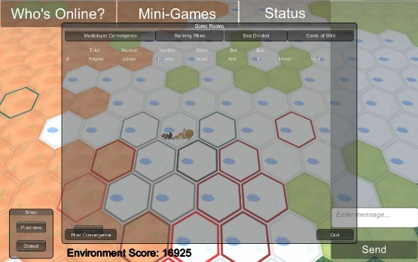
5. Selecting a single player game or a multiplayer game. These mini-games have been carefully designed to follow the principles of Gamification. That is, to be both entertaining and educational.

There are presently 6 mini-games, each was designed with the stated objectives in mind:

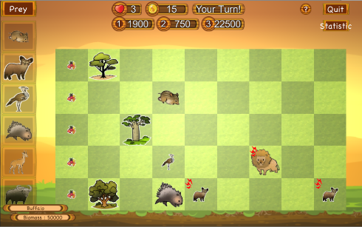
1. Don’t Eat Me:
The player seeks to prevent predators from reaching the left side of the board by placing appropriate species its way.

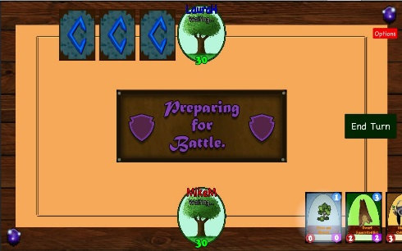
2. Cards of the Wild:
Two players compete by placing cards with species that can attack the other’s Tree of Life. The first player to devour her opponent’s tree wins.

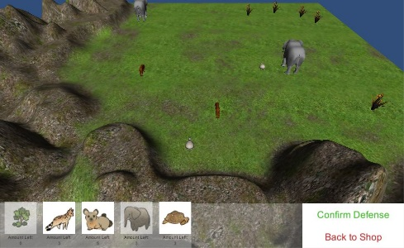
3. Clash of Species:
The player competes with other players who have previously set up their ecosystems. One player’s ecosystem attacks another’s ecosystem and the results are tabulated.

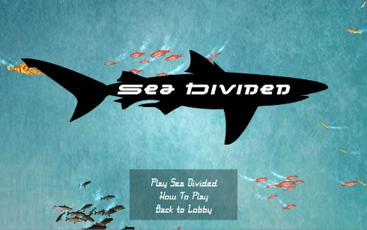
4. Sea Divided:
Two players are placed in the sea and the player that obtains the most points wins the 3 minute round. Players gain points by eating prey fish and lose health by being attacked by predator fish.

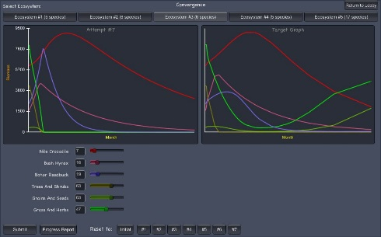
5. Convergence:
This single player game is described in this document and is the foundation for the Multiplayer Convergence game.

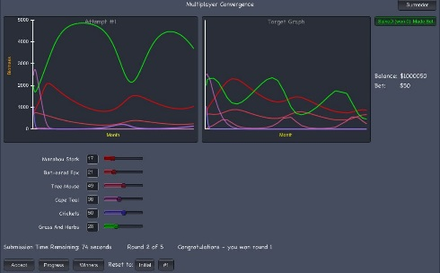
6. Multiplayer Convergence:
This multiplayer game is a central part of this MS Project and discussed in this document.

2.1 Player Interactions

The graphic below shows the interactions as viewed from the player’s perspective and not from a computer science perspective. From a computer science perspective all the player client interactions are with the server. However, the graphic below attempts to represent interactions as viewed by the player.

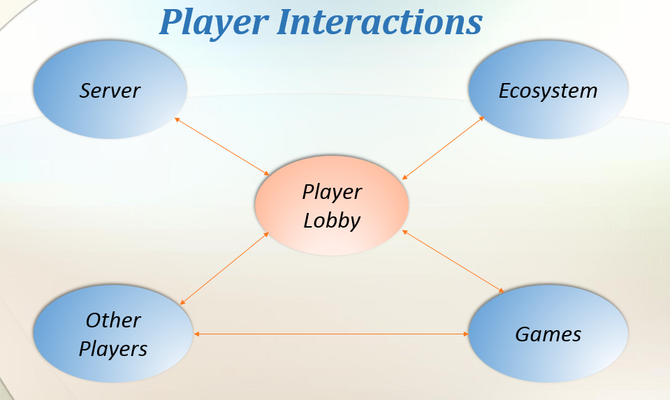

The player is aware of the server as she logs in and out and does other administrative tasks. The player interacts were her personal ecosystem as she views current biomass values, buys additional biomass and view progress over time. The player plays single and multiplayer games. The player also interacts with other players, both directly, through messaging and, indirectly, through multiplayer games.

2.2 Project Scope

This project encompasses four basic components that are developed further in this document:
1. The development and preparation of the Multiplayer Convergence game for game testing and production.
2. The development of periodic, automatic ecosystem simulation.
3. The enabling of Lobby functionality, especially in connecting Lobby functions with the server so that they transition from graphical demonstrations to usable player features.
4. Enhancing and updating the website to be the proper “face” of World of Balance.

Chapter 3: Design

3.1 Client-Server Architecture

World of Balance uses a standard Client-Server architecture as employed by many network games. The server does not use HTTP protocol. Messages contains numbers sent as binary values. The figure below shows the client, server and SQL database that is used.

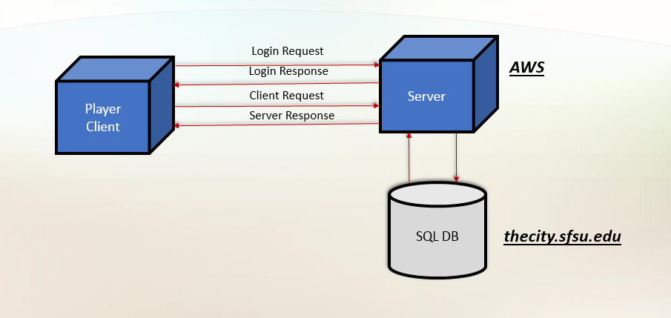

The database has been on thecity throughout this project. Currently, the server resides on an Amazon Web Services (AWS) host (IP: 54.153.66.118). During this project the server has also resided on smurf and thecity. Of the three hosts, AWS has provided the best performance. Using AWS has allowed the implementation of the “Preview” feature in Multiplayer Convergence. The Preview feature allows the user to view simulation results based upon changing one specie/plant slider without committing to that choice. The AWS host runs the ATN simulation fast enough to support this feature. The fast simulation gives the player rapid and interactive response. It has not been too difficult to port the World of Balance server to other hosts during this project. If necessary, it can be ported back to smurf or thecity or to another host. Care should be taken to replicate the directory structure and files presently on the AWS server. Java 8 will be necessary.

3.2 Ecosystem Simulation

Periodic simulation of every player’s ecosystem is vital to the proper functioning of World of Balance. A primary purpose of World of Balance is to teach about ecology and ecosystem dynamics. Integral to that purpose is for each player to have her own ecosystem that she builds and maintains. Also necessary is that this ecosystem progresses over time according to the laws of nature that are built into the ATN simulation engine. A population dynamics computation model is incorporated in the simulation engine. [6] The simulations will cause each player’s ecosystem to progress over time. The player will observe this and see the impact of past purchasing decisions. Without ecosystem progression, the player will not learn about this important part of ecology science. Therefore, it is of prime importance to the World of Balance project that each ecosystem undergoes periodic simulation.

As a result, one part of this project was to get the periodic automatic simulation of every ecosystem running for World of Balance. This capability existed in an earlier version of WoB, but was not transported to the current version and efforts to find this old periodic simulation code were not successful to help this project.

It was decided to implement the regular simulation of every player’s ecosystem in the GameServer class. The GameServer object is always in execution when the game server is running. Therefore, it was logical to have the GameServer object run the ecosystem simulation for all players’ ecosystem on a regular basis. There was some discussion of having the player’s GameClient object run the simulation for the specific player. However a GameClient object is only present for a player while she is logged in and the goal is to have every player’s ecosystem simulated at regularly scheduled intervals whether or not the player is logged in. The most efficient way to accomplish this is using the GameServer object. The implementation will be explained in chapter 4.

3.3 Multiplayer Convergence

3.3.1 Game Origin – Single Player Convergence

The Multiplayer Convergence game flows from its older ancestor and is the idea of Dr. Yoon to bring together two key parts of the World of Balance environment; science education and gaming that will attract people.

The purpose of the World of Balance (WoB) environment is to educate people about ecology. The means to get their attention is through interesting games and a gaming environment. The gaming environment includes an ecosystem the player builds and maintains, as well as credits the player earns. The player must earn credits to pay for the species to maintain her ecosystem. The principle of “Gamification” is employed where games are used to teach science and potentially help advance science. The games help to draw the interest and attention of people.

The Convergence does a good job of teaching science, among the best of any of the WoB games. The player adjusts parameters in an ecosystem in order to achieve a certain target ecosystem progression. The parameters relate to animal and plant species in the ecosystem such as growth rate, metabolism and carrying capacity. After setting the parameters a simulation of the ecosystem over time is performed and results are compared to a desired target. The closer the player gets to the target, the better her score.

This process allows the user to learn about the progression of ecosystems and the impact of parameters changes upon the results. As mentioned, the Convergence game is among the most educational of the WoB games. However, it was one of the least played games. While being very educational, it was not that interesting to play. A screen capture of the Convergence game is shown below:

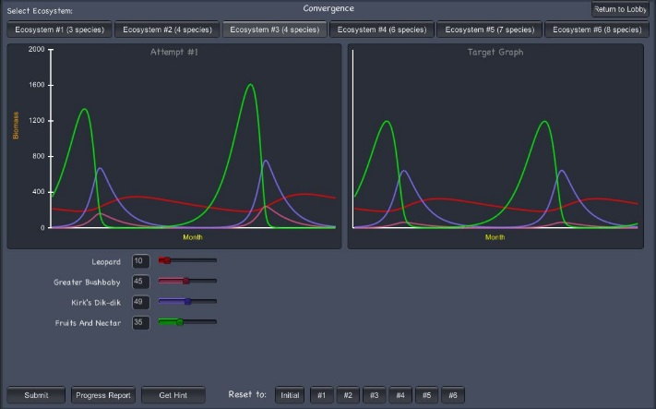

The player adjusts the sliders (This ecosystem has four) in an effort to make the left graph match the target graph on the right. Each line shows how the biomass of a particular specie changes over time. Helps are also provided so that the player can learn more about each specie and its interactions with the other species in the ecosystem. After adjustments are made to the sliders, the player presses the submit button to see the impact of her changes.

We can see from the screen capture above that this game is potentially not as interesting as other games available to players. As Dr. Yoon discovered, Convergence was not played very much. So, she came up with the Multiplayer Convergence with the goal of retaining the educational aspects of the while making it more interesting to play.

3.3.2 Game Overview

Multiplayer Convergence is Dr. Yoon’s idea to help the Convergence game concept fulfill the goals of Gamification: Teach and advance science through games that players find interesting to play. Multiplayer Convergence retains all of the educational aspects of the Convergence game while providing more excitement through a competitive environment and the awarding of credits for best performance.

A screen capture from Multiplayer Convergence shown below. In this game there are only 2 players, but up to 5 players can play together as one time.

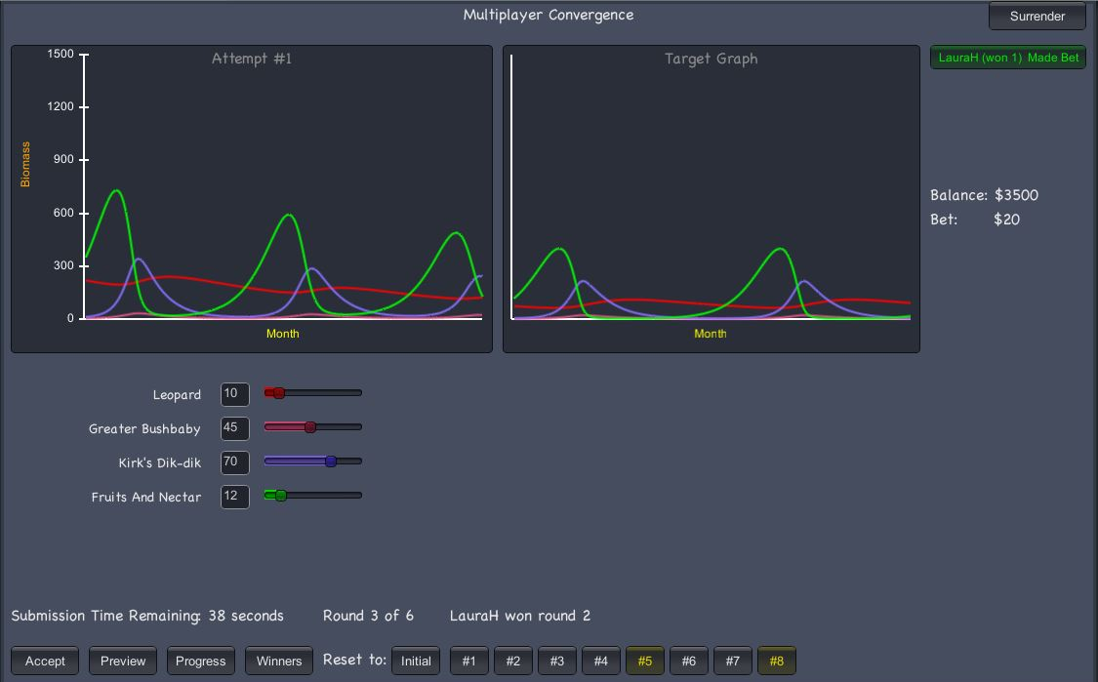

There are features in this game that have been designed by Dr. Yoon and her students to make the game more exciting and interesting to play, while retaining the educational aspect. Some of the features are:

1. Time limit to enter your play (or bet) for this round: Near the lower left, the remaining time is shown. If a player does not enter his selection within the time limit, he will not play that round and will lose the opportunity to win credits that round.

2. Audio feedback: A variety of sounds are made during the game, including a 10 second warning and a 5 second count down. Also, when any player enters his/her submission, every player hears a gong sound. This is to increase the pressure to play. Different sounds acknowledge round winners and losers.

3. A fixed number of rounds: The number of rounds is fixed and set by the host of the game. This makes the game of definite duration, like other games. In the above, the player sees that this is round 3 of 6.

4. Status of other players: In the upper right corner is a button with green text. It has the name of the other player and the number of rounds that she has won. Green text indicates that she has made her submission. There are buttons for each of the up to 4 other players. The button start out with red text, but change to green text after the submission has been made. These different notifications are to increase the excitement and intensity of the game.

5. Preview results: The second button over from the lower left is the preview button. When pressed, the simulation is run and the graph is updated, but the submission is not made. The player can see the impact of changing one parameter at a time. This allows the player to optimize her submission to be the best play possible within the allotted time. Once the optimal choice has been made or time is running out, the Accept button can be pressed. This submits the play for this round.

6. Prior attempts: As in the single player game, buttons to go back to prior attempts are shown at the bottom of the display. A prior attempt button exists for each Preview or Accept situation. In the screen capture above, prior attempts #5 and #8 are in yellow. The yellow signifies that these are actual submissions.

7. Round winners: The player can press the Winners button, fourth from the left in the bottom row, and see the round winners so far, as shown below.

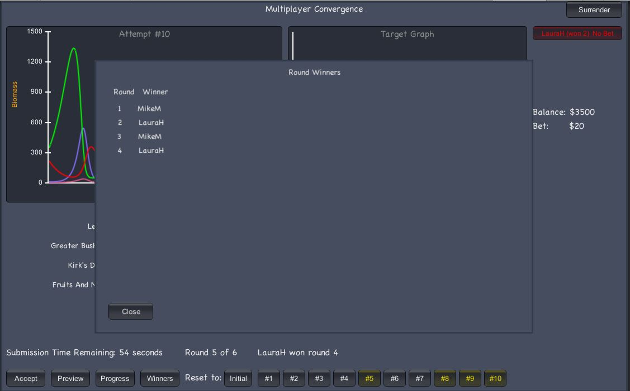

8. Progress: An important part of improving ones score is see past scores. This feature of Convergence is also present in the Multiplayer game. However, some minor adjustments have been made. The progress report can be seen in the screen capture below. For the multiplayer game, the graph has been made a little smaller and fit in the lower right corner and made unmovable. It was found that moving the progress report was difficult because of all of the activity going on in the Multiplayer game. Attempting to move the graph was taking a lot from the game action, so it was decided to shrink the size, set it in in the lower right corner and make it unmovable. When there are many species, a slider will appear allowing access to make adjustments for all species even while the progress chart is showing.

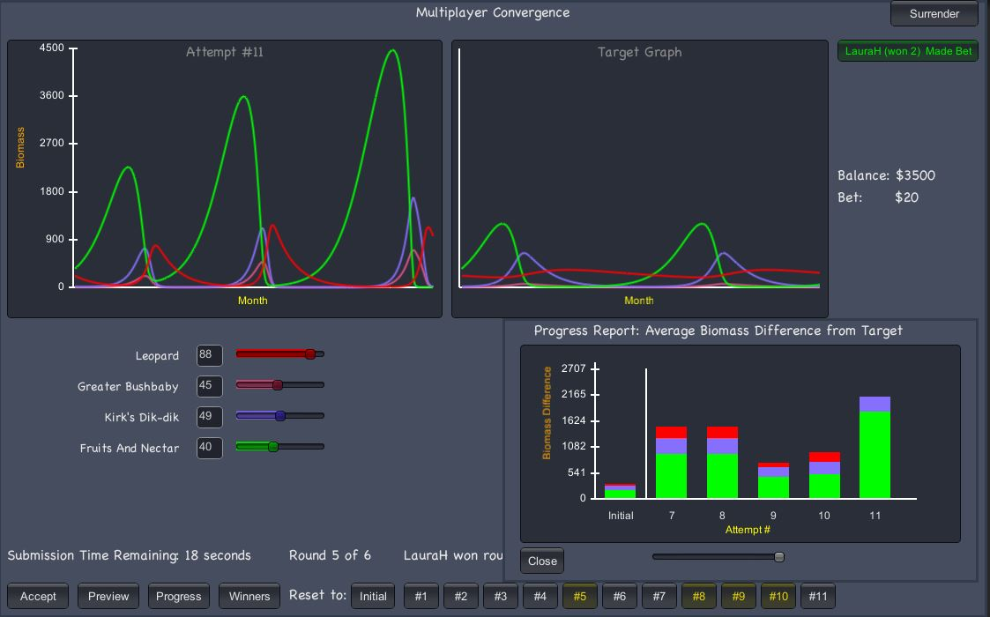
9. Opponents Progress: To increase the challenge and excitement of the multiplayer game, it was decided to expand the progress chart feature to show the progress of opponents as well. Any opponents progress chart can be viewed by clicking her button in the upper right part of the screen.

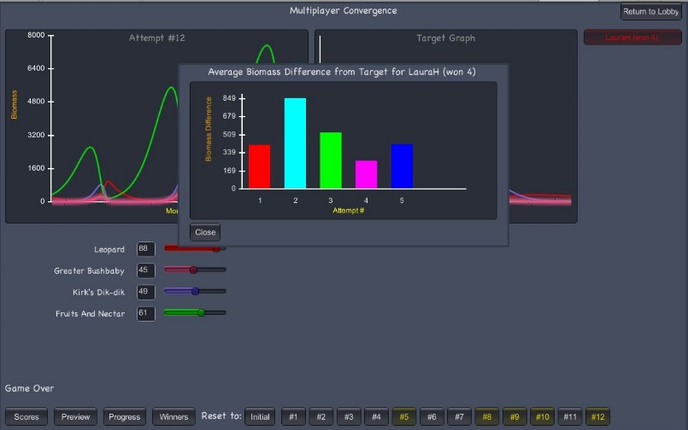

10. Game over, Final scores: After the game is over, a final display is shown giving a summary of information for each player, including number of rounds won, total winnings/losses and final delta to the target score. We see in this example, that LauraH got much closer to the target graph, being only 418 units away. Another important point, is that the winner of the final round, the one who ended the game closest to the target, gets an extra bonus of one half of the total amount bet during the game. This amounts to 120 credits for LauraH plus the 20 she won from MikeM by winning more rounds. The button in the upper right corner is used to return to the Lobby. During the game, if it is pressed, then it is a surrender button.

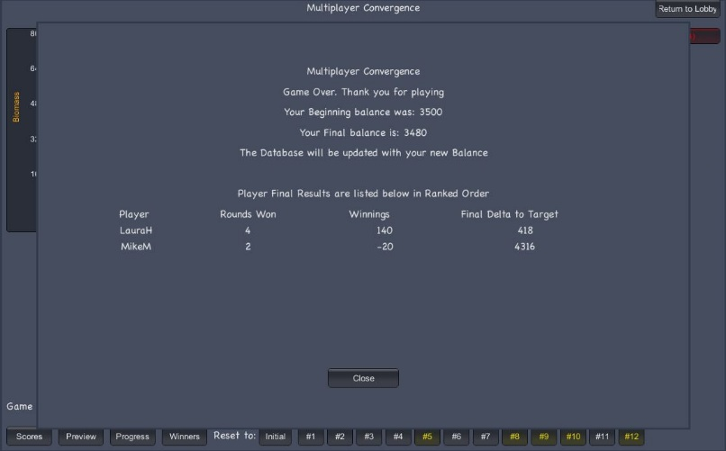

3.3.3 Joining in the Lobby

Multiplayer Convergence is unique among the WoB multiplayer games in that it supports more than 2 players. The other Multiplayer games have exactly 2 players. Multiplayer Convergence supports from 2 to 5 players. This required a new matching scheme. No longer is the joining of another person after the host establishes the game room an indicator that the game is ready to begin. For Multiplayer Convergence there is 1 host that establishes parameters for the game and the other players are non-hosts. The host establishes the game session in the Lobby. Below is a screen capture of what the host sees when she establishes a Multiplayer Convergence game. The screen was reached by clicking on “Multiplayer Games” under the “Mini-Games” menu option. The window below appears. Then, “Multiplayer Convergence” is selected at the upper left of the new window. Finally, in the lower left, “Host Convergence” is selected.

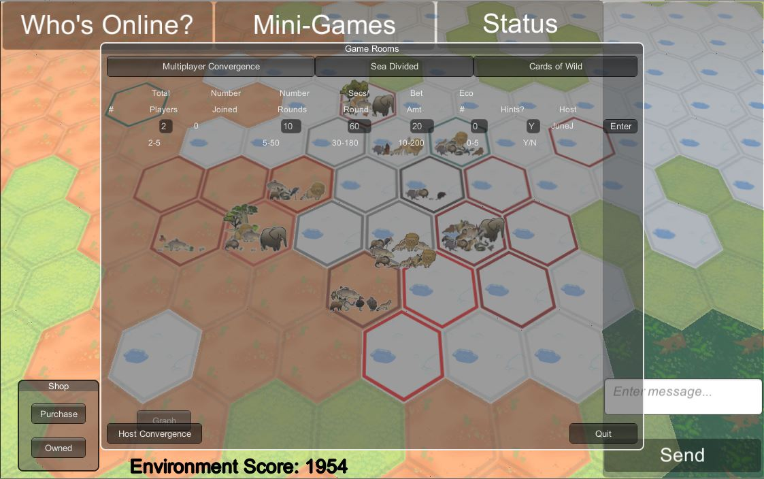

As can be see above, 6 attributes must be specified for the multiplayer game. The host enters those values in the boxes. Default values are already loaded. If an out-of-range value is entered, it will be flagged and the host must correct it. The 6 attributes and their ranges are:

1. Total Players, 2 to 5
2. Number of rounds, 5 to 50
3. Seconds per round, 30 to 180
4. Bet amount per round, 10 to 200
5. Ecosystem number, 0 to 5. This is the present number, but it could be increased.
6. Enable Hints, Y / N.

Enabling Hints causes “*” to appear above the sliders where the optimal selection range should be. This feature only works on ecosystems that have these hints prepared for them. Presently, no ecosystems have these hints prepared. Once the host has specified the parameters and has pressed “Enter”, the display changes to that shown below. This display is seen by the host and every other user who views this screen in the Lobby.

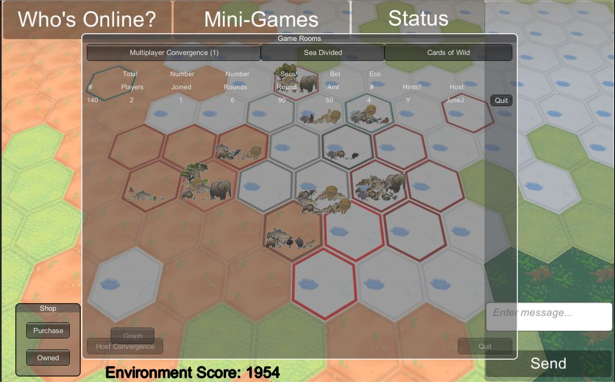

Once all the players have joined, each player leaves the Lobby and enters the game.

3.4 Ecosystem Display in Lobby

The Lobby is the starting point after login and the center of all activities in the WoB environment. A screen capture of a typical Lobby view is shown below. Each of the hexagons is an ecosystem tile which can be purchased by a player, if it has not already been purchased by another player.

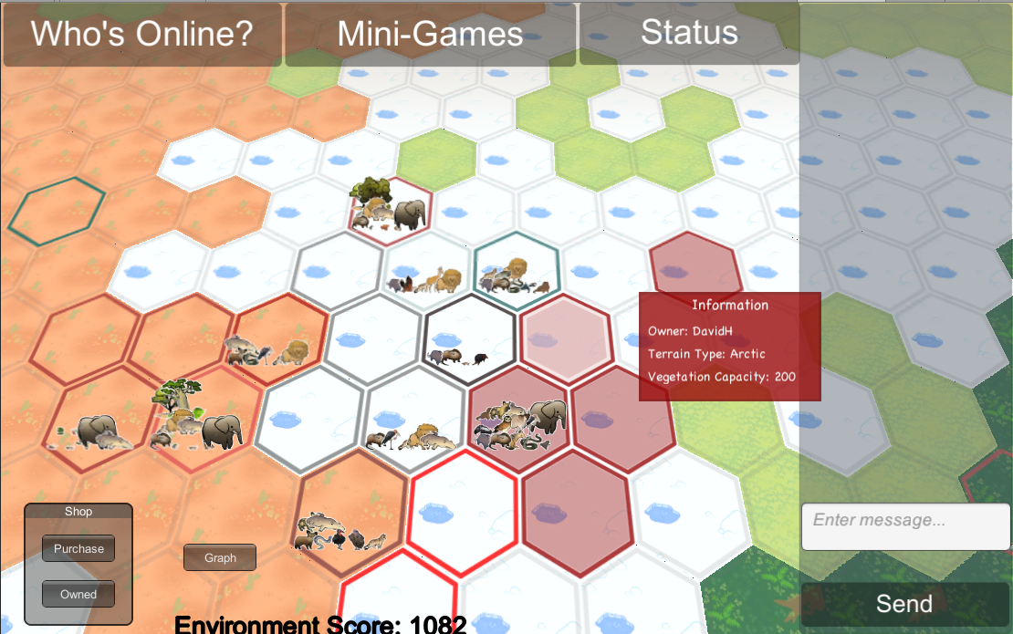

As part of this project, the species owned by players are displayed on their tiles. The tiles below with species have been purchased by players and their species are displayed on the tile, one next to the other. The tiles without species could be unowned, or owned by a player with another tile which has her species.

This was done to make the World of Balance environment more exciting and also to stimulate player interest in expanding her ecosystem. When the player enters the Lobby, she can see the ecosystem species for other players. She can see how other players’ ecosystems have grown over time. This can motivate her to expand her ecosystem by playing mini-games better and earning more credits. These credits are used to purchase more species for her ecosystem system. Another benefit of adding the species to player’s tiles is that it makes the display more interesting.

3.5 Ecosystem Graph

The Ecosystem graph is a feature of the Lobby. An example display is shown below. The ecosystem graph is of vital importance to the game. It allows players to see how their ecosystems have progressed over time and make appropriate corrections. For example, if one specie is declining, perhaps the ecosystem needs to be augmented with more food for that specie. The Ecosystem graph makes this possible.

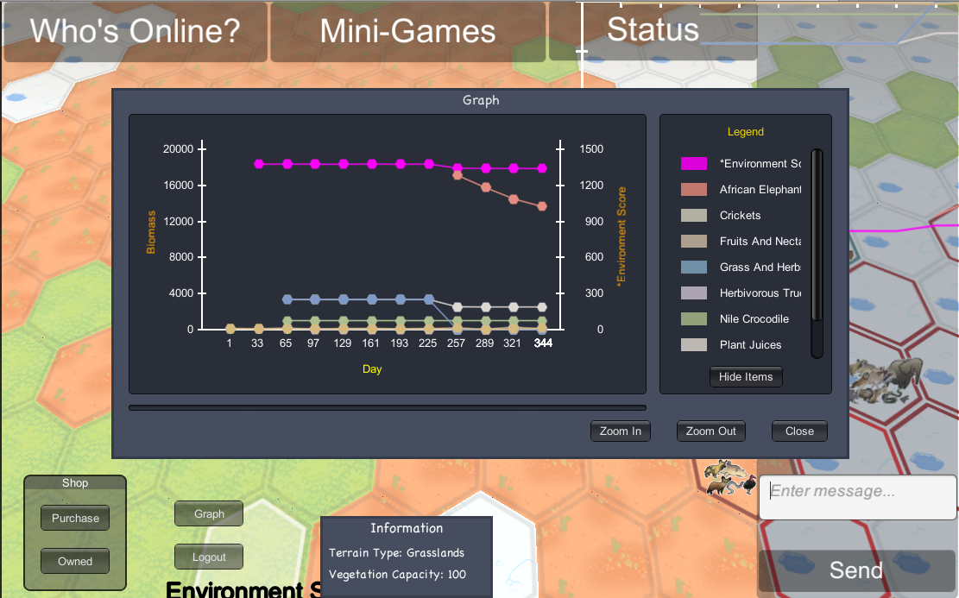

Prior to this project, the ecosystem graph was not connected to the database but was loaded from a hardcoded CSV object to display some sample specie information. Also, there was no zoom capability, nor was the environment score visible. This graph is of vital importance so it must be connected to the database in order to display actual player data. Also, the stated features are necessary. Therefore, these items were added as part of this project.

To give more detail about the Ecosystem graph, the biomass values of each specie is displayed with the axis on the left. The Environment score is noted by a *, and is on the top of the list and is displayed also. It’s axis is on the right. The day is along the bottom. Note, that this day is not a calendar day, but an ecosystem simulation day. Presently the ecosystem simulation occurs every 1 hour, so there are 24 ecosystem days in 1 calendar day. The screen capture above shows the graph zoomed out to the maximum. For this day count, it is scaled by a factor of 32. They are 32 days for each tick on the horizontal line. The graph can be zoomed into 1 day per tick. A slider is provided to scan through the data.

The graph contains a lot of data, especially for players with many species and many days of play. This was causing a pause of multiple seconds before the graph would display. To solve this problem, a local caching scheme was implemented. The caching works by writing the data retrieved from the server into a local file that has the player id appended to the name. This way, if this client directory is used for multiple player ids, only the correct local cache is used for a player. Then, the next time the graph is generated, the program first looks for this local file. If it finds the local file it reads all the data through the day stored in that file. Then, it displays the graph based upon that data alone. This allows the player to see the graph right away. Then, the client contacts the server for any additional days of data after the date stored in the cache. After that data has been received by the client the graph is redrawn with the complete the data. Because of the nature of the drawing system, most of the time the player will not notice the graph being redrawn. This is because the data being added is at the high end of the days, not initially seen.

3.6 Bar Graph Enhancements

To increase the excitement in Multiplayer Convergence, it was decided to give the player more insight into how his opponent is doing. Specifically, it was decided to show a player his opponent’s bar graph. This is the graph that appears when he presses “Progress”. However, some detailed information about opponent’s progress would be hidden. The two screen captures below show these two bar graphs. The one on the left is the player’s own progress results. The one on the right is for an opponent.

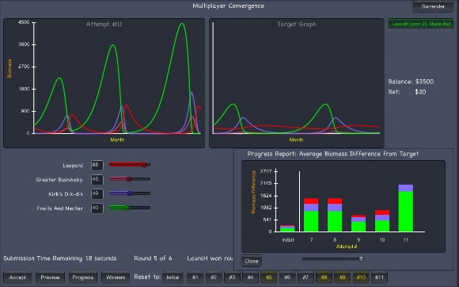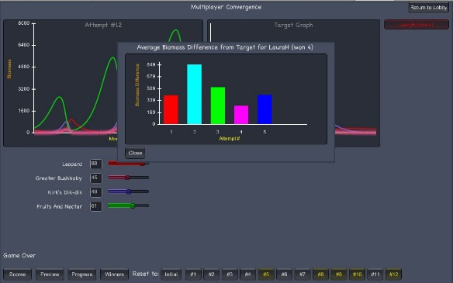

The right graph shows opponent information, but not as much detail is given. It is not a stacked bar chart. This is to allow the player to see how the opponent is doing, but not all the detail about the individual species is given. The purpose of showing the opponent’s bar graph is to create more excitement and stimulation to improve the player’s own score.

3.7 Shop Purchase

The shop is used to purchase species and view species that are already owned. It is accessed by the little block in the lower left corner as shown below.

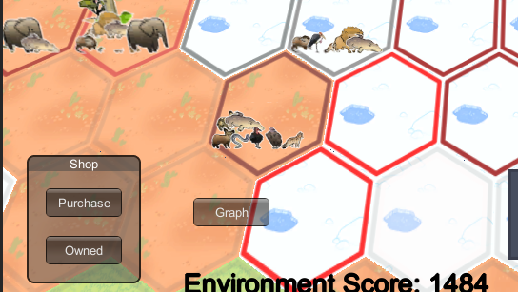

The shop functionality existed prior to this project but it was not integrated with the server so that purchases did not persist and credits were not deducted. As a part of this project, these tasks were completed and some additional features were added to the shop that are explained below. In this discussion, we will focus upon work done in this project.

The screen capture below shows the shop purchase windows that appear in the Lobby. There are three windows. The main panel with the cards to select a specie is referred to in the code as ShopPanel. Below it is an information display of the last species clicked. This panel is the ShopInfoPanel. The panel on the right, including the little panel on top is referred to as the ShopCartPanel.

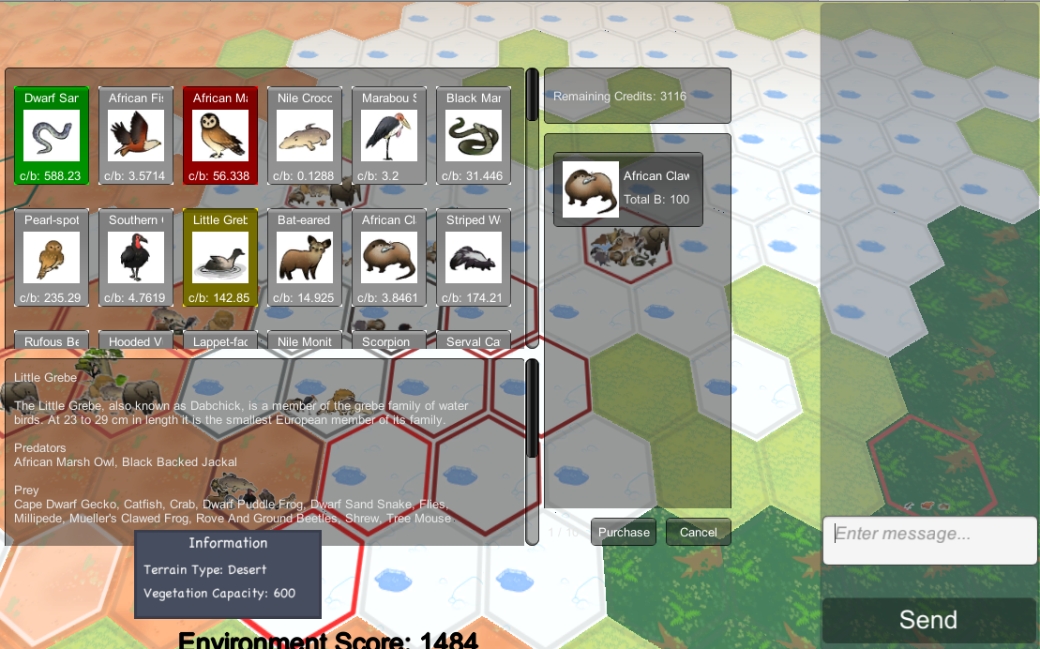
No changes were made to the ShopInfoPanel. In the ShopPanel, the cost per biomass was added for each species. It is shown on the specie card below the drawing. It has the label c/b: followed by a number. This is the credits per unit of biomass. Also, the purchase dialog process was improved. Previously, when a specie was selected for purchase, a standard amount for the biomass was put in the cart. A value for biomass of 100 or 500 was chosen. This was changed to allow the player to select how much biomass she wants to buy. As a helper, the cost of that amount of biomass is displayed as shown below.

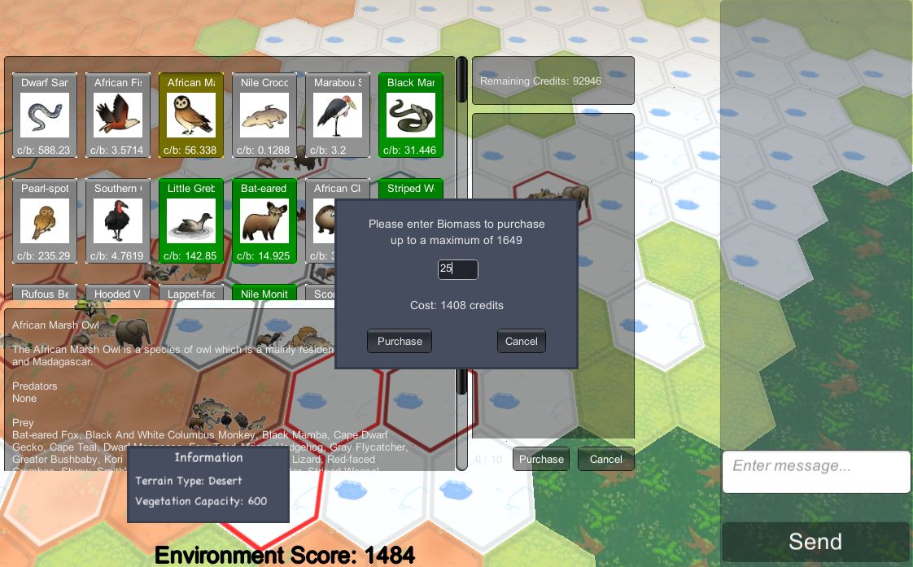

3.8 Shop Owned

Previously, the “Owned” button for the Shop was not working. The player’s species were not appearing correctly. Also, the predators and prey were not appearing correctly either. The problems were caused by the fact that the appropriate classes were not connected to the server properly. Also, the biomass owned by the player has been added to the bottom of the species card. Please see the screen capture below.

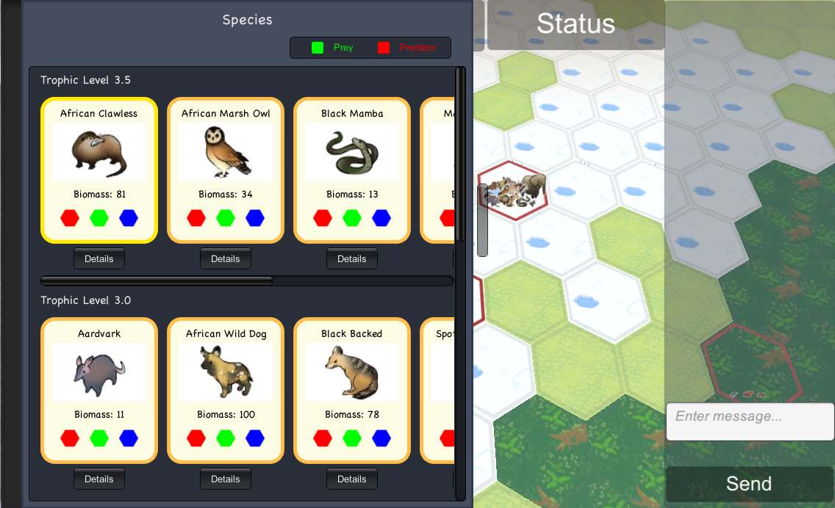

This species display has two way scrolling. Up and down views species from different Trophic levels. Left and right views species of the same Trophic level. The class that produces this display of species is called Database. The biomass amount owned has been added to each card. The screen capture below shows the predator / prey view that appears for a specie when the “Details” button is pressed. In the example below, it was for the African Clawless. In the resulting display, the African Clawless is in the middle. On the left are predators and on the right are prey.

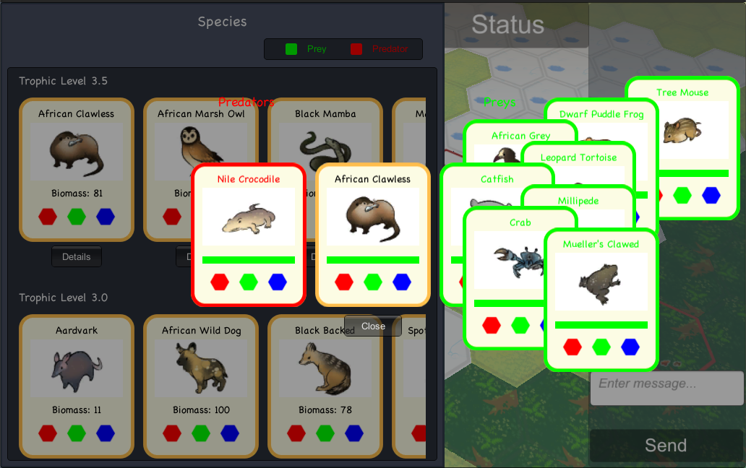

For the Convergence game, only those predators and prey that are in the game are displayed. This feature is handled by the View class that assists in drawing the cards. In the code block below, if the mode is convergence and the specie is not in the game, then it is not drawn.

3.9 Website Enhancements

Extensive modifications were made to the World of Balance (WoB) website to bring it up to date and provide additional features. These changes and enhancements will be discussed here. The purpose of this section is also to give an introduction to how the website is constructed. This will help future students make updates. This is the website that showcases the project to others and helps them get started. It is in a sense, the “face” of the WoB project. The URL and screen capture of the website are shown below.

http://smurf.sfsu.edu/~wob/

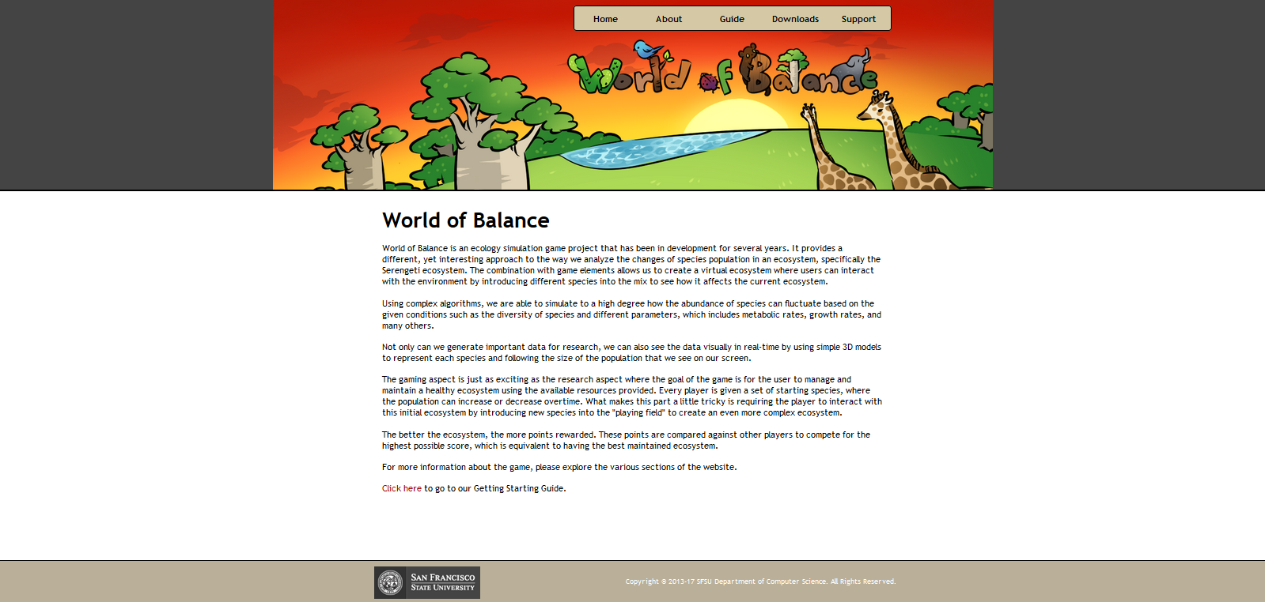

This page is constructed with HTML, CSS and JavaScript. However, it does use some PHP commands to improve the construction. The PHP provides a convenient way to obtain the site base URL. Below is a screen capture of the top part of the header.php file which contains JavaScript and JQuery setup and shows an example of the PHP code in use to include the base URL.

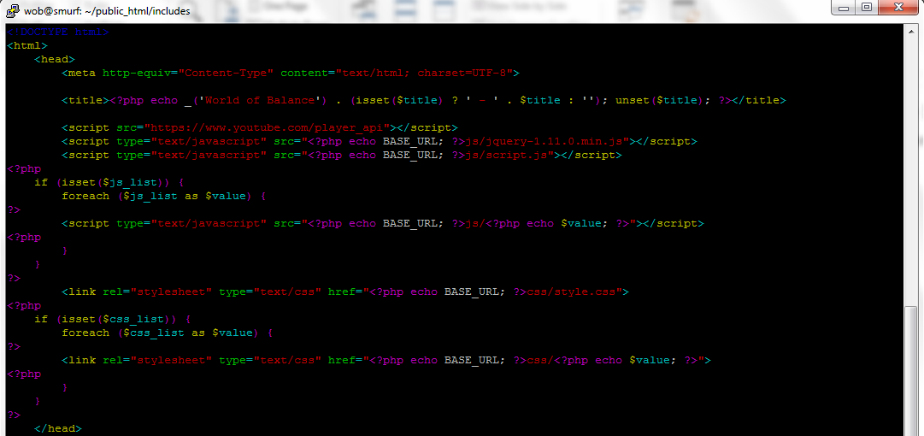

The menu bar at the top of most screen occurs later in the header. To illustrate the design, part of it is shown below:

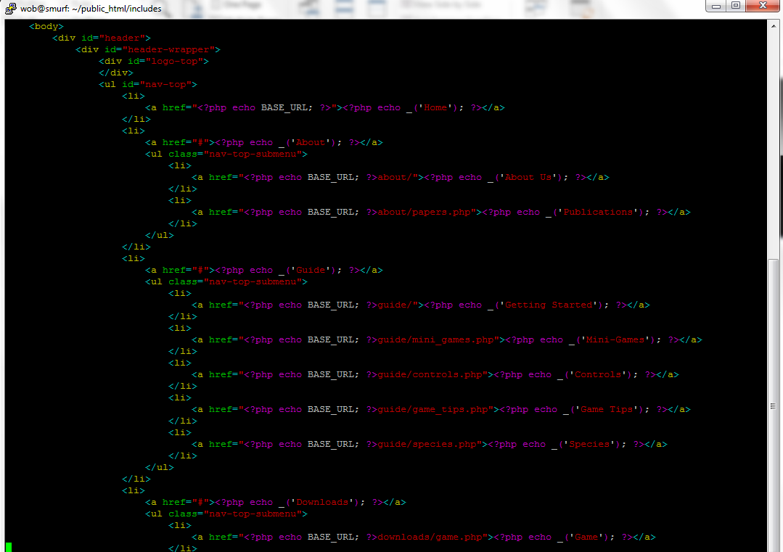

The config.php file is shown below. This shows part of the DB access logic.

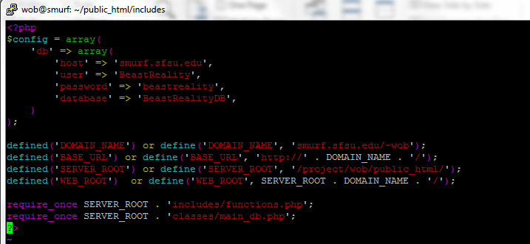

The “Guide” dropdown is shown below. It has most of the content of the website.

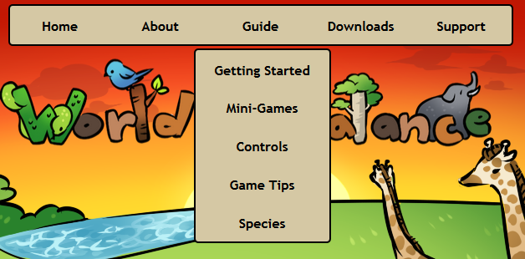

The “Getting Started” section is shown below. Enhancing this section was a big part of the website project. A table of contents is provided to allow the user to move quickly to the section of interest. These are the red hyperlinks below. They are red because of recent selection.

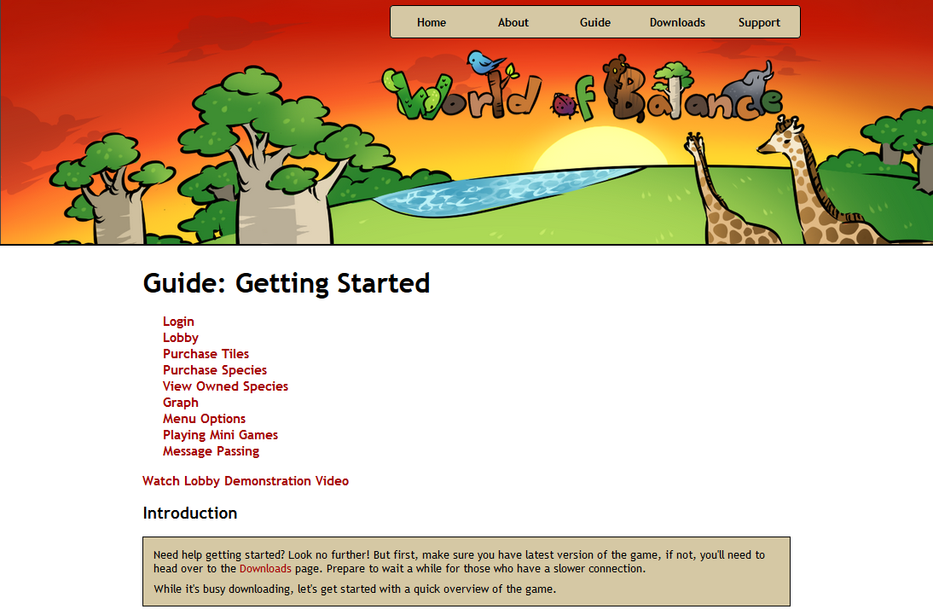

Many new features were added or enabled in the Lobby and these are explained in this page. This page really provides an overview of the Lobby, the starting point for all the games and the place for the player to manage her personal ecosystem. One example screen capture from this page is shown below. This is where a player joins an existing Multiplayer game.

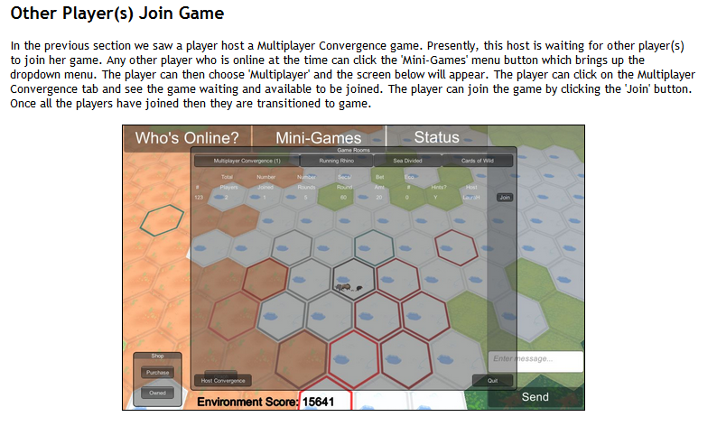

Another noteworthy part of the website is found in Guide -> Mini-Games. It is shown below.

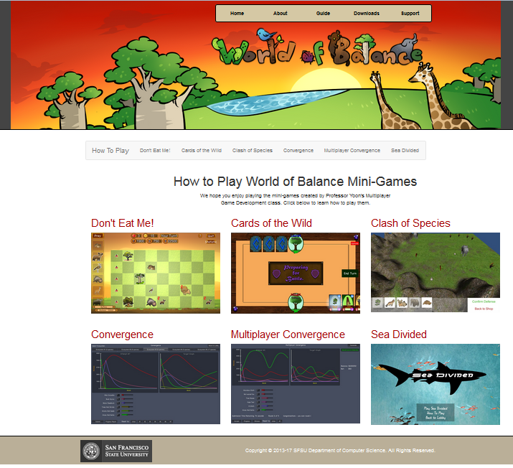

This page shows the six mini-games that are presently available. This page is constructed with Twitter Bootstrap. Part of the page code is shown below:

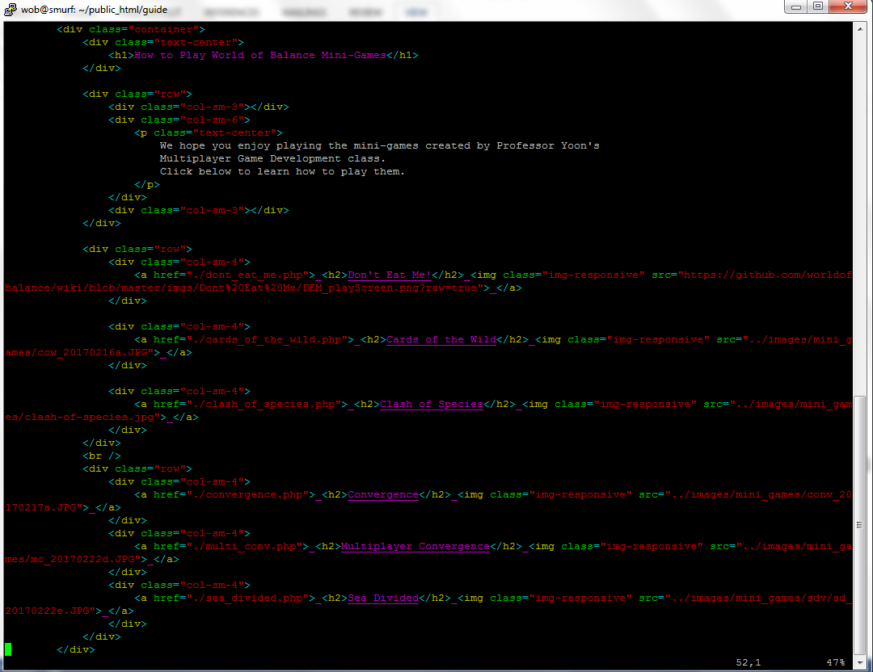

The container class setup is seen. Also, the col-sm-6 and col-sm-4 classes are seen that are used to divide up the display. A basic understanding of Bootstrap is necessary to modify this page and the mini-game pages.

A portion of the “Don’t Eat Me!” mini-game page is shown below. The other mini-game pages are similar.

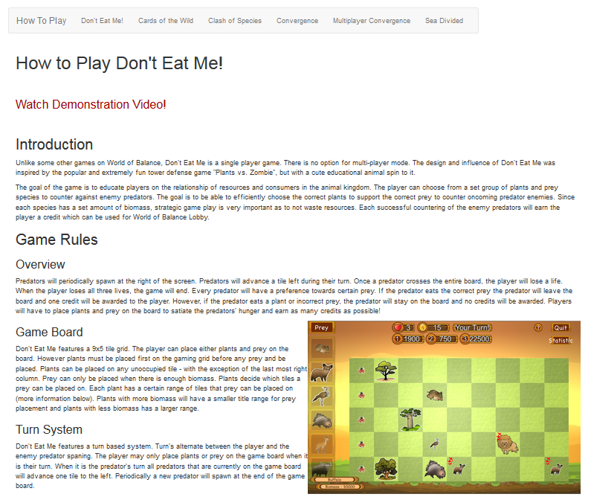

There are generally two columns of data, but not always. Text is generally on the left side with a graphic on the right side. The corresponding code for the “Don’t Eat Me!” page is shown below.

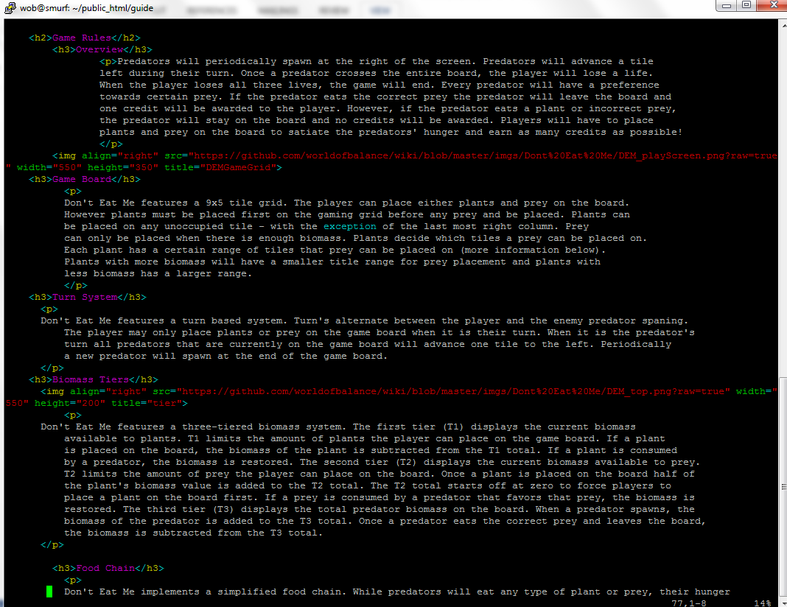

The align=”right” attribute is used on the image to put it on the right side.

Some pages, like “Cards of the Wild” uses Bootstrap to do the alignment. A section of that page is shown below.

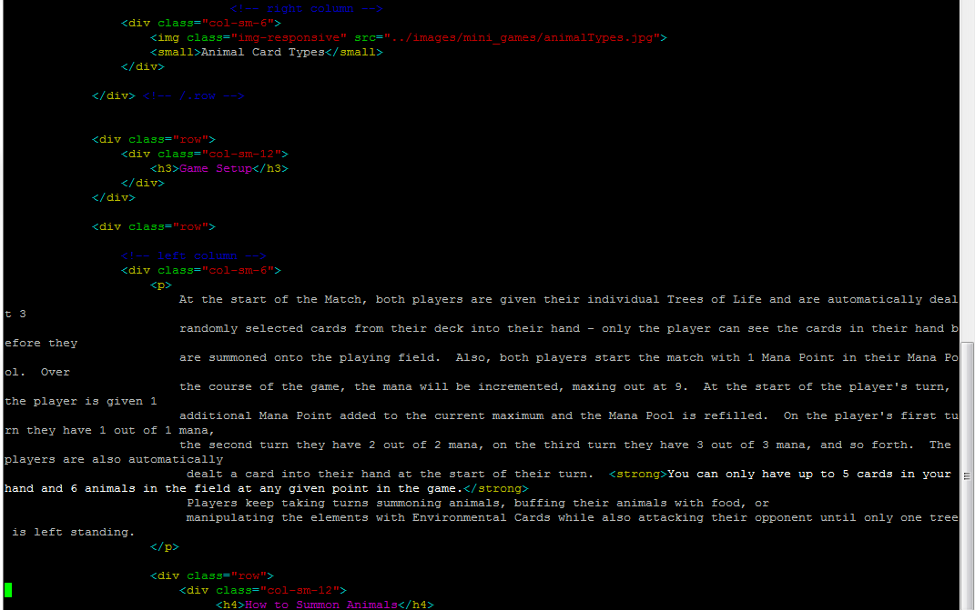

We can see the col-sm-6 near the top. It places the image with text on the right side because earlier there was another col-sm-6 class. Then, we see the col-sm-12 class for the “Game Setup” label that covers all columns. Then, we see the start of the left column with the col-sm-6 class. This approach results in the text staying on the left side as shown in the screen capture below. These slight style variations between pages were not changed due to high priority on the development of some key Lobby features.

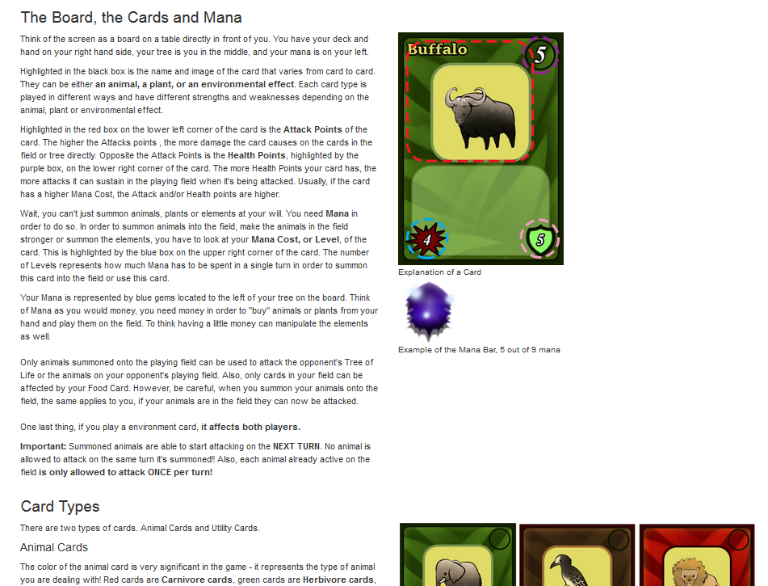
The screen capture below shows the screen if Downloads -> Game is selected. This section goes through some detail in getting WoB working on one’s computer.

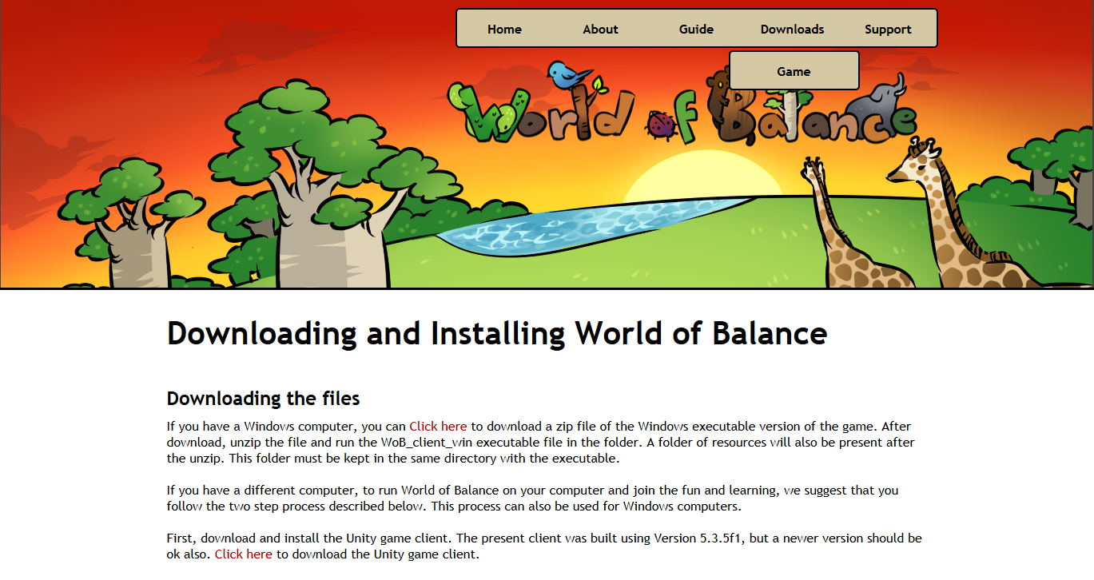

The first line we read from the section above is, “If you have a Windows computer, you can Click here to download a zip file of the Windows executable version of the game.” This downloads an executable version of the Unity client with the WoB game. This is the easiest way for the Windows player to start playing the game. This executable file and the path to it are seen in the screen capture below:

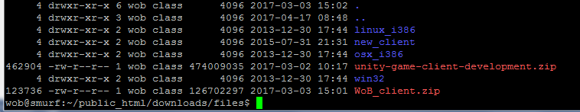

It is the file, WoB_client.zip. It is presently the only executable file that is posted on the website. For other Operating Systems (MAC, Linux), the players must follow the instructions to download and install Unity, and to pull the latest development branch from GitHub. This file must be kept up to date as changes in the client are done. How to create a new executable client are explained in the section “Windows Executable Creation”.

Chapter 4: Implementation

4.1 Ecosystem Simulation

Below is the main() method contained in the GameServer class. It starts the server. For this project, two lines were added to this method. First, the server prints out the current WoB day as shown below. This day is maintained in the SpeciesChangeListDAO object as a static field and is accessible using the fetchDay() method. The day is written to the database every time a simulation is done through the storing of species biomass changes that occur in the new ecosystem day. Presently the ecosystem simulations occur for every player every calendar hour, so that 24 ecosystem days occur in one calendar day. This setting is changeable by editing a configure file as will be explained later.

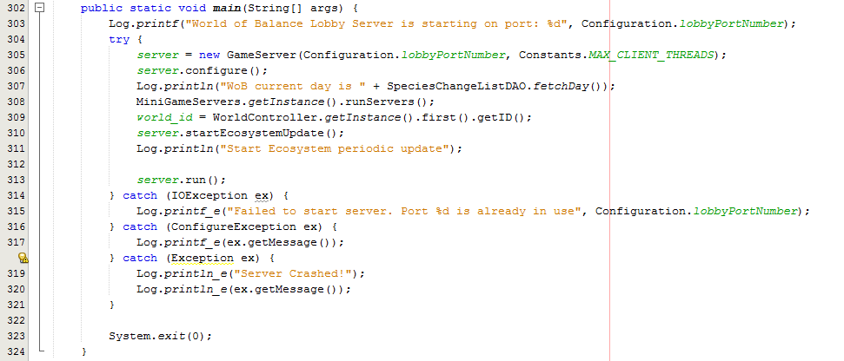

The second change to the main() method is to call the startEcosystemUpdate(). The code for that method is shown below.

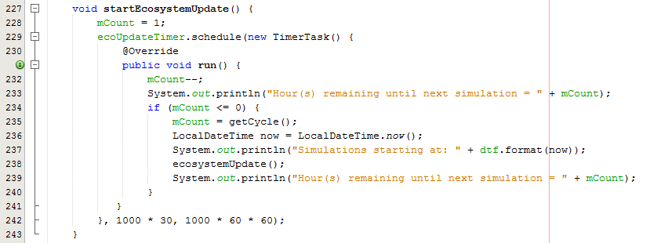

The center of this method is the Java TimerTask class. It enables the scheduling of periodic events which is exactly what is needed for the ecosystem simulation. The variable mCount contains the number of hours plus one between simulation cycles for all ecosystems. It is initially set to 1 to begin the simulations shortly after the server is started. After mCount is counted down to 0 the simulations of all ecosystems are initiated by the ecosystemUpdate() method. Status is sent to the log file. The time counts near the bottom are in milliseconds. Before the run() method is executed, 30 seconds passes. Also mCount is decremented every hour, giving 1 hour resolution.

The getCycle() method is read after every count down. This is to read the number of hours until the next simulation from a file, which allows the value in the configuration file to be changed, altering the number of hours between simulations.

The getCycle() method is shown below.

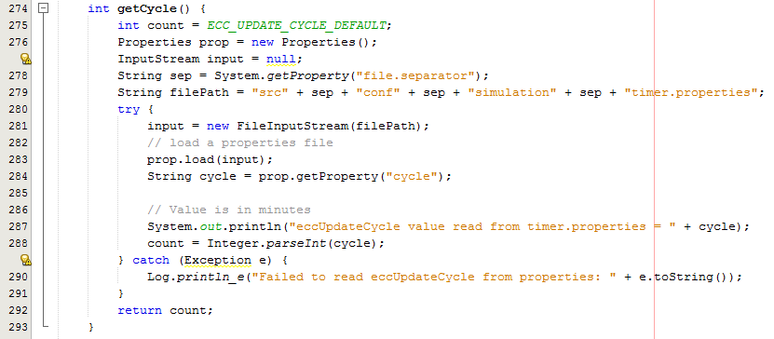

There is a default value, ECC_UPDATE_CYCLE_DEFAULT, if the file cannot be found or an error occurs in reading the file the default value is used. It is set to 24 hours as shown in the screen capture below.

The configuration file and path is src/conf/simulation/timer.properties. It is a Java properties files and the property is “cycle”, so the data appears in this format as shown on the server:

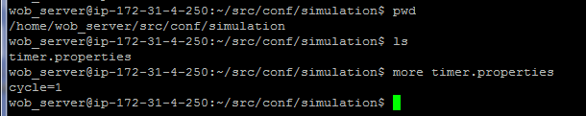

This file can be edited on the server and after the next simulation cycle, the number count of hours will take effect.

Earlier we saw that the ecosystemUpdate() method was called to start the simulation of every ecosystem. This method is shown below.

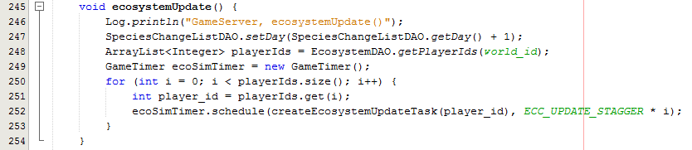

The first thing that is done is to increment the current WoB day. Whenever all the ecosystems are simulated, the WoB day count is increased by one. One WoB day corresponds to the simulation of all ecosystems. The day is incremented using the setDay() and getDay() methods. The getPlayerIds() method of the EcosystemDAO class will provide all players ids returned in an ArrayList. The GameTimer class, which is a subclass of the Java Timer class is used. For our purposes, The GameTimer class works effectively the same as the Timer class and is used to schedule an upcoming event. It was found to be more efficient of threads (and thus system resources) to have one GameTimer object and schedule multiple events.

We see that the player ids are cycled through and a simulation is scheduled for each player. The simulations are staggered by ECC_UPDATE_STAGGER which we saw earlier was 20 seconds. An ecosystem simulation normally finishes in less than 10-15 seconds. This minimizes multiple simulations occurring at the same time, while not delaying the simulations too much so that one set does not finish before the next set begins an hour later.

We see that the createEcosystemUpdateTask() method is called. This method returns a TimerTask object which contains a run() method that specifies the task to be executed. These tasks are schedule with the ECC_UPDATE_STAGGER stagger value.

The createEcosystemUpdateTask() method is shown below.

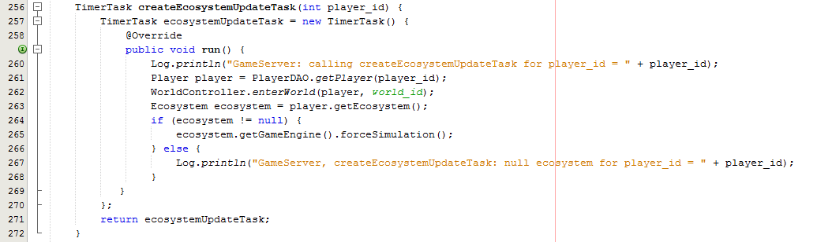

The steps necessary to run the ecosystem simulation are specified in the run() method. These are steps are followed when the player logs in and his ecosystem is created to allow him to interact with the ecosystem. To run the simulation of a player’s ecosystem, we must effectively log her in to create the necessary data structures to run the simulation. Only those login steps necessary for simulation are performed to save system resources.

First, the Player object is read from the PlayerDAO, out of the database. With the Player object then the enterWorld() static method of the WorldController class must be called. This sets up data structures that are necessary for the simulation to work. After that, an Ecosystem object can be obtained by calling the getEcosystem() method in the Player object. Some old players in the database do not have an ecosystem. This must be checked. If an ecosystem exists, then the GameEngine object (that runs the simulation) can be obtained from the Ecosystem object. The forceSimulation() method is called which runs the simulation. The TimerTask object that contains the run() method is returned. It will be queued and run.

This is the process that runs the simulation.

4.2 Multiplayer Convergence

4.2.1 New Protocols

A good way to understand client-server game such as Multiplayer Convergence is to examine the unique network protocols it has. The operation of the game is centered around its client-server network protocols. Therefore we will now explain those to give understanding into the game operation.

1. MCSetup

This protocol is used by MultiplayerGames to setup a game room for a new Multiplayer Convergence game when the player selects to host. The screen capture below shows the MultiplayerGames code section that uses this protocol to request that the server setup a game room.

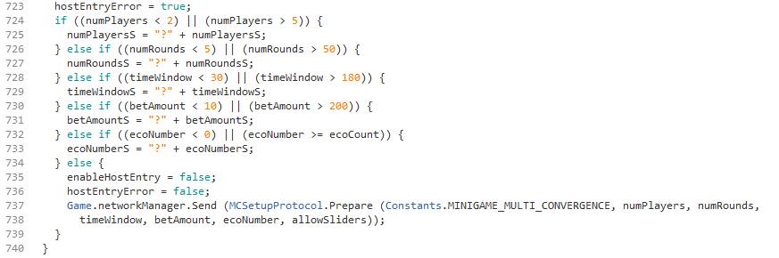

The top of the above code is the error checking of the host value entry. If all values check out within range then line 737 executes the MCSetup protocol to request that the server setup a game room for Multiplayer Convergence according to the 6 specified parameters. The screen capture below shows the code on the server side that receives the message in the MCSetup protocol.

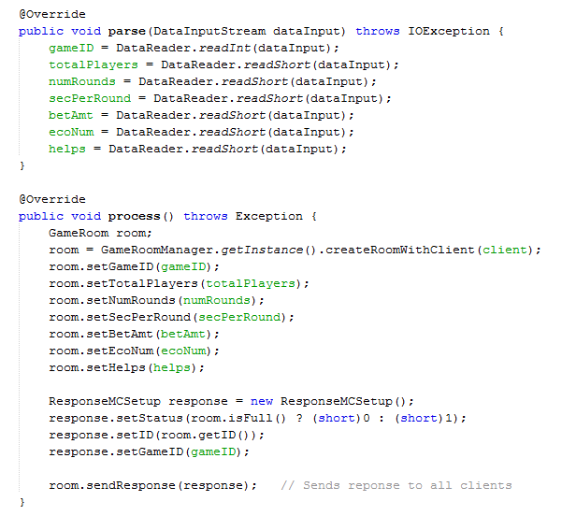

The host has specified the 6 game parameters and those are read from the network data stream and stored as parameters for the game. The response is issued at the bottom. The game room structure and protocols used here is similar to that developed for the previous two-player games. In fact, the Multiplayer Convergence (MC) game room code is based upon the code used for those earlier games. However, the additional code above is added to read the 6 parameters from the host. This separate MC game room, beyond the standard one, is necessary to store key parameters for the MC game. Also, it is necessary to check the player count to make sure the room is full, and not assume it is full after the second player joins. This is the protocol used setup a game in the Lobby by the host client.

2. MCMatchInit

This protocol is used by MultiplayerGames to add a player to a Multiplayer Convergence game room. These players are referred to as non-host players. The code below is from MultiplayerGames and is used to process a player that wants to join an already existing game in the Lobby. The player has clicked the “Join” button to the right of the game in the Lobby.

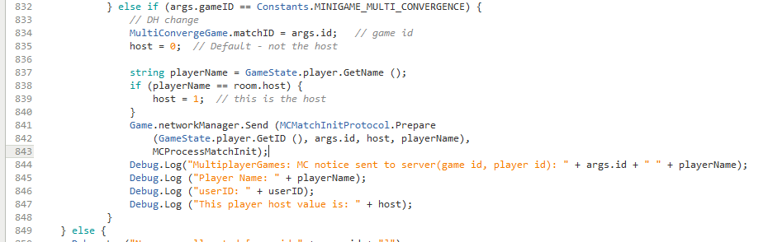

This code detects if the player selected Multiplayer Convergence (MC). If so, the MCMatchInitProtocol is used to message this to the server. This is necessary to add this player into the MC game room.

Part of the server network protocol code is shown below.

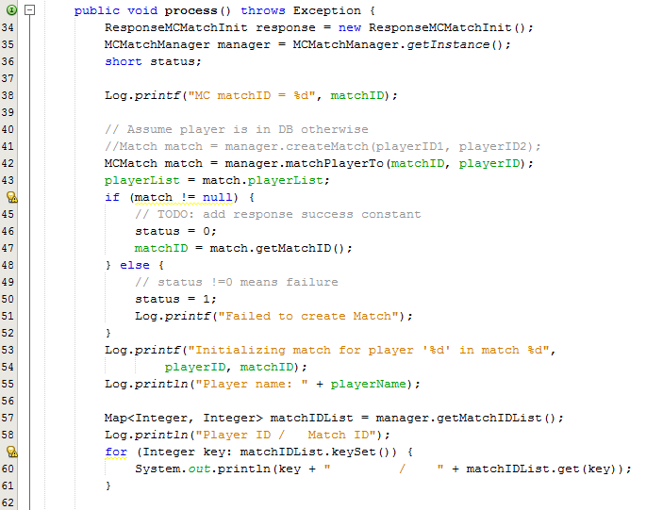

This code is used to match this player with the MC match setup. After the match, the player is added to the MC game match data structure. This data structure will be used throughout the game to track the game and players progress. The MCMatch data structure is obtained from the Match ID and the matchPlayerTo() method will add the player with the player ID to the match. The success of the match process is verified. Because only messages using existing matches are sent to the server, the error condition should never occur.

Additional code from this protocol routine is shown below.
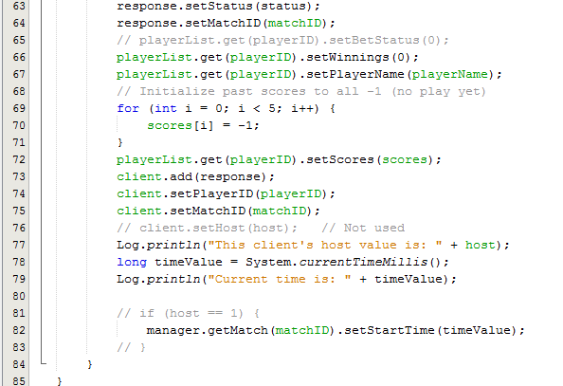

This code configures fields of the GameClient object and the MC game data structures to prepare this player for the game. Some game parameter information is stored in the client, including the player id and match id. Previous round scores must be reset to -1 since this is the beginning of the game and there are no previous rounds. These scores will be sent when requested by other player clients to see the progress of this player. The winnings must be zeroed out and the name of the player is set.

3. ConvergeGetTime

In the Multiplayer game, the server keeps track of the time left to enter a bet. The client contacts the server periodically to get how much time is remaining. This helps to make the clients and the server all stay synchronized to the same time. The server returns the amount of time remaining for the current round. For synchronization purposes, the client sends its current round to the server so that the server can know to which round the client is requesting. This helps with corner cases. The ConvergeGetTime protocol is used to obtain the remaining time. The use of this protocol in MultiConvergeGame is shown below.

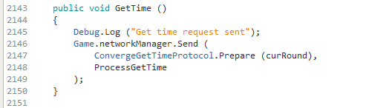

The routine that processes the server response is shown below. There is other information that the client needs periodically and the server includes this information in the response. In the code below we see the time returned being assigned to the variable timeRemain that will be used by other processing routines. The client also needs to know the play (pressed “Accept” to enter a play) status of all the other opponents. There are up to 4 other opponents. This is sent over along with the time update. The betStatusList List is updated with the current bet status. This will be used to display the opponents button text in red or green. Also, if another player has pressed the Accept button, the gong sound will be played in the client.

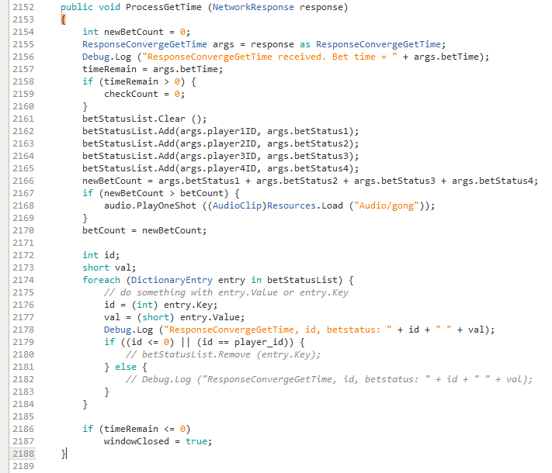

The code below calls GetTime() which sends the server the ConvergeGetTime message. This message is sent about 2 times every second to keep the game up to date.

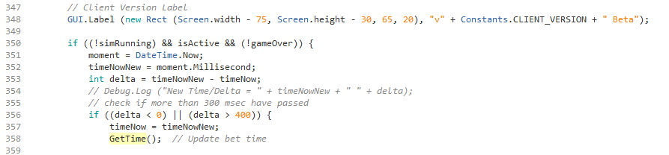

In the next two screen captures is the main portion of the server code that implements the ConvergeGetTime protocol. The formula to calculate the remaining time, betTime, is straight forward. More processing is needed to return the bet status of each of the opponents. The routine cycles through the list of players. Some players may have left the game. To keep the game running properly those players are not removed from the game data structure, but rather they are noted as having left the game. This is necessary so that the server does not wait for them press Accept in order to complete the round. By cycling through the player list, an output data structure is created and sent back to the client.

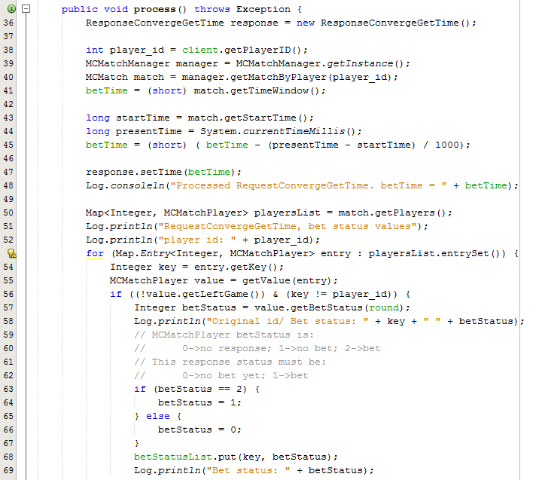
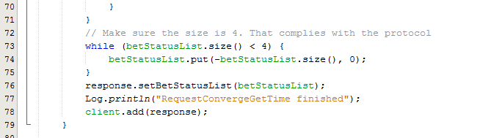

4. ConvergeGetNames

This protocol, as its name suggests, is used to obtain the names of the other players. It also obtains their player ids. Obtaining the player names is somewhat tricky. Each client wants to know this information right away to display the opponents’ names in the upper right corner of the screen and setup the data structure that tracks round winners. However, due to network latency and game client start up delays, not all players may have replied and confirmed they are in the game immediately. So, some delay time is built into obtaining these names. As a result, there is a delay of some seconds before the opponents’ names appear on the screen.

Also, an opponent can leave in the middle of the game. The player can surrender, leaving the remaining players to finish the game. Or, a player could get disconnected or just stop his client. Therefore, each remaining player client must check with the server periodically to update the list if a player leaves the game. If a player leaves the game, his button in the upper right corner will be removed, but his data will be retained for the winners display. The periodic checking of player game status is done about every 4 seconds.

The client code below checks the server about every second for the first 10 seconds of the game to make sure it gets all of the player names. Most of the time, all the player names are available within a few seconds, allowing the opponents to be displayed quickly. Occasionally, one or player names become available later. This code allows all of the player names to be registered while displaying the names promptly.

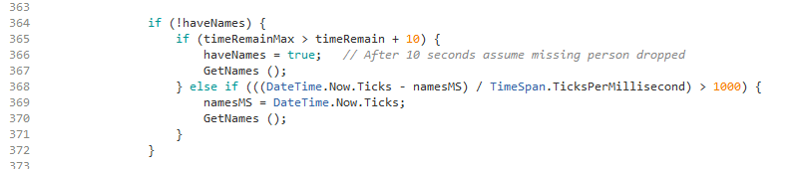

The program code below processes the server response to the GetNames() method that uses the ConvergeGetNames protocol. This code initializes the data structure that maintains the player name and the number of rounds won. This data is also used when displaying the final results at the end of the game. The program is designed to build this data structure within the first 10 seconds of the game. If a player already exists in the data structure, she is not added again.

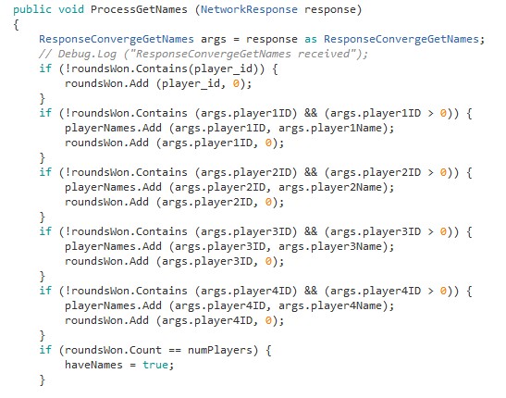

The code below checks for player names every 4 seconds. These are the names used for displaying in the upper right corner of the screen. This periodic checking is necessary to detect players that have left the game. The original set of names obtained at the beginning of the game with GetNames() is maintained for historical references, such as the display of round winners.

Below is the heart of the server code that implements the ConvergeGetNames protocol. The names are retrieved from the MC game data structure. Those players that have left the game are not returned. This allows the players displayed to be the current players. The left players are retained in the data structure for final score calculation. The protocol is specified to return 4 player results. For the non-existent players, a negative player id is returned to signal no player.

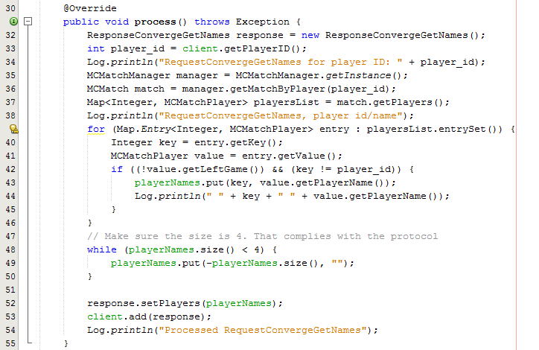

5. ConvergeGetOtherScore

This protocol is used to obtain the 5 most recent scores of a given player. The server data structure keeps track of each player’s 5 most recent score values. The score value is the delta between the player’s graph and the target graph. The smaller the score is better.

To make the game more interesting, a player can view the 5 most recent score values from any opponent in a bar chart similar to his own progress chart. This chart is obtained by clicking on the button of the opponent in the upper right portion of the screen. When the opponent button is clicked, this protocol is used to obtain the 5 most recent score values for the selected opponent and those are delivered to the bar graph utility to be displayed.

The opponent buttons are displayed by the following code. The color of the button is based upon whether the player has played (pressed “Accept”) this round and indicates the number of rounds won. Near the bottom of this code block we see the GUI.Button() method that displays the button and returns boolean true if the button was pressed. If pressed, the displayOtherGraph() method is called. This displays the graph for the other player.

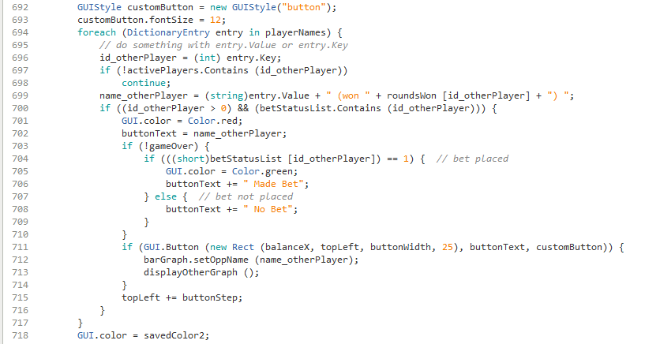

Below is the displayOtherGraph() method code and the callback that handles the server response.

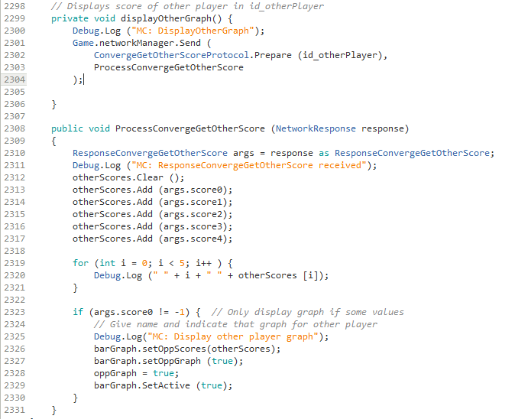

The other player id is sent to the server. The response contains the 5 most recent scores for the other player. These are loaded into a C# List structure. Some additions have been made to the BarGraph class that enable it to draw the opponent graph as well as the player graph. However, the opponent graph gives less information as explained earlier. The BarGraph object must be loaded with the other scores, a flag big set. Then, the graph can be set as active. This will cause the bar graph of the opponent to appear.

Below is the main portion of the server code that implements the ConvergeGetOtherScore protocol. The MC game data structure contains the 5 most recent scores. These scores are updated as new bets are made. These scores are loaded into the response and returned.

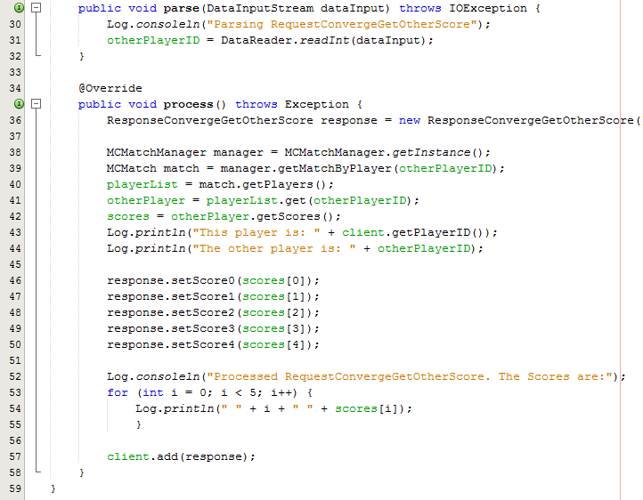

6. ConvergeBetUpdate

This protocol is center to the game operation. This is the protocol in which the client informs the server of the player’s actions this round (pressing the Accept button or not before time runs out). When the player presses the Accept button, the client notifies the server using this protocol. When time runs out and the player does not press the Accept button, then the player has chosen not to participate in this round. When time runs out, the client also notifies the server that the player has chosen not to participate in this round using this same protocol, but with different settings. Here are the code segments for both options

Below is the code that sends the message if the player presses Accept before the time expires.

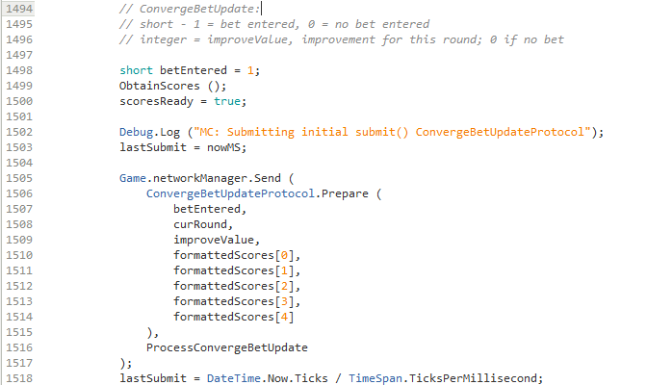

The variable, betEntered, is set to 1 to notify the server that this player did submit a play this round. The variable, improveValue, holds the score that the player received for this round. The smaller the value, the closer the player is to matching the target. This values are compared by the server and the player with the smallest value wins the round. Ties are also processed by sharing the round winnings.

A checking of the code will show that the improveValue is generated by the Improvement() method of the BarGraph object. The BarGraph is displayed when the user presses the ‘Progress’ key and shows a stacked bar chart of the players scores since the game began. Again, a lower value is better. It means a closer match to the target graph. The BarGraph object obtains scores from the ecosystem simulation that returns results via the ConvergeNewAttempt and ConvergeNewAttemptScore protocols that cause the server to run the simulation (based upon the player input) and return the updated data for the graph. This allows the BarGraph object to calculate the new improveValue.

The current round, curRound, must be sent to make sure the client stays in synchronization with the server. The formattedScores array contains up to the last 5 rounds of score results for the player and is usable by other clients to report the player results.

The server responds to this message by one of two types of messages. The first possibility is that all players have entered a bet. That is, this player was the last one to respond. That message will report whether this player won the round or not, and if she did win the round, how much she won. Or, the server will respond that not all player clients have responded yet. In which case, the client delays a short time and asks the server again. The code that receives the message back from the server is shown below. The code is long and takes two screen captures and therefore will be explained in two sections.

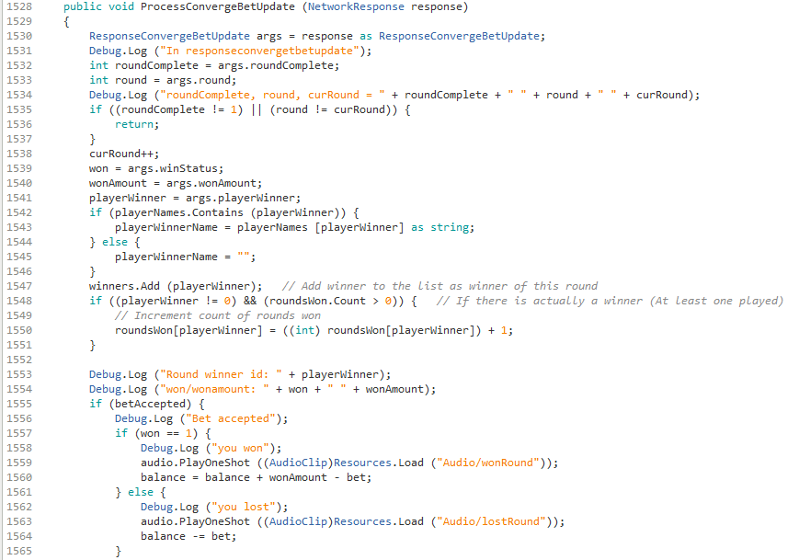

The message is received above from the server. The variable, roundComplete, indicates if all player clients have responded. If that is not 1 (round not complete) or the completed round does not match the current round, then the routine exits. This means that client must wait a while and check again if the server has received every client’s response for the current round. Otherwise, the winner counts are updated. The balance is updated and the appropriate music is played.

Below is the screen capture of the remaining code in the block.

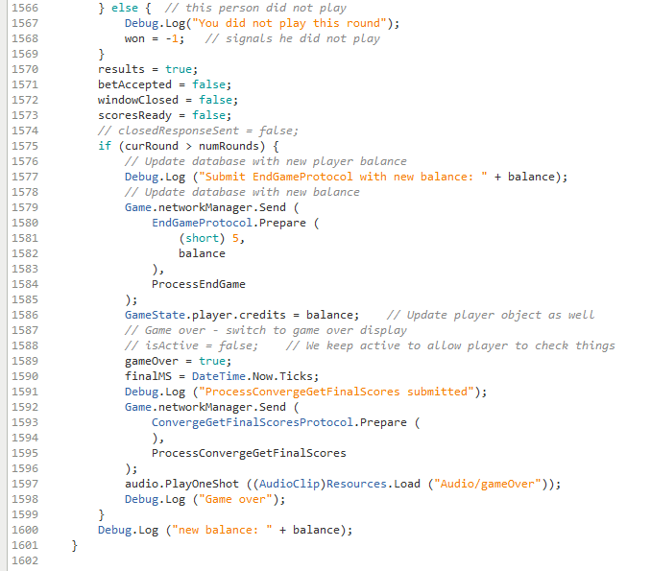

The variable, won, is set to -1 when the player does not play that round. If the number of rounds is completed, the end game data is fetched from the server. Status flags are updated.

In the case in which all the clients have not responded yet, the server informs that to the client and the client must wait a while and poll the server again. The code below performs this repeated messaging of the server until all clients have responded.

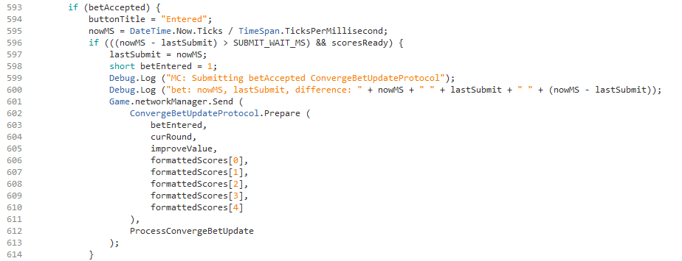

In the code above, the conditional checks if the time elapsed since last check has exceeded the amount, SUBMIT_WAIT_MS, which is set to 700ms presently as shown below:

When the player does not press Accept and time expires, the client notifies the server of this fact also. In any case, every client must respond every round to notify the server of its player’s actions. The code below performs this function. The variable, betEntered, is set to 0 to indicate that this player did not press Accept this round. She is not participating this round. She will neither increase nor decrease her balance this round.

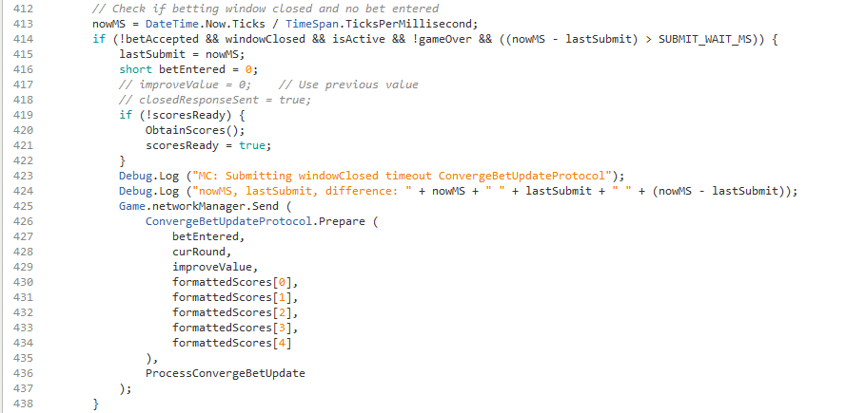

The code above is very similar to the previous code examined, with the exception of the betEntered = 0 indicating no participation this round. The response is handled by the same routine as when the player enters a play.

The corresponding server code is shown below. It is broken up and explained in three portions.

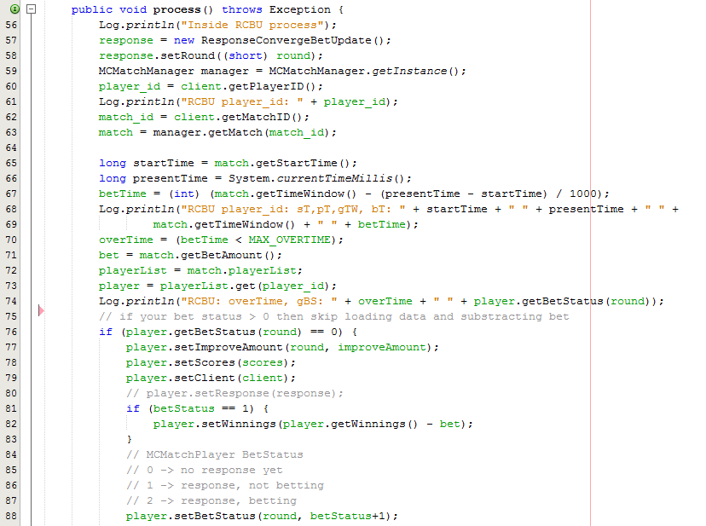

The code above receives the client’s message with the player’s information. This is stored in the game data structure for future comparison with other player information, once information from every player has been received. This routine is called multiple times until the all clients have responded and then the server replies with winner information. If the player did bet, then the bet amount is subtracted from his score. If he wins the round, it will be later added in. The overTime flag detects if the time has passed that clients should have responded. That flag will be used later to remove clients that have not responded.

The code below is the next block of the ConvergeBetUpdate server code.

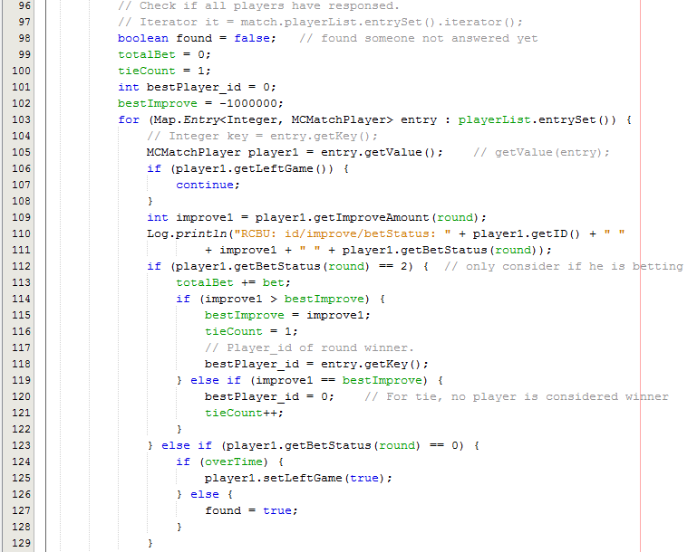

This block compares the results of each client that has responded to determine who has won the round. Code is present to handle ties. The total bet must be summed so that it can be split among the winner(s). If there is found one client that has not responded yet, then this data will be discarded. The server waits until all clients have responded.

The code at the bottom of the screen capture above removes clients that have not responded within 5 seconds of the round ending. Such a player is marked with the setLeftGame() method that indicates that this client has left the game and will not be considered for game input anymore. This is necessary if a client is stopped or crashes. Without this feature, the game would hang for the remaining players. This replaces the function of the ConvergeCheckPlayers protocol which is not used anymore.

Below is the block of code that is executed if all clients have responded. That is, (found == false), indicating that no clients were found that did not respond.

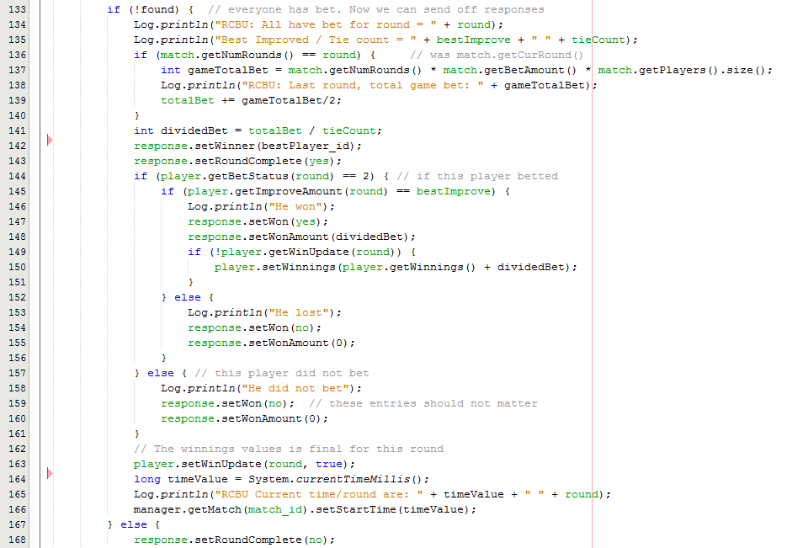

This code updates this client’s response with status that indicates if he won or not, and the amount of winnings. The response is sent back to the client.

7. ConvergeGetFinalScores

This protocol is the last one and it is used to get the final scores of all players as the name implies. Once the last round play has been submitted for all players and the client receives the results for that round, it knows that the game is over. It uses this protocol to get the final scores for each player which is displayed as shown earlier in this report.

The code below shows the messaging of the server with this protocol.

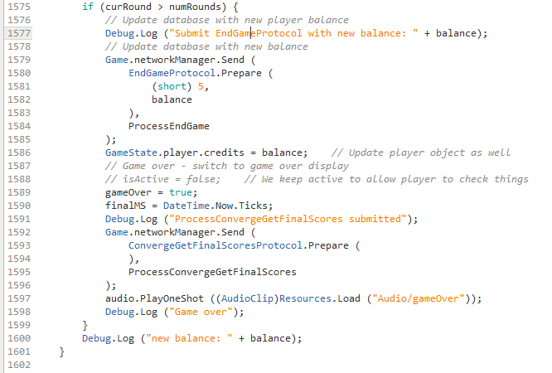

When the condition at the top of this block is true, the last round has been completed, and the results have been received from the server indicating that all players have bet. The EndGameProtocol is used. The code 5 is for the Multiplayer Convergence game. This protocol updates the player’s credit balance with the new balance (balance) on the server. The client object GameState is a static object that persists during the game. The field GameState.player.credits holds the player credits on the client side. It is also updated to maintain consistence. Other Lobby programs require this consistency to be maintained.

The ConvergeGetFinalScores message is sent and the end of the game music is played. The code that handles the response from the server is shown below:

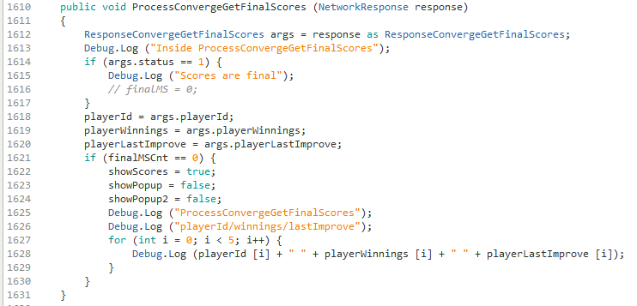

The results are obtained from the server and copied to arrays (playerId, playerWinnings, playerLastImprove) that hold the values for displaying. The three ‘show’ status flags indicate which windows to display. The showScores is set to display and other pop ups are turned off.

There are some timing issues. The clients do not all receive their updated scores at the same time. It depends upon when they request the update and when the last client has submitted the bet results. Clients poll for the results about every second. So, all the clients do not request the final scores at the same time. This causes the first client to possibly get a non-final score for another client. The result is the display of winnings for an opponent is not accurate. Because of system delays, it was difficult to get this timing correct. So, it was decided to send the ConvergeGetFinalScores protocol 20 times, once every 0.5 seconds, extending out up to 10 seconds. Initially a displayed value might be out of date for an opponent, but it is automatically updated within 1 to 2 seconds. The code that does this repeated messaging to the server is shown below.

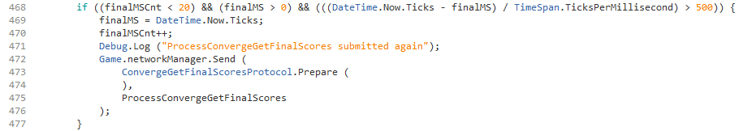

4.3 MultiplayerGames

The MultiplayerGames code manages the joining of a multiplayer game in the Lobby. Before Multiplayer Convergence (MC), all multiplayer games only had 2 players. Also, none of the games had any parameters entered in the Lobby. MC increased the number of players to 5 and introduced parameter-setting in the Lobby. These and other capabilities had to be added to MultiplayerGames to support MC. This section talks about these changes. All the code in MultiplayerGames will not be explained here, but rather that code that is new or modified for MC will be discussed.

The code shows how the field labels and entry boxes are displayed to support MC.

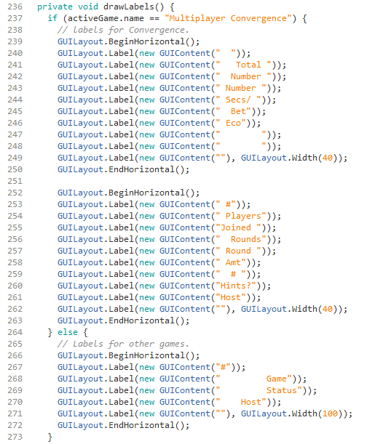

The above code shows that two rows of carefully spaced labels are drawn using Unity GUI features. The correct positioning of the words is accomplished by assigning the correct number of spaces. No problems with this approach have been found after trying various screen sizes and platforms.

The code that accepts the user parameter field input is shown below.

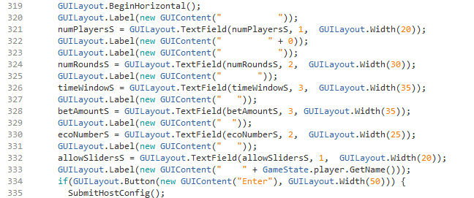

The GUILayout.TextField command is used. It allows a default value to be specified as shown above. This function manages most of the work associated with accepting an input. The value must still be checked that it is within range.

The code that handles a user invalid entry is shown below.

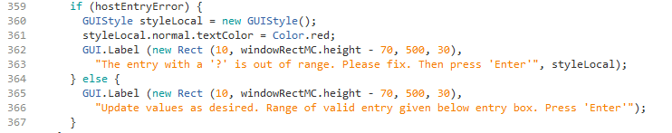

When the user submits his choice, if a value is found to be out of range, a question mark is added to the field, the hostEntryError flag is set and the code below notifies the users. The error message is displayed. Otherwise, the user is notified that she can edit any values.

The default values are set in the code block below. This is setup before the user is enabled to enter values.

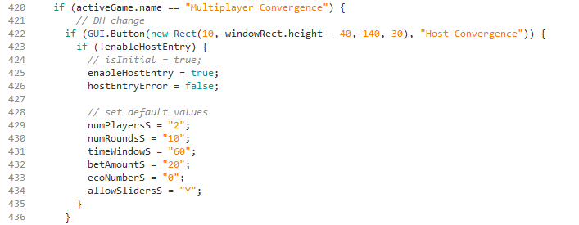

The code below handles conversion of the user inputs and, if the values are all valid, preparation of the message to notify the server of the game.

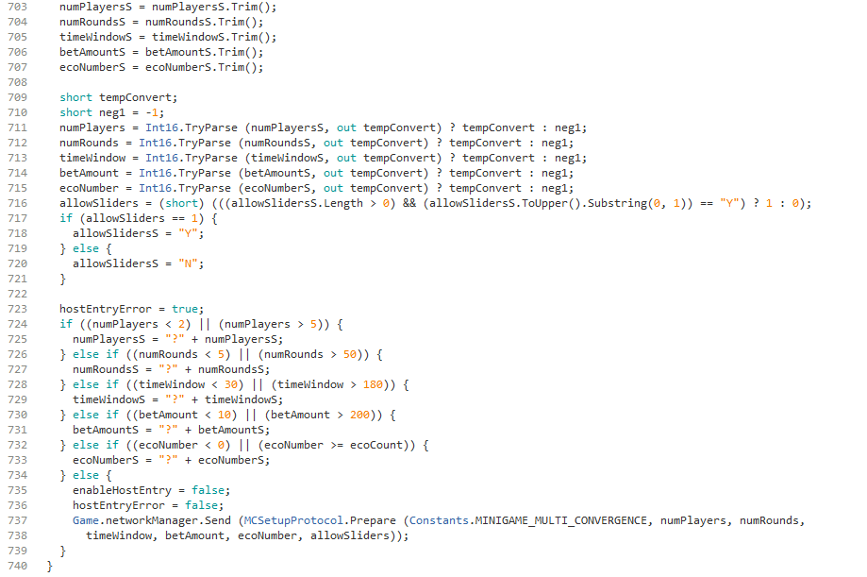

The GUILayout.TextField command works with string values. Numeric values must be converted from the string entry. Leading spaces must be eliminated to prevent an error. If a value out of range is encountered then hostEntryError flag remains true and the invalid entry is noted with a question mark. If there are no errors, the MCSetup protocol is used to establish a game room. As explained earlier, the MCSetup protocol is used by the game host to establish a game room. This protocol sets up the necessary data structures to support the MC game and adds the host as the host player. With this data structure in place, all other clients in the game room will also see this game as available.

The OnPairResult() method that adds a player to a game is explained for MC in two screen captures below. The top capture shows the entry point for this method and the bottom capture shows the code that handles the MC game.

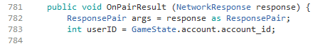

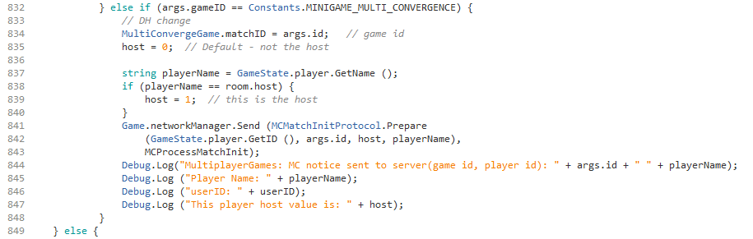

When a player wants to join a game that is already posted in the Lobby, she joins as a non-host. The MCMatchInit, as explained earlier, performs the process of adding a player to an existing MC game in the Lobby. Once the allotted number of players has joined, MultiplayerGames will transition all players into MC. This is handled by the code below:

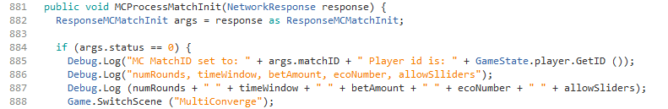

The MCMatchInit protocol results with a status value. If this value is 0 then all players have joined and it is time to transition to the game. The message is sent to all players in the room so that they will all enter the MC game when the last player has joined.

4.4 Ecosystem Display in Lobby

The screen capture below shows the Lobby scene. Species are displayed on the tiles to show the species belonging to each player’s ego system. This includes this player and all other players. These are the results of two blocks of code. First, code has been added to display the player’s species on her tile. Also, code was added to display the species of all of the other players. These two blocks of code will be explained separately. They have significant differences.

Code that displays player’s species

The GameState class is an object that persists throughout the game session. Therefore, it contains many important game state objects in a static form that are easily accessible to other class routines. A screen capture of the beginning of GameState is shown below to illustrate this point.

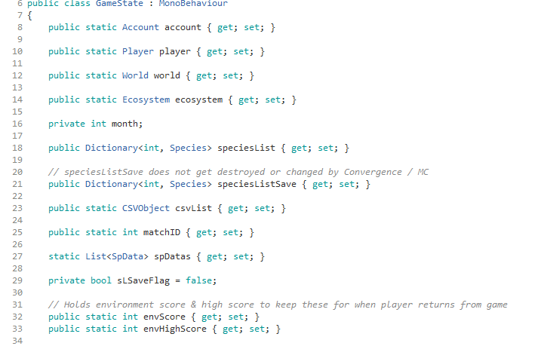

Many important static objects are maintained in GameState as shown above. This includes Account, Player, World, Ecosystem, matchID, envScore, envHighScore. Other important objects, like speciesList, are not maintained as a static object. It is necessary to get a GameObject object name to access those.

When the player logs in the server will send information to the client. The client will provide this information to the player or will use it to make the games function correctly. The client listens for these messages from the server. The GameState object has code to listen to three types of messages as shown in the block below.

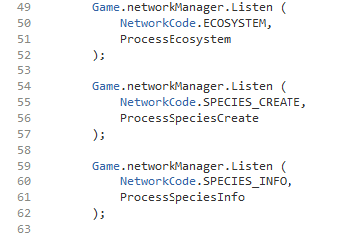

The ECOSYSTEM messages contain information about the player’s ecosystem. This information is used to create some ecosystem data structures on the client side and is made available to the player and used by some games. The SPECIES_CREATE messages tell the client which species the player owns. They trigger the creation of a species object in the client used by the Lobby. The SPECIES_INFO messages were added in this project. They are used to give information about other player’s species so that those graphics can be drawn on the tiles. We will look at these messages in the next section.

When a SPECIES_CREATE message is received, the ProcessSpeciesCreate() method is called. In addition to creating the species in the client data structure, it also displays the species on the player tile. The displaying of the species was added as part of this project. This routine is shown in the screen capture below:

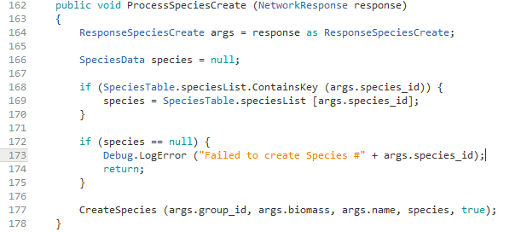

The ProcessSpeciesCreate() method is complex so we will focus on the extension added in this project. First, the code checks if the species id is found in the SpeciesTable object. If not, an error message is displayed. This failure is significant because it means that the client database does not contain a species that the server database has. The client database is supposed to contain all the species presently in the game.

After that the CreateSpecies() method is called. A screen capture of that method is shown below.

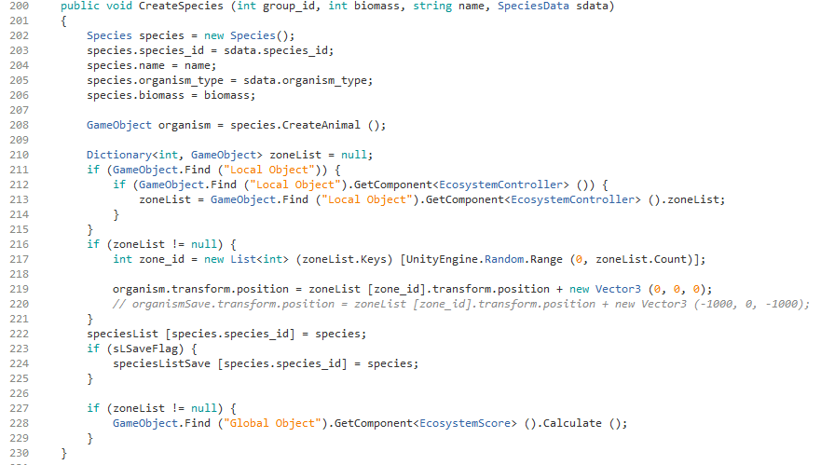

This code does a number of things to create this player’s species in the client data structure. In order to display the species Lobby tile, line 217 extracts the zone_id of the player’s tile from the data structure and then uses it in line 219 to access the tile (called a zone) for that player and place the organism on the tile.

When the species is created the CreateAnimal() or CreateOrganism() methods of the Species class are used. These methods do a similar action in regards to placing the species on the player tile. So that the species do not stack on top of each other and become obscured, each specie is shifted over a little on the tile when it is placed. This shifting happens in the X direction. Once the end of the tile is reached, then a shift in the Z direction happens. The Z direction is what we normally think of as the Y direction. The code below performs this function.

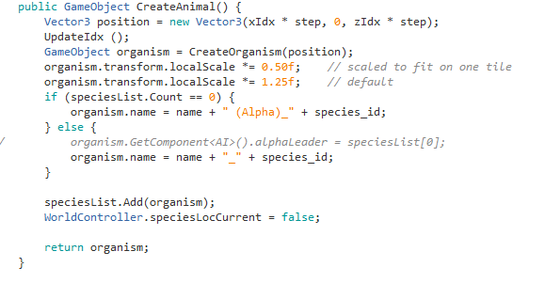

The specie is placed at the location xIdx and zIdx. The variable step provides a scaling factor that effects how much the species graphics overlap. After placement the method updateIdx() is called. It updates xIdx and zIdx to shift them over to make each specie visible. That code is shown below.

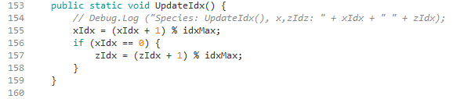

These code blocks cause the player’s species to appear on his tile, shifted over a little so that all are visible.

Code that displays species of other players

The code that displays species of other players has some similarity as the code discussed above, but there are some significant differences. The other players species are not part of the player’s specie data structure, nor can they be. Another approach is necessary for handling the other players’ species.

As mentioned above, GameState also listens to SPECIES_INFO messages. This protocol is new for this project. New code has been added to the server to send these messages to inform the client about the location and type of other players’ species. To understand this, let’s look at the server code that sends these messages.

The startEcosystem() method in the EcosystemController class sets up the data structures to start a player’s ecosystem after login. A snippet of the beginning of this method is shown below.

At the end of this method, code was added to send species and ecosystem tile information to the client. This code is shown below in two sections.

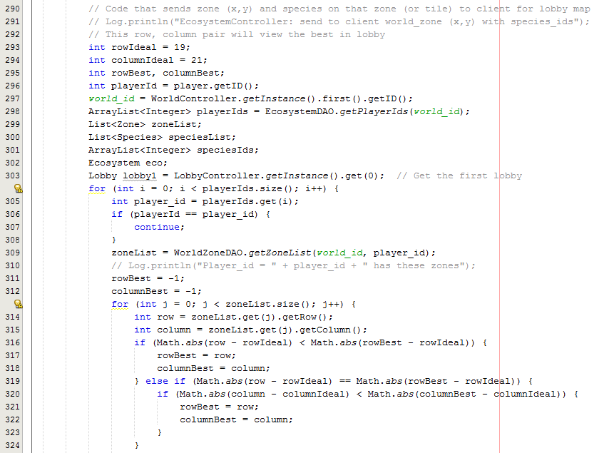

The ideal row and column are the center of the Lobby map. If a player owns multiple tiles, the one nearest the center is chosen to make the Lobby look more densely populated. The EcoSystemDAO is used to get a list of all player ids. An ArrayList with each player id is returned. Then, the code cycles through each player id. If the logged-in player is found, it is skipped. We have already placed the species for this player. Then the zone list is obtained for that player. This is the list of tiles that the player owns. That list is cycled through to find the tile closest to the center of the Lobby. The code explanation continues with the code block below.

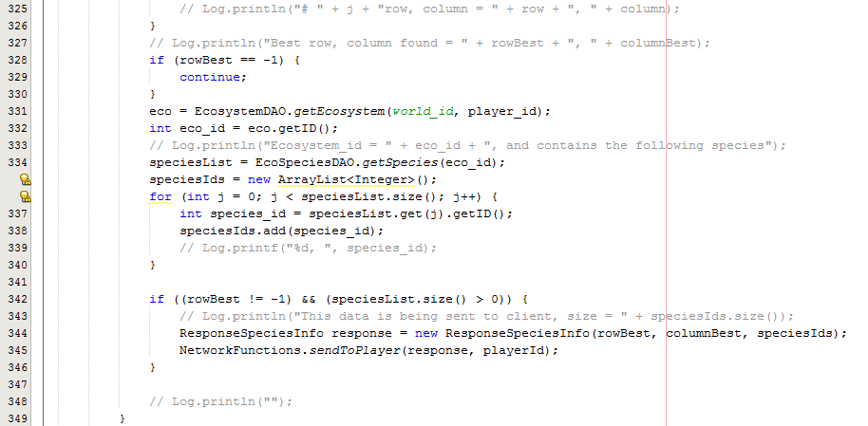

The ecosystem for the player is retrieved. Among other things, it contains the list of species ids that the player owns. These are added to an ArrayList. Then, a SPECIES_INFO message is sent to the player client containing the row and column of an owned tile and a list of species ids that the player owns. This process is repeated for all players with tiles.

Next, let’s look at the code on the client side that receives the SPECIES_INFO messages. These are received by the ProcessSpeciesInfo() method of GameState. This method is shown below.

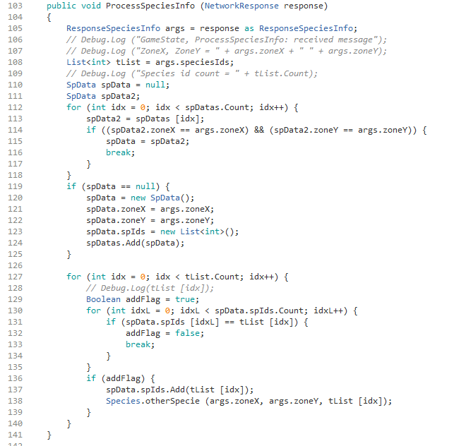

This method extracts the List of species ids. The first block of code prevents duplicate species from being displayed. The server will repeat the data due to various circumstances, including the purchase of additional biomass of the species. Starting in line 119 the case for the first placement on a tile is handled. The location of the last species to be placed on a tile is kept in a SpData object. The first time a specie is placed on a given tile, this object must be created.

A specie listed twice redundancy check is done starting in 130. If the specie has not been placed before on the tile, then it is added using the otherSpecie() method of the Species class. This method is shown below.

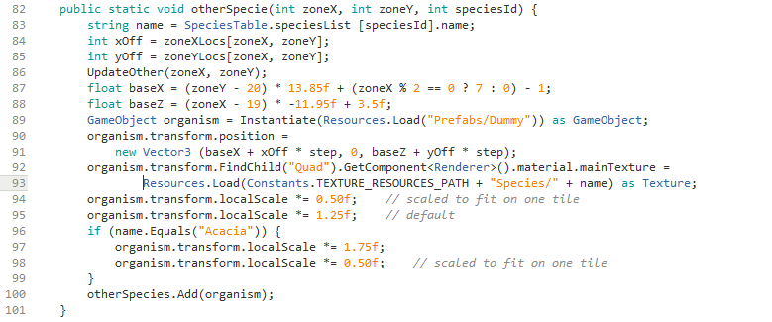

The zone offsets are stored in arrays. The location for the X & Z component is calculated using the strange formulas in lines 87 & 88. These adjust for the hexagon size of the tile and the interleave placement. The position of the graphic is set by these two values. Some scaling is done to make the species fit better on a tile while still being discernable. The UpdateOther() method on line 86 shifts the offset locations to the next position on the tile. This block is shown below.

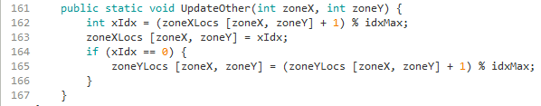

4.5 Ecosystem Graph

The Ecosystem graph is a feature of the Lobby. An example display is shown below.

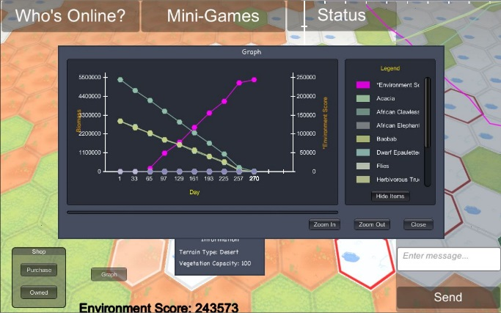

To explain the implementation of the new features in the Ecosystem graph, we will start with some critical basic components. The first one is the GetData() method which is called to get the data to draw the graph based upon local cache and server data. The first part of this method is shown below.

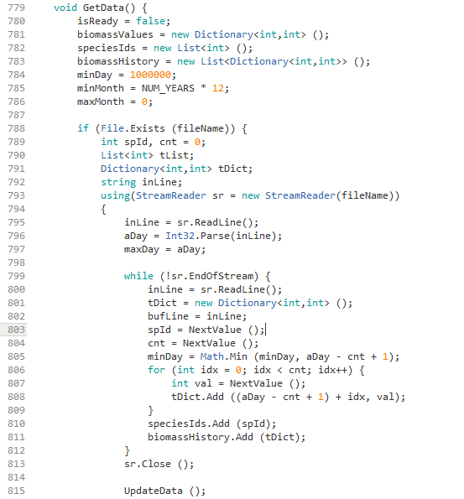

The method begins by initializing some variables and objects that will be needed. Then, the code checks if the cache file exists. If not, the block of code that reads the local cache is skipped. The first time a player selects the graph, no file will exist and all the data will need to be fetched from the server.

If the file exists, it is read. The first line that is read is a single number and it is value for the variable aDay. This is the highest day for which there are values in the file. All species biomass data in this file will have values through this day. Next, the routine reads a line in the file. Each line will contain the biomass history from the species inception day in this ecosystem until aDay. The method NextValue() fetches the next number from the CSV-formatted file. bufLine is a global string and it is edited by NextValue() to extract the value read. The first two values in the line are the species id number and the count of days stored in this line, cnt. So the days stored in the line range from [aDay – cnt +1, aDay]. The cnt is not necessarily the same for each specie. These values give the biomass of the species for each day. These values are added to a Dictionary for displaying on the graph. After the Dictionary is complete for this species, then the species id is added to SpeciesIds which is a List of species ids, and the dictionary is added to biomassHistory a List of dictionaries. The UpdateData() method will display the graph based upon the file data.

The screen capture below contains the next portion of the GetData() method.

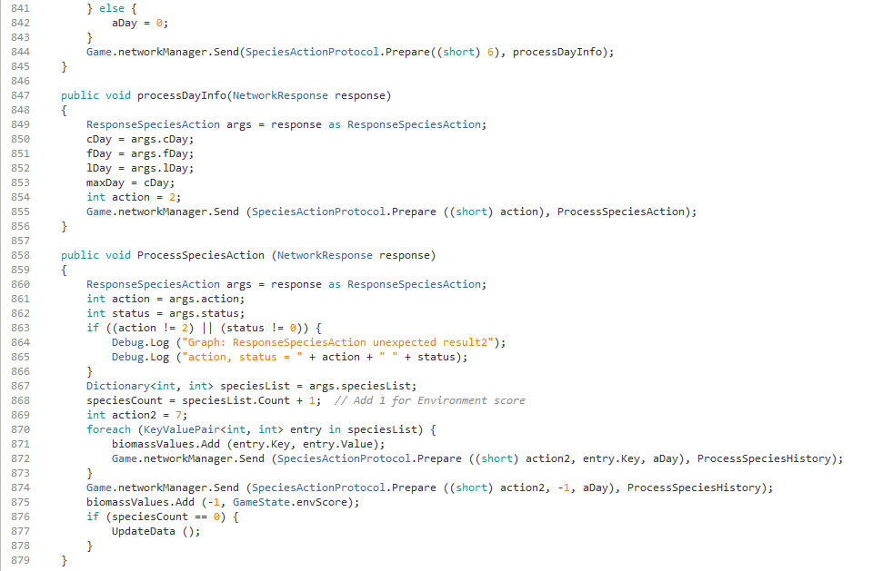

At the top of the code, the else clause sets aDay = 0. This is the case where there is no cache file. This indicates that the server must be accessed for player species data all the way back to the beginning of game time.

The code that follows is executed both when a cache file exists and when one does not exist. There is a series of network messages and receipt of data. The first step is to get the current day. This done through the SpeciesAction protocol with action = 6. This returns 3 day values. The last one is the current day in the game. It used to determine the end point of the graph. The variable maxDay is assigned to it. This is the maximum day displayed by the graph.

After this, the SpeciesAction protocol is used again, this time with action = 2. This returns a Dictionary that is assigned to speciesCount. The keys of the Dictionary are species ids and the values are current biomass values.

For each species in this Dictionary it is necessary to request the daily species value changes from the server. This is done by using mode 7 of the SpeciesAction protocol as shown in the code above. The variable action2 is set to 7 to select this mode. One additional request is done for species id = -1, which is a code for the environment score. It is also plotted on the graph. Notice that the value of aDay is included in the network message. This variable instructs the server as to the starting day to fetch the daily biomass change value. If no file is present, aDay will be 0 and the fetch will go back to the start of the species for this ecosystem. If the cache file is present, aDay will be set to the last day read from the cache. This will be the first day of access from the server, so only the values not present in the cache file will be read from the server. The day of aDay will be read from the server even though it is in the cache. This is necessary because it is possible that the biomass changed again on aDay after the cache was created, through a purchase, for example.

The screen capture below shows the next block of code in the graph routine.

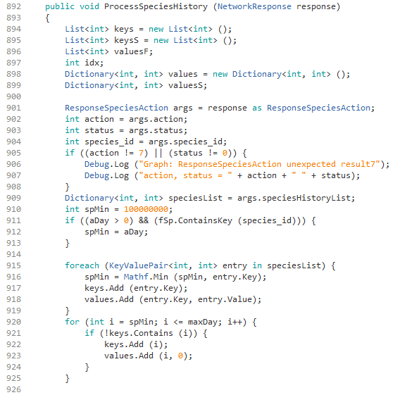

The code block above is continued in the screen capture below. First, we will discuss the code above. The code is the callback from the server. The server responds with the daily biomass change values since aDay. Actually, only values are returned for days where there were changes. The server database does not store entries for days in which there is no change in biomass to save database storage.

This block creates some data structures that will be necessary. The data structure, speciesList, is a Dictionary with keys of days and values of biomass delta that occurred on that day. The variable, spMin, is used for 0 filling the days where there are no changes in the biomass. This is necessary so that there is a value for each day in the graph. It makes the graph easier to understand. If there is a cache file (aDay > 0) and the cache has this species id (it existed before aDay) then spMin will be set to aDay. This will be the start of the 0 fill of missing days. Otherwise, spMin will be set to the smallest day value in the server daily biomass change history. This is to make sure the 0 fill goes all the way back to the first daily value, and no further. The code starting at line 920 does the 0 fill.

The screen capture below completes this block of code.

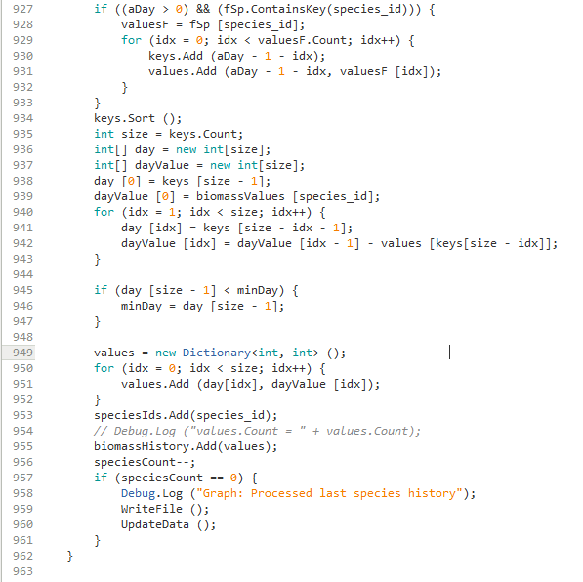

The code starting in line 927 checks for any data for this species that was in the local cache. If there is any, then it is added to the data from the server. The keys are sorted for displaying the graph. This data must be changed to be displayed in the graph. The data from the server is daily biomass changes. This needs to be changed to actual biomass values. The code starting in line 940 does this function. The minDay value updated starting in line 945 is used for display. It is the lowest day in any biomass and sets the starting point for the graph. The next code transfers the data into the display data structure. The variable speciesCount is decremented. Once that becomes 0 then the last species data has been received from the server. The UpdateData() method updates the display. Normally the player does not even see any change on the screen from this because the update happens in the later days and the graph is initially set at the starting day.

The code below rewrites the local cache. It is rewritten with the latest graph data. Also, the method, NextValue(), is used to parse the line from the local cache which is written in a CSV format.

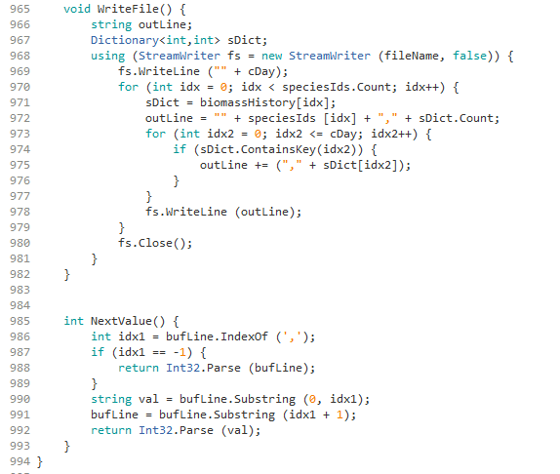

4.6 BarGraph Enhancements

The BarGraph class used by both Convergence games was modified to support the opponent’s bar graph feature. The contrast between the two graphs can be seen below.

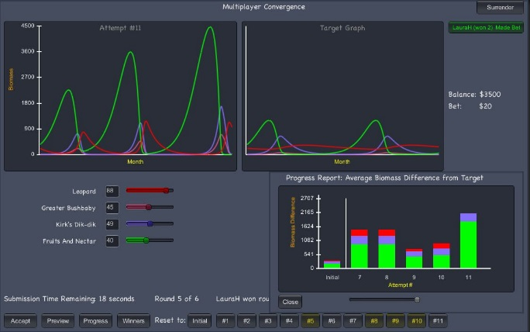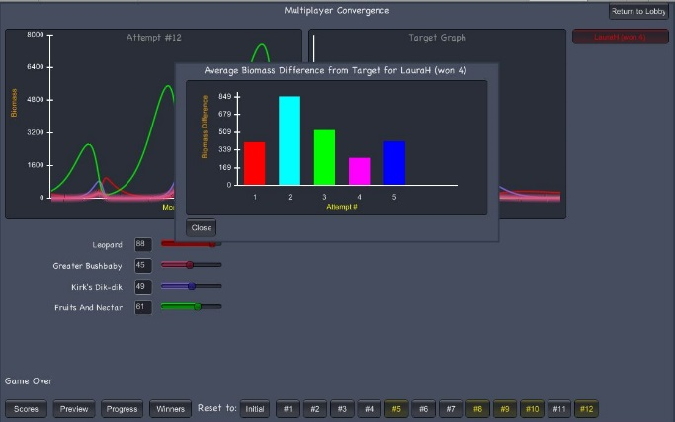

The right graph shows opponent information, but not as much detail is given. It is not a stacked bar chart. This is to allow the player to see how the opponent is doing, but not all the detail about the individual species is given. This reduced information graph is produced by the game BarGraph class, but utilizes some additional code as explained below.

The InitializeBarGraph() and GenerateBarGraph() methods are shown below.

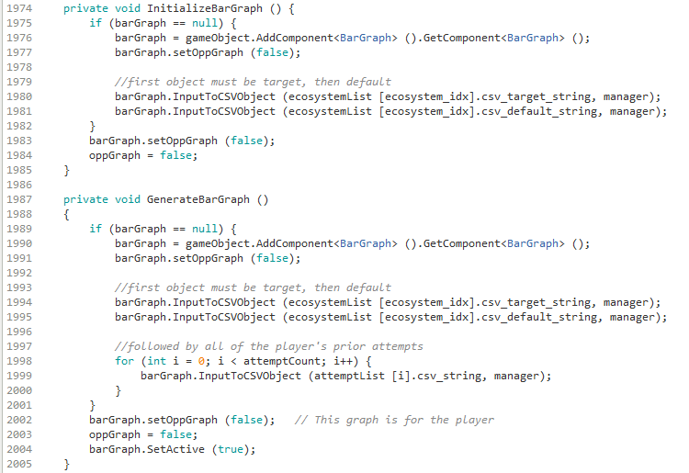

The InitializeBarGraph() method is called when the game is first begun and it is used to create the BarGraph object. The object is loaded with data necessary to display the player’s results. The GenerateBarGraph() method is called when it is time to display the player’s stacked bar chart as shown in the first example earlier. In both cases, if the BarGraph object has not been created, it is created. The recent attempts are added to the object for displaying. The MC game added the new method setOppGraph(). This is a flag to indicate which of the two graphs will be displayed. The SetActive() method turns on the graph display.

The code below is from the BarGraph class and it is the method that makes the window every OnGUI() cycle. References to the flag oppGraph can be seen. This flag is set true when drawing the opponent graph, the second one in the example. The location of the graph depends upon which graph is being drawn. Also, the title is customized. The method calcOppValues() is designed to calculate the values for the opponent graph. It is only necessary when drawing the opponent’s graph.

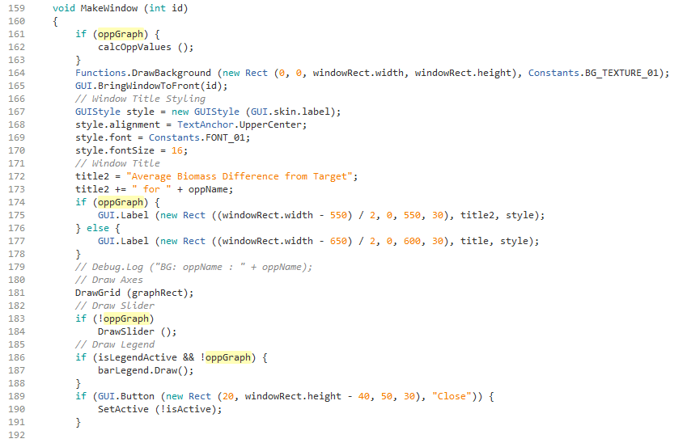

The code below draws the bar. In the case of the player graph, it is a stacked bar chart. In the case of the opponent graph, there is only one bar.

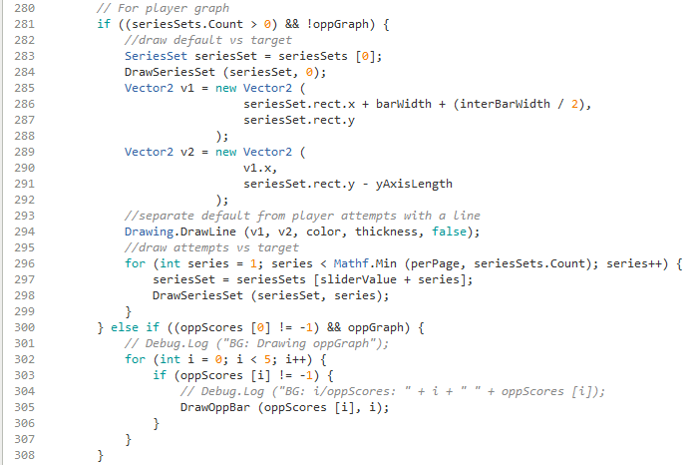

For the player code shown at the top, there is a cycling each of the species delta values to draw a color-coded bar for each species delta. For the opponent graph, the code near the bottom draws a single bar for the opponent score. Depending upon which graph is drawn, the size and location are different. This is shown in the code below.

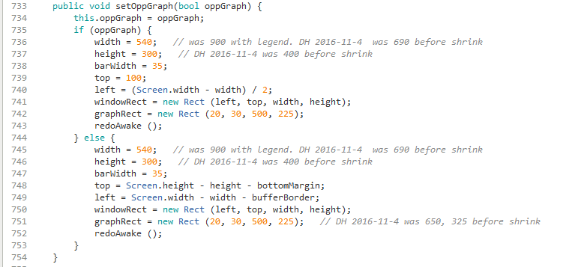
To make the game most effective, the player stacked bar chart is fit into the lower right corner as seen in the first image shown earlier. This allows the player to look at the two ecosystem progression graphs, the stacked bar chart and the sliders all at the same time. The positioning code to do this is shown above.

The Improvement() method is shown below. It is an important method. It is called by the MC game to calculate the player score. The lower score is better because it is a measure of the difference between the player’s graph and the target graph. Different algorithms have been used at various times. As the comment below says that in the September 2016 meeting, it was decided to use latest score obtained by the player. This is obtained by taking the most recent score obtained for the player, which is the last entry in the scores List. Then, subtracting that number from 0. The number becomes negative. The larger number (or closest to 0) is better.

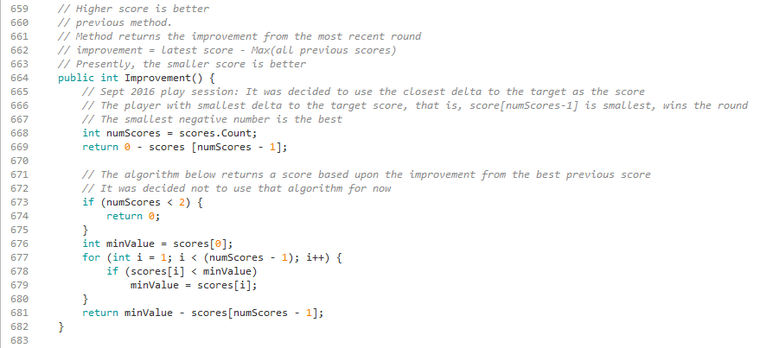

4.7 Shop Purchase

The shop purchase screen is seen in the screen capture below.

Each specie is represented by a card which has a drawing of the specie in the middle. Below the drawing is a line with the characters “c/b: “ followed by a number. The number is the cost per one unit of biomass. This gives the player some indication of how much each specie will cost. The code that provides this information is shown below.

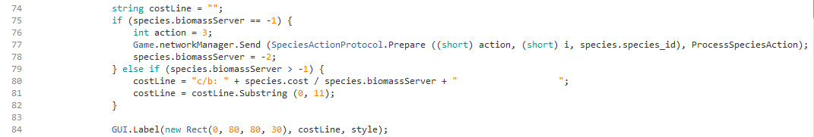

This code is in the OnGUI() method that is called every frame update. Initially, the biomassServer value is set to -1 when the species is created. If this is the first run, then the -1 value will cause the message to be sent to the server requesting the cost of the species. The -2 value is assigned to prevent the message from being sent a second time. If the cost is greater than -1 the cost has been received and can be displayed.

The code that receives the message from the server is shown below:

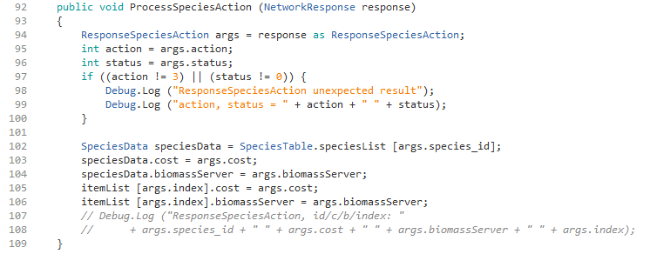

This code receives the species cost for a set biomass. The values are updated so that during the next screen refresh the cost per unit of biomass will be displayed.

While in the shop purchase, the upper right corner displays the credits remaining. This is assuming that the player decides to purchase the items in the cart. In the screen capture a few pages back, the African Clawless is in the cart for purchase of 100 biomass units. This purchase has not been done yet. It will not be done until the player clicks “Purchase” near the bottom right. However, as a convenience, the upper right shows the remaining credits, assuming this purchase was done. The code that implements this feature is shown below:

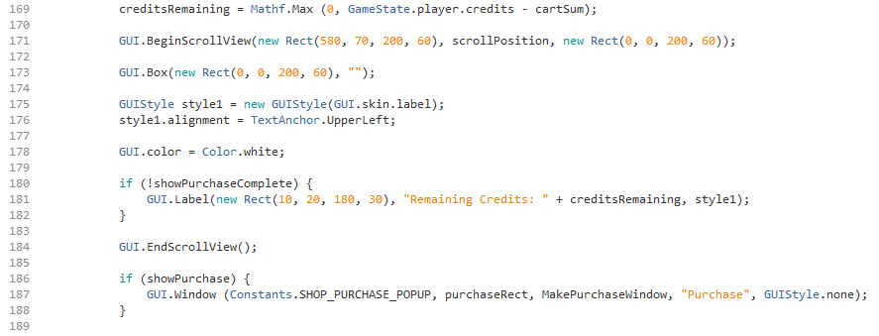

Near the top, the credits remaining is calculated by taking the existing credits and subtracting the cart total. This shown on line 169. Then, on line 180 & 181, this amount is displayed. The ShopCartPanel class was enhanced to contact the server to update the species in the database as well as to deduct the credits. This was necessary to persist the transaction. The code that implements the purchase is shown below:

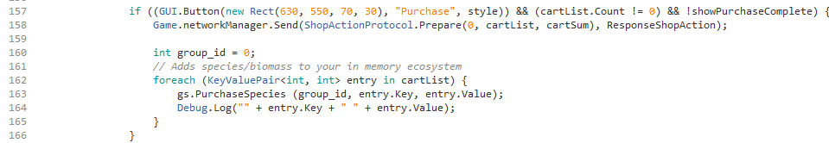

There are two parts to the code. On line 158 a message is sent to the server to purchase the items in the cart list. This part was not present previously. Neither was the correct server protocol to receive the message in place. The code starting in line 162 completes the purchase on the client side, updating the local copy of specie totals.

The server protocol that receives the message is shown below.

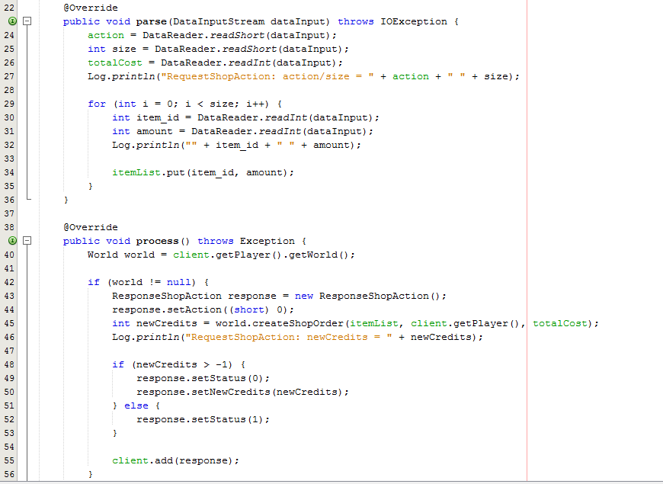

The purchase data is parsed from the message and the processing step involves using the World class method createShopOrder() to implement the purchase. The server and client code have been synchronized to prevent the server from ever determining that there are insufficient funds. So, the legacy code in lines 48 to 53 is not relevant for purchases anymore. In the past, it was possible for the server to reject the purchase because of insufficient funds. The client has been changed to accurately calculate the cost in the client and make sure no purchase request is made that exceeds the credit balance.

The createShopOrder() method code is shown below.

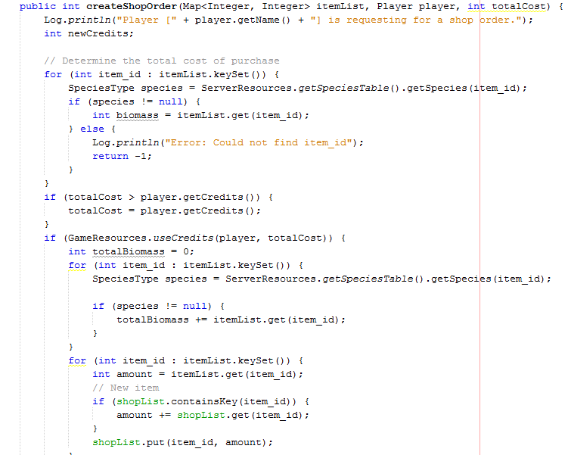

For each item in the purchase list, the species information is found, including the amount of biomass the player presently owns, if any. The adjustment is made to the biomass and the credits are deducted in the server database.

On the client side, the PurchaseSpecies() method of GameState is used to update the local credit balance. The code for it is shown below.

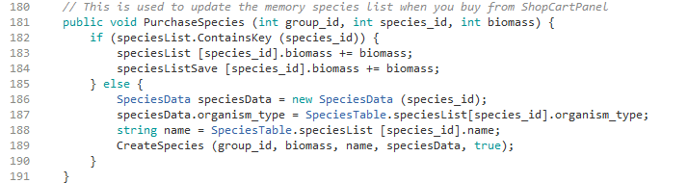

The species biomass counts are updated. If the species does not exist for the player, it is created. This process keeps the server and client species biomass counts and credits in balance. Proper game play requires this.

4.8 Shop Owned

Previously, the “Owned” button for the Shop was not working. The player’s species were not appearing correctly. Also, the predators and prey were not appearing correctly either. The problems were caused by the fact that the appropriate classes were not connected to the server properly. Also, the biomass owned by the player has been added to the bottom of the species card. Please see the screen capture below.

This species display has two way scrolling. Up and down views species from different Trophic levels. Left and right views species of the same Trophic level. The class that produces this display of species is called Database.

The class provides a static method for obtaining the instance reference as shown below.

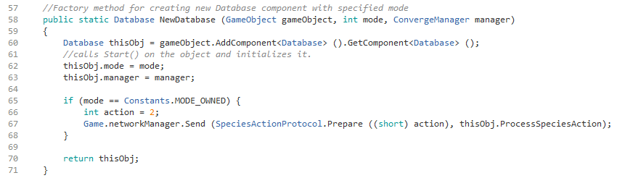

We can see in the code above when this method is called and the mode is MODE_OWNED a network message is sent. This mode is for the Shop Owned display that we saw above. The network protocol obtains all of the species and their biomasses that are owned by the player. The problem with the previous code was that the server was not being accessed to obtain the species information. The problem is that the client may not have the complete information on the current species biomass values. So, accessing the server is necessary for this mode to work properly. The code that receives the server response is shown below.

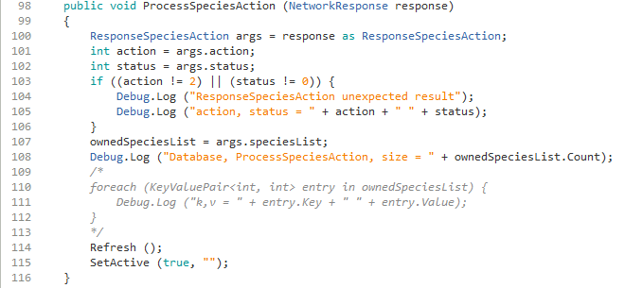

The object ownedSpeciesList is a Dictionary of species ids for keys and biomass for values. Once this data is received the chart can be set active as is shown at the end of the method.

This same display is used in other parts of the system as well. For example, it is used by the Convergence game. In the Convergence game, there is no biomass value to display. In order to provide the option of some uses have the biomass and some do not, a second Draw() method was added to the Card class. A Card object is created for each specie to be represented in this chart. The Draw() method is used to draw the card. An overloaded version of the Draw() method was created which contains a biomass parameter. When that method is used the biomass is also drawn. Please see the code block from the Card class below.

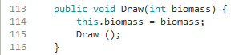

The regular Draw() method has no arguments and is a very long routine. For applications that require the biomass to be displayed, the above version is used. The biomass is supplied as a parameter. The biomass is set and the regular Draw() method is called. The Card object is created with biomass set to -1. The code for a portion of the Draw() method is shown below.

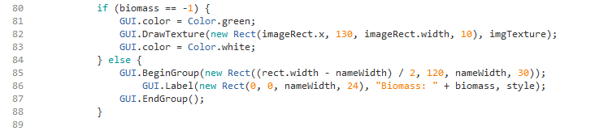

If the regular Draw() is called, then biomass will be its default -1 value and no biomass will be drawn. If the Draw(int biomass) version is called, then the biomass is displayed.

The screen capture below shows the predator / prey view that appears for a specie when the “Details” button is pressed. In the example below, it was for the African Clawless. In the resulting display, the African Clawless is in the middle. On the left are predators and on the right are prey.

For the Convergence game, only those predators and prey that are in the game are displayed. This feature is handled by the View class that assists in drawing the cards. In the code block below, if the mode is convergence and the specie is not in the game, then it is not drawn.

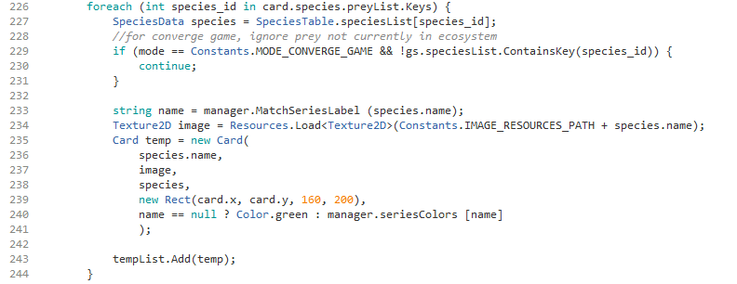

4.9 Windows Executable Creation

The Windows Executable must be updated whenever development is changed

The executable is convenient for the players, but demands more work for the WoB team. This executable must be updated every time that development is changed in any way that impacts the player. The update process is explained below.

First, inside Unity select File -> Build Settings
It gives a window similar to the screen capture below:

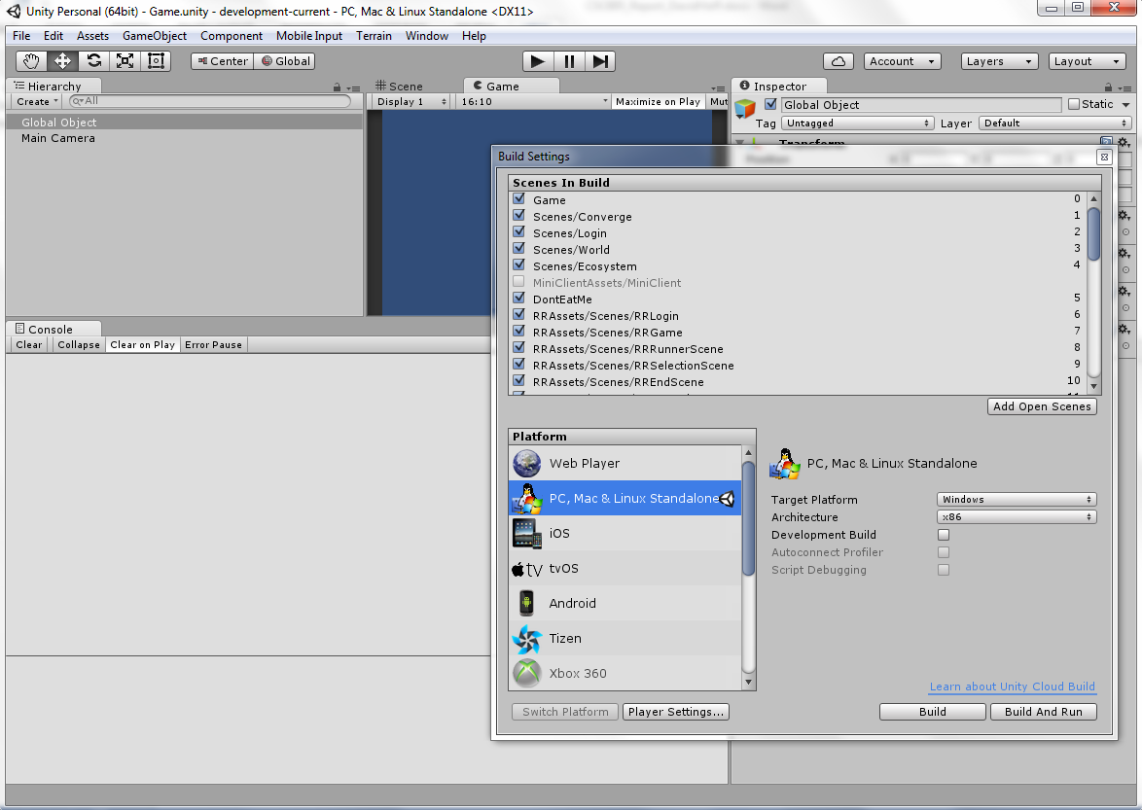

All the scenes should be selected. The MiniClientAssets/MiniClient is not selectable. It should not be selected. Choose the desired platform and architecture. To make a build for debugging, clicking the “Development Build” box provides helpful debug messages. The Development build is useful to debug game crashes. It will print out an error message when the client crashes. Sometimes the executable client will crash because it is missing a file that the GitHub version is not. For the release version, it is not recommended to use the Development build. Then, press the “Build” button.

This will produce a WoB_client_win.exe file. It will also produce a directory, WoB_client_win_data. This file and directory must be in the same directory for the executable to run. However, other things seem to be necessary to make it work. These are explained in the file “readme_to_make_exe.txt” that can be found in the Unity top level game folder.

The first statement is, “1. I had to copy the sqlite3.dll into the Plugins folder from the x86 subfolder of SQLite4Unity3d. The zip file is in this folder.” The SQLite4Unity3d.zip file is in the top level game folder. It should be unzipped and down the path, SQLite4Unity3d.zip\Plugins\x86, there is the file: sqlite3.dll. This file has to be copied into the folder WoB_client_win_Data\Plugins. Next, the help file says, “2. I had to copy Database folder into the WoB_client_win_Data folder!”. The Database folder is under the Assets folder. It has to be copied into the WoB_client_win_Data folder. Finally, the help file says, “3. The converge-ecosystems file must copied to the same directory level as the exe file.” There is a file in the game folder, “converge-ecosystems”. It must be copied into the folder with WoB_client_win.exe file and the directory, WoB_client_win_data. These three entities can then be zipped together and posted to the website. When that zip file is downloaded and unzipped, the player should be able to double-click the exe file and run the game. The exe file will run faster than starting Unity and specifying the Unity game folder.

4.10 Server Deployment

The sever is written in Java and is presently deployed to an AWS host (54.153.66.118). The server can moved to another host. In the past year it was been hosted on www.thecity.sfsu.edu and www.smurf.sfsu.edu . The AWS server is more powerful, and possibly more stable, than these other two systems so we are presently using the AWS server.

Running on AWS has made the Multiplayer Convergence “Preview” command more practical. The Preview command runs the ecosystem simulation and displays the result without submitting the play to the server. This command is only practical if the simulation runs fast. On thecity and smurf, the simulation run was slow and so the Preview command might not result in good user experience. However, on AWS, the Preview command operates acceptably fast.

Previously we have used the Travis environment (https://travis-ci.org) to deploy the server when the server was running on thecity and smurf. Travis integrates with GitHub and provides a nice compiling error checking process and deployment process. This was setup by Jens Vanderhaeghe. However, after Jens graduated a problem developed with the key process and the Travis deploy began to fail. Travis still does an error checking when commits are made to GitHub. It was decided that we would put resources into preparing the client and server for the game trial and leave automatic deployment for a later date. Therefore, we will discuss the manual deployment process

This section discusses manual deployment using a Linux environment. Deployment using MAC would be very similar. The Linux installation used for this deployment is actually running on a Windows system using VirtualBox from Oracle. In this case, a recent version of Ubuntu (16.04 LTS) was installed using VirtualBox. A shared folder was established with Windows. This allowed working in a Windows environment and then using Ubuntu to compile and deploy the server.

The deployment steps can be found using commands found in a script in the server scripts folder. The scripts folder is part of the Travis environment. The Travis configuration file can be found in the top level directory, in the file .travis.yml. In the scripts folder, there is a file called compile.sh. This file contains commands to manually compile the server. The scripts folder is in the top level folder for the server project. It can also be obtained from the top level directory in GitHub as shown in the screen capture below. The .travis.yml file can be seen there also.

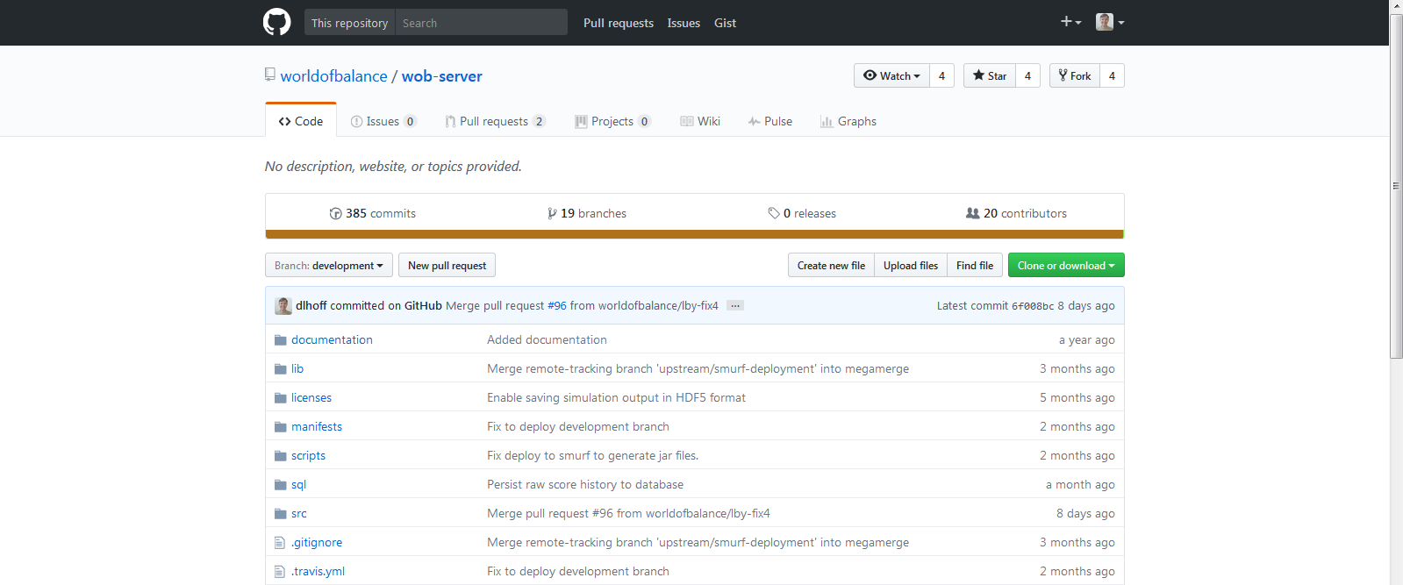
To compile the server into a jar file, follow the instructions from compile.sh shown below. Not all the steps in the script are included, but only those needed to manually deploy the server.

>>>
cd src

# fetch a list of all the Java Classes
find . -name "*.java" > sources.txt

# Compile all the Java Classes
javac -cp "./../lib/*:." -target 1.8 @sources.txt

rm -rf sources.txt

# create a jar file for each game, based on their appropriate manifest files.
jar cfm '../dist/lobby.jar' '../manifests/lobby.manifest.txt' *
jar cfm '../dist/cards-of-wild.jar' '../manifests/cow.manifest.txt' *
jar cfm '../dist/clash-of-species.jar' '../manifests/cos.manifest.txt' *
jar cfm '../dist/sea-divided.jar' '../manifests/sdv.manifest.txt' *

<<<

Comments included from compile.sh should not be typed in. The four ‘jar cfm’ commands will produce 4 jar files; one for the Lobby and the other three for the three game servers. Most of the deployments only involve the lobby.jar file. So, only the Lobby ‘jar cfm’ command is necessary in those cases. If one of the game servers is updated, then the jar for it must be regenerated and deployed.

Once the jar file(s) have been generated, they need to be copied to the server. The jars are stored in the ‘dist’ folder, so it is necessary to type ‘cd ../dist’. From the ‘dist’ folder, the Linux scp command can be used. Here is an example;

scp lobby.jar wob_server@54.153.66.118:/home/wob_server

The password for the account can be obtained from Dr. Yoon. This will copy the file to the AWS server. If a different server is used, then use the appropriate IP address and directory path.

Next, login to the server. From a Windows computer this can be done using putty. The jar file(s) will be in the top level directory. First, it is necessary to kill the process for any server that is being deployed. The ‘ps aux | grep wob’ command can be used to see the process numbers of the servers. The ‘kill -9 <process_id>’ command can be used to kill the appropriate servers. Replace <process_id> with the process id obtained from the ps command. Do not kill all servers, but only those that are being deployed.

The server jar binary files are stored in the directory: wob-server-binaries. The old jar file(s) should be removed and the new ones should be moved into that directory. Then, the jar file can be started with a command like shown below. The example is for the Sea Divided server. All the mini-game servers are done the same way.

java –jar wob-server-binaries/sea-divided.jar > logs/sdv.log 2>&1 &

This command is to begin execution of the Sea Divided server. The three mini-servers are deployed in a similar manner. It is suggested to follow the same naming convention of the existing log files found in the logs folder. This command will overwrite the existing log file. If the existing log file should be kept, then it should be renamed before executing this command. This command redirects the log file into the logs folder. Also, the error output is redirected into the same log file using the sequence, 2>&1. This captures the error output as well for later debug. This option has sometimes been associated with the server crashing on AWS without giving any message. If crashing is a problem, the server could be run without this option to see if that helps.

The ‘&’ runs the process in the background. The log file can be checked to see if the server says that it is ‘> Now accepting connections…’. All four game servers will report this message early in their log file. For the lobby server, it will begin simulations within a few minutes depending upon the configuration file setting.

For executing the lobby.jar file, the command is different. There is a shell script, startLobby.sh, found in the /home/wob_server directory. It has two commands. The first is: source activate atn-tools. This is necessary to configure the server to generate the food web graphs. The second command is the standard command to start the lobby server. The shell script should be run in the background like:

./ startLobby.sh &

This will activate the atn tools and start the Lobby server.

Chapter 5: Results

5.1 Testing

Multiple testing layers were employed in this project. First, the student tested the code using localhost on one computer. It was possible to run the server and two clients on one reasonably powerful laptop. This approach provided quick feedback on changes to both the client and server. The screen capture below shows two overlapping clients playing Multiplayer Convergence on one laptop. Here, three programs were running on one laptop; the server and two clients.

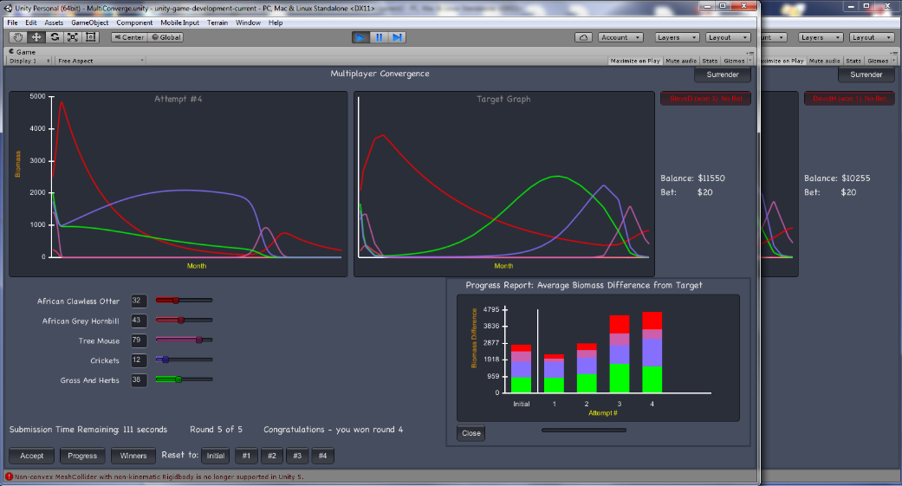

When that passed, the server was deployed to the remote host. Three remote hosts were employed at various times; smurf, thecity and an AWS host (IP: 54.153.66.118). The remote server runs more reliably and was employed when frequent server changes were not required. After both the client and server were passing both tests, then two computers were employed to run the two clients. This verified that Multiplayer Convergence would still work when used in the more normal way of one client per computer. Also, this allowed the testing of up to 5 players. Multiplayer Convergence supports up to 5 players. To test this feature, two computers were employed; one with 2 clients and the other with 3 clients. This allowed the student by himself to test up to 5 players playing.
The next group of tests involved the professor as well as the student. The two played Multiplayer Convergence. Good feedback was received from someone other than the program developer (the student). Then, the next step was to include additional WoB students in the play session. This resulted in 3 or 4 separate players playing Multiplayer Convergence. The next step is the game trial with non-WoB developers. This is scheduled for Summer 2017.

5.2 Testing Protocols

The following testing protocols are used to test the features implemented in this project. Each feature has its own testing protocol that is run to verify the functionality. Client #1 and #2 are clients setup for testing Multiplayer Convergence. Any two different accounts can be used. The other features only need one client for testing. Those do not state a starting point, as the starting point is assumed to be the Lobby as it was through the previous test.

5.2.1 Multiplayer Convergence Testing Protocol

Multiplayer Convergence
Test  ID | Test Description | Test Steps | Expected Result | PASS  /FAIL
M01 | Select host MC | Starting Point: Lobby, Client #1  1. Select Mini-Games, Multiplayer  2. Select Multiplayer Convergence  3. Select Host Convergence  4. Enter some parameters value to test, but keep number of players at 2  5. Press Enter | MC appears in Game Room with parameters as specified and a Quit button. This player is the game host. | PASS
M02 | Select player MC | Starting Point: Lobby, Client #2  1.Select Mini-Games, Multiplayer  2. Select Multiplayer Convergence  3. Press Join for previously setup game | Both clients enter Multiplayer Convergence | PASS
M03 | Test Accept | Starting Point: Client #1  1. Move a specie slider  2. Press Accept button | Accept button should change to Entered and gong should sound | PASS
M04 | Test Preview | Starting Point: Client #2  1. Move a specie slider  2. Press Preview button | Left graph should change to show update. | PASS

Multiplayer Convergence (cont.)
Test  ID | Test Description | Test Steps | Expected Result | PASS  /FAIL
M05 | Test round player | Starting Point: Client #2  1. Move another slider  2. Press Accept button | After some time both clients should show winner and loser and have audio update | PASS
M06 | Play a few rounds | Play a few rounds as shown above | Winner and loser should be announced each round and game updated | PASS
M07 | Test Winners | Starting Point: Client #1  1. Press Winners button  2. After result verification press Close | The round winners should be shown | PASS
M08 | Test Progress | Starting Point: Client #2  1. Press Progress button  2. After result verification press Close | A stacked bar chart with player results should be shown | PASS
M09 | Test initial prior attempts | Starting Point: Client #1  1. Press Initial button to the right of “Reset to:” | Two graphs should return to initial display at game beginning | PASS
M10 | Test later prior attempts | Starting Point: Client #2  1. Press a prior attempts button with a number on it to the right of “Reset to:” | Two graphs should return to show the results of that attempt | PASS
M11 | Test opponent progress | Starting Point: Lobby, Client #1  1. Press button with Client #2 name near the upper right corner | Opponent’s progress chart should be shown in the middle | PASS
M12 | Test final scores | 1. Complete game through the last round for both clients | Final score summary should appear | PASS
M13 | Test Return to Lobby | 1. Press Return to Lobby button near top right of screen | Lobby screen should appear | PASS
M14 | Test Logout | 1. Press Logout near bottom left | Login screen should appear | PASS

5.2.2 Ecosystem Graph Testing Protocol

Ecosystem Graph
Test  ID | Test Description | Test Steps | Expected Result | PASS  /FAIL
G01 | Test view graph | 1. Press Graph button | Ecosystem progress graph appears | PASS
G02 | Test pan function | 1. Mouse over slider at bottom left of Graph. Click and hold down.  2. Drag slider all the way to the right | Ecosystem data sweeps across to current day | PASS
G03 | Test Zoom Out once | 1. Drag slider back to left side  2. Press Zoom Out once. Be sure mouse is not near slider track | Data should appear with 2 days between each horizontal tick | PASS
G04 | Test Zoom Out full | 1. Repeatedly press Zoom Out until display does not change. Be sure mouse is not near slider track | All days of data should be visible. | PASS
G05 | Test Zoom In once | 1. Press Zoom In once. Be sure mouse is not near slider track | Data should appear with 2X zoom in from previous view | PASS
G06 | Test Zoom In full | 1. Repeatedly press Zoom In until display does not change. Be sure mouse is not near slider track | Data should appear with 1 day between each horizontal tick | PASS
G07 | Test Close | 1. Press Close button | Graph should disappear | PASS

5.2.3 Shop Purchase Testing Protocol

Shop Purchase
Test  ID | Test Description | Test Steps | Expected Result | PASS  /FAIL
P01 | Test shop purchase panels | 1. Press Purchase in Shop block | Shop purchase three panels should appear | PASS
P02 | Test specie select | 1. Single click on a specie card | Specie information should appear in bottom panel and other species are colored according to prey / predator relationship | PASS
P03 | Test specie purchase modal appearance | 1. Double click another specie card | Purchase modal should appear | PASS

Shop Purchase (cont.)
Test  ID | Test Description | Test Steps | Expected Result | PASS  /FAIL
P04 | Test specie purchase modal operation | 1. Enter biomass quantity  2. Press modal Purchase button | Cost should update interactively as numbers are typed and item should be entered into cart on the right side | PASS
P05 | Test repeated operation | 1. Repeat P04 for a few more species | P04 results should be repeated | PASS
P06 | Test purchase operation | 1. Press Purchase button at the bottom of the cart | Purchase complete modal should appear with new credit balance | PASS
P07 | Verify purchase operation | 1. Checked shop owned to verify species & biomass values are updated | Species and biomass values should reflect purchase operation | PASS

5.2.4 Shop Owned Testing Protocol

Shop Owned
Test  ID | Test Description | Test Steps | Expected Result | PASS  /FAIL
S01 | Test shop owned panel | 1. Press Owned in Shop block | Shop owned panel should appear | PASS
S02 | Test vertical scrolling | 1. Mouse inside panel on right side. Vertical slider should appear.  2. Click and hold slider. Drag up and down. | Species by Trophic level should be viewable | PASS
S03 | Test horizontal scrolling | 1. Mouse underneath row of specie cards that extends beyond right side. Horizontal slider should appear.  2. Click and hold slider. Drag right and left. | Species within one Trophic level should be viewable | PASS
S04 | Test food web | 1. Press Details button on one specie card | Food web of cards should appear. The predators should appear on the left and prey on the right | PASS

Shop Owned (cont.)
Test  ID | Test Description | Test Steps | Expected Result | PASS  /FAIL
S05 | Test food web close | 1. Press Close button in middle of food web | Food web cards should disappear but shop owned panel should remain | PASS
S06 | Test shop owned close | 1. Press vertical button in the middle to the right of the shop owned panel | Shop owned panel should disappear | PASS

5.3 Major Accomplishments

The major accomplishments of this project have been covered in this document. They are summarized below.

1. Developed Multiplayer Convergence Game
Multiplayer Convergence adds increased interest and fun to a very educational game. This game was developed using the Convergence game as a starting point and contains many new features. There have been internal trials and testing for more than a year, and many features have been added.

2. Implemented automatic periodic ecosystem simulation
Automatic periodic ecosystem simulation is fundamental to the World of Balance concept. A chief goal of World of Balance is to teach ecosystem ecology in a fun way. The teaching is greatly enhanced for students as they see their own personal ecosystem progress over time. As a result of this progression they are able to make changes to their ecosystem by purchasing additional specie biomass. Afterward, they can see the result of these purchases and learn more about ecology and ecosystem dynamics. The core of this process is the automatic periodic ecosystem simulation that was added in this project. The capability existed in an earlier version of World of Balance. However, the code could not be found and so it was done newly for this project.

3. Connected Lobby functions to server & enhanced functionality
The Lobby has several very important features that assist the player in obtaining the maximum benefit from the World of Balance environment. However, many of those features were not enabled for the players. They were not connected to the database, so the player’s data was not seen, rendering those features basically useless for the player. To help World of Balance reach its full potential as a learning environment, these features were connected to the database and enhanced in this project.

4. Updated and enhanced WoB website
The World of Balance website can be found at this URL: http://smurf.sfsu.edu/~wob/ . The website is basically the “face” of World of Balance to academia and the world. It is what people see first when they come in contact with World of Balance. It gives people their first impression of World of Balance. Therefore, it is important that the website is of high quality and also up to date and accurate. Accomplishing these objectives was also a goal of this project.

Chapter 6: Conclusion

The objective of the World of Balance (WoB) environment is to advance science education through Gamification. The goal of this MS project is to further advance WoB. The goal here is to document the work done in this project so that future students will be able to more quickly understand this work and it advance it further.
The Multiplayer Convergence game is now ready for trials beyond the WoB team. The Lobby is also ready and the other mini-games have been checked to confirm that they are ready for game trial. The feedback obtained from those trials can be implemented to further the games. Every game will benefit from player trial with the resulting feedback being used to improve the games.
This project implemented periodic ecosystem simulations again. This will allow players to develop ecosystems and see how they progress over time. This will help the students learn more about what a world in balance means. The website has been made current. This will help students learn about the WoB environment so that they can obtain the maximum benefit.
The activities of this project together help forward World of Balance. Through this, science education and science itself is forwarded through the enjoyable process of Gamification.

6.1 Learning

The following are the major areas of learning in this project. There were many other areas of learning of lesser degree than those listed here.

1. Client-Server Game Architecture
Client-Server architecture was studied and applied to a minor degree before this project. However, it was learned and applied to a great degree in this project. Network games utilize the Client-Server architecture approach. Some examples includes how the server receives player information, computes results and returns those to the player client. Also, how other players are updated from the server processing of another player’s activity. The World of Balance is a very large code-package worked on by many students for a number of years. Many parts of this code-package had to be involved in completing the tasks of this project.

2. Network Protocols
Network Protocols were a big area of learning from this project. More than 10 new protocols were developed and others were enhanced or fixed. Many changes were done to the server to support the new Multiplayer Convergence game or fix or enhance other aspects of the World of Balance system. World of Balance sends both ASCII (strings) and binary (numbers) data across the network. Also, the environment is setup to allow the client to listen for server messages in addition to the sending the server a message and providing a callback for a response. Many different aspects of networking were utilized on this project.

3. Ecosystem and Ecosystem Simulation basics
World of Balance employs some state-of-the-art concepts and methods for ecosystem simulation. Dr. Yoon works with other researchers in this field to stay current on this developing field. Also, her department has published multiple papers at reputable conferences. So, the World of Balance ATN simulation engine is advanced and current. Therefore, working on this project gave exposure to ecosystem and ecosystem simulation. These topics were not a primary focus of this project so the understanding gained can only be classified as “basic”.

4. Unity GUI Framework (2D)
This version of World of Balance was built upon the Unity game engine. Unity is a 3D game engine and some World of Balance games, like Clash of Species, utilizes the 3D capabilities. However, none of the activities of this project involved 3D graphics. Rather, this project made extensive use of the Unity 2D capabilities which can be seen by viewing the many images included in this report. The approach of Unity 2D has noteworthy overlap with Android graphics with which the student has experience. This project helped to build 2D graphics understanding.

5. Large scale programming
The World of Balance project is certainly a large scale programming project with many thousands of lines of code. There are about 900 program files in the whole World of Balance package. This project required contact with many diverse program files in World of Balance because the project tasks were very diverse. Also, many lines of code had to be written to accomplish all of the project objectives because of the complex features that were added.

6. Usefulness of documentation that explains code operation
Dr. Yoon has collected a good library of World of Balance documentation and related documentation over the years. This documentation was read in preparation for and to aid in the completion of tasks for this project. The documentation was very helpful and had the side benefit of increasing knowledge.

6.2 References

[1] Berlow, E.L., J.A. Dunne, R.J. Williams, N.D. Martinez, P. B Stark, and U. Brose. 2009. Simple prediction of interaction strengths in complex food webs. Proceedings of the National Academy of Sciences of the USA 106: 187-191.
[2] Brose, U., E.L. Berlow, and N.D. Martinez. 2005. Scaling up keystone effects from simple modules to complex ecological networks. Ecology Letters 8: 1317-1325.
[3] Boit, A., Martinez, N.D., Williams, R.J. & Gaedke, U. (2012). Mechanistic theory and modelling of complex food-web dynamics in Lake Constance. Ecology letters, 15, 594–602.
[4] Otto, S., Rall, B. & Brose, U. (2007). Allometric degree distributions facilitate food-web stability. Nature, 450, 1226–1230.
[5] May, R.M. (2001). Stability and complexity in model ecosystems. Princeton University Press.
[6] Yoon, I., Ng G., Rodrigues H., Nguyen T., Paik J. H., Yoon S., Williams R., Martinez N.D., (2013) Iterative Design and Development of the 'World of Balance' Game: From Ecosystem Education to Scientific Discovery, IEEE Games Innovation Conference
[7] L. von Ahn and L. Dabbish. Labeling images with a computer game. In CHI ’04: Proceedings of t e SIGCHI conference on Human factors in computing systems, pages 319–326, New York, NY, USA, 2004. ACM.
[8] Peekaboom: a game for locating objects in images. In CHI ’06: Proceedings of the SIGCHI conference on Human Factors in computing systems, pages 55–64, New York, NY, USA, 2006. ACM Press.
[9] Predicting protein structures with a multiplayer online game, Cooper, S. et al. Nature 466, 756–760 (2010).
[10] Crystal structure of a monomeric retroviral protease solved by protein folding game players, Firas Khatibet al. Nature Structural & Molecular Biology 18, 1175–1177 (2011)
[11] Ilmi Yoon, Gary Ng, Zoran Millic, Supakit Kiatrungrit, Yiyi Miao, and Sunggye Hong, “Educational Multiuser Online Game, ‘DeBugger’ Game for Introductory Computer Science Class,” International Conference on Frontiers in Education: Computer Science and Computer Engineering, July 2011, pp 393-398.

