CSC899: Report on
Designing and Developing Debugger

By
Ameya Athalye
Computer Science Department
San Francisco State University

Advisor: Prof. Dr. Ilmi Yoon
Computer Science Department
San Francisco State University

Abstract:
MMORPG i.e. Massively Multiplayer Online Role Playing Game is a multiplayer computer role-playing game that enables thousands of players to play in an evolving virtual world at the same time over the Internet. These games form an online community of players who interact with each other in the game and keep progressing through the game.
“Debugger” game works on the similar lines with a little difference. It tries to follow the game based learning approach. It is an educational massively multiplayer online (MMO) game for current and future CSC210 students of San Francisco State University and also to those who would like to test their knowledge of C++ programming language, to create them a virtual world of exploration, with the purpose of having fun while learning about the principals of computer science.
The game presents a world where the player can fight bugs by answering the questions, create and customize his/her own avatar, with personalized skills and attributes, make money, sell and buy items, and socialize and become a part of a virtual, educational community of other students. The primary objective of this work is to extend and enhance the current version of the game in order to make it more interesting and involving.
The study presented here, describes the game ‘debugger’ as MMORPG and its use to learn C++ programming language concepts. Also, the current work on this project along with future scope.

Introduction:
What is MMORPG:
MMORPGs are online multiplayer games. Most MMORPGs work on basic features such as theme, character progression, social interaction, role playing and system architecture. Almost all MMORPGs are theme based, they follow some or the other theme such as fantasy, science fiction etc. Most of them have a goal of character development i.e. progression. Character progresses by earning money or points, by destroying enemies or simply by reaching new higher levels. Social interaction is one key feature of this genre of games. As a large number of people can play the same game at the same time; they can interact with each other in the game and thus build a social connection.
The other important characteristic of such games is players usually play a role throughout the game. They select the character and play that role to improvise the character, which is character progression. Also, if they are playing in a guild, which is a party formed of people playing the game; they can take up the role of leader, or follower or any other required role in order to progress with the team. The basic architecture of most of the MMORPGs is based on client server model. Server creates the persistent world for the game and maintains it along with request handling from the client and client interacts with the user and connects them to them server.
What sets MMORPG apart from the normal games is the presence of the massive online community. No other genre features thousands of players playing together in real time, during a persistent environment. The community is thus, the defining characteristic of an MMORPG. The other difference is adopting the persona of a fictional character and controlling the character’s actions as well as background, personality, etc which can be considered as role playing. For e.g. in a racing same or a shooting game, a player just controls the character’s action whereas in a MMORPG like world of war craft player is essentially ‘living’ as a fictional character. Character development in normal pc games end with end of the story, but in MMORPG the story never really ends and so does the character, which instead keeps on growing.
Why MMORPG:
MMORPGs are form of sheer entertainment, but there are some games which are educational games, which help us, learn few fundamental qualities such as team work, leadership, management etc. Psychologists and sociologists are able to use MMORPGs as a tool for academic research as the interactions between the players in MMORPGs are real and which can be considered as a measure to calculate efficiency. The concept of game based learning can fit best with MMORPGs due to following reasons.
- 3-dimension, graphics, audio: Elegant visual display in 3dimentional world, with high graphics and an embedded audio can help in retaining the player with the game.
- Ability to interact, move within virtual environment: As player has the freedom to move around in the virtual world, he can explore different maps and terrains, which can generate and maintain his curiosity and interest. Also the questions can be incorporated in such a way that the player can enjoy finding and answering more questions.
- Chat in text or audio: As the players are in virtual world along with other players, they can interact with each other. The chatting feature can help in knowledge sharing, and thereby knowledge gaining. The quest sections which are typically designed in many MMORPGs can make use of it.
- Questing: Quests are designed to motivate users by engaging them in harder and more complex tasks over time. Quests mostly imply team problem solving. As the player progresses through the quests, they require the use of more complex skills and the ability to work as a team to progress through various components of a quest. By creating quests, various tasks can be designed that can engage students or learners by giving them hands on experience of ‘learn by doing.’
- Rewards: Rewards can be useful in encouraging students to keep playing and answering more questions which increase knowledge.
- Social interaction: The social interaction in MMORPGs can help in gaining knowledge the elements of competition and peer pressure common in MMORPGs might also be motivating for some students, as might the social nature of the games. The game world can reach beyond the classroom due to the networked nature of MMORPGs.
Debugger:
The “Debugger” game is being built with the similar concept as MMORPG. The "Debugger" game provides an interactive environment for students to learn basic to standard software development concepts. This game is a massively multiplayer online game with many similar game characteristics to popular MMORPGs (such as games like World of War craft, Guild Wars, and other popular MMO games) with a reduced and focused scope.
The “Debugger” game, like many popular MMO games, places its students in a virtual and persistent world where they can interact with other players in real time. This game also offers the students the opportunity to explore environments such as the inside of a computer. These environments will give users the chance to encounter and defeat computer “bugs.” The user will then be able to defeat these bugs, an act of which is called “debugging”, where this game explicably gets its name from.
The game presents a world where a player can fight bugs by answering the questions asked by bugs within given time. When winning the bug, players can earn gold and special game items if lucky. Players can create and customize his/her own avatar, with personalized skills and attributes, make money, sell and buy items, and socialize and become a part of a virtual, educational community of other students.
Debugger as MMORPG:
The game relates to a MMORPG in following ways:
- The game presents a virtual yet persistent world to the students. It is 3 dimensional and with good graphics.
- The game is online and number of players can play the game simultaneously. Thus it offers an online community of players.
- Students will be able to chat during the game, add friends and thus can experience social interaction. They can form a team and can work in different roles.
- They need to fight bugs in order to gain experience, and in reward they can earn gold which can encourage them to stay in the game for a longer period of time.
- The character progression i.e. character development can happen via buying items and customizing the avatar, and gain experience, gold by fighting the bugs.
- Students can increase the contents of their inventory, scroll through it, and switch between worlds.
- The quest is the battle system, which involves involves a question answer session in order to progress in the game. There can also be player Vs player or a group of players fighting a bug/ bugs.
- In this whole process, students are actually ‘living’ the character they have selected throughout the game.

Background:
The game, “Debugger” was created in Fall2009 by the class CSC631 and CSC831 (multiplayer game development) at San Francisco State University under the guidance of Pro. Ilmi Yoon. "Nursetown", an educational online game developed by San Francisco State University students, was used as reference material during the development of "Debugger".
The current version of game has the basic functionality of login and player registration along with the battle system. The battle system is fairly simple and straight forward. It’s a simple request response interaction between client and server. The bug has an attack range within which a player approaches; then he/she is asked a question or series of questions depending on the type of the bug. If the player answers the question/s correct, the bug gets killed and vice versa.
The server side of the game was implemented using java programming language and the NetBeans (www.netbeans.org) IDE. A subversion (hosted @thecity.sfsu.edu) was used in order to turn in all modifications of the code.
The client side of the game was implemented using the python programming language and the NetBeans (www.netbeans.org) IDE, and the Eclipse IDE (www.eclipse.org). For the game engine, Panda3D was used, which can be downloaded for free at www.panda3d.org. In order to implement the game in NetBeans, extra steps were taken that were necessary in order to get the game to run, these steps are the installation of the python programming language plug-in and setting up the right Panda3d paths in order for Panda3D to launch. Also, a subversion client, (hosted @ thecity.sfsu.edu) was used in order to turn in all modifications of the code.

Game components and tools:
“Debugger” game uses Panda3D as a gaming engine which is freely available at http://www.panda3d.org/. The client module is written in Python to manipulate Panda3D game engine. The game utilizes the Panda3D library to easily implement collision detection of objects, map changing, communication between players, and all of the events that occur while in the game such as attacking bugs, answering questions, using equipment and potions, and any other required game logic run smoothly and in an effective manner.
The game server is written in Java which uses JDBC for database connection. The server is mainly the master which keeps track and verification of player login, bugs and their movement, attack, spawning, and handling the essence of game i.e. the questions of C++, and their use, items that players will buy from the shop section, items dropped from the bug, chat, parties formed by players etc.
The database used for this game is mySQL. It is connected to the Debugger server. The database stores all the important information like user, user inventory, last login, last position, level of the game, quizzes, player friends. This information becomes important as one need to store all the information and progress of the players as they move in the virtual world competing with other players.
A special website is developed for students in order to contribute to new questions and make the game more demanding. The new questions are validated before their use in the game. This site can be treated as question creator which is directly connected to the database.
The basic architecture of the game looks like as shown in the following diagram.

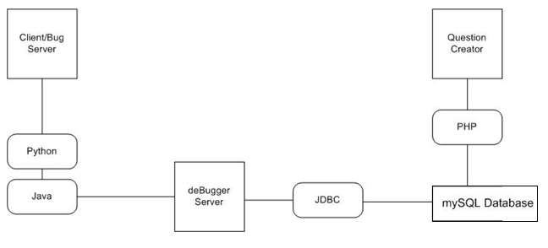

Key Concepts:
Server:
The debugger Java server handles the events of players and bugs. It also initiates the bug server. Connections from clients are tracked on the basis of movement, deaths, quizzes, item drops, and other tasks such as logging in/out. It connects to the database and retrieves the required stored information. It holds in queue information that has been sent to the server since the last update for each client so that when a client sends a heartbeat request, the server will send the queued requests back to the client. Each client has its own thread in which the server processes the events.
Client:
Client gets information from the players. This is the login information that client collects. Then this information is passed on to the server for authentication. Once the player is authorized, he can start playing. And all the movements and actions of the player, collects the information which is sent to sever in form of packets. This communication occurs through the packets which is also taken care by the client. Such packets contain the information required for proper response for player’s request or the actions the player performs which is to be sent to the server along with the action code (protocols). In addition to it, it also updates the player by getting the information of other players currently playing the game from the server and vice versa. This information the client collects via heartbeats. Client is also responsible for handling the collision of the player with other players, other game entities and ground, which is taken care in python effectively.
Bug Server:
Bug Server is a modified client with its graphics window disabled. It manages the movement of bugs walking in a scene to facilitate the load from the server. The bug server keeps track of various pieces of information about a bug such as its health points and level, as well as initiating attacks with
The bug server is also a client which co-ordinates the movements of multiple bugs through a single connection to the server. Bugs are generated throughout the game that players fights with to answer questions, gain gold, and obtain various item drops and progress through the game. When bugs are moving, each bug sends an update on its position while it’s moving, as well as polling the server through the heartbeat.
The bug server acts like a client to the server, and the server updates the position of the bugs accordingly because it knows that a bug server is connected through the login that the bug server connected with.
Database:
The database used in the game is mySQL which is connected to the server and question creator. It stores and returns the data such as user information, equipment, questions, and bug information. Question creator has the ability to update the game with new set of questions dynamically as it is also connected to the database.
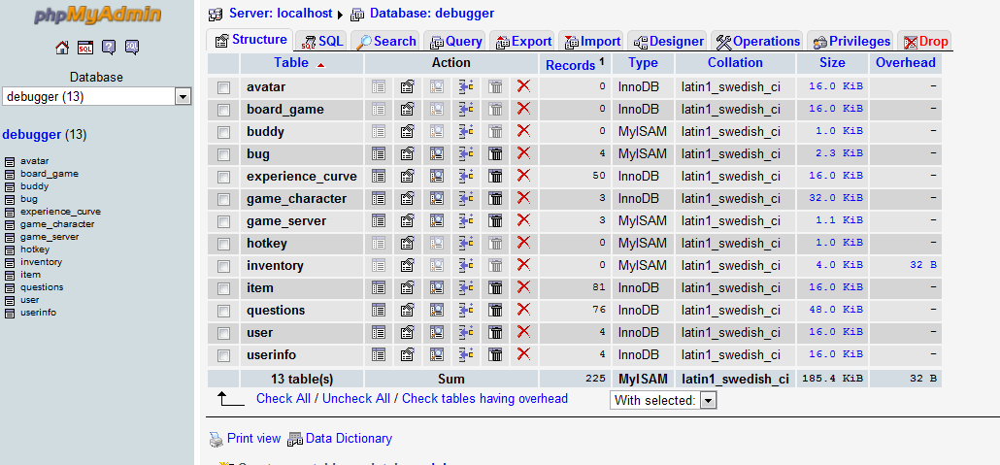
The database has 13 tables namely avatar, board_game, buddy, bug, experience curve, game_character, game_server, hotkey, inventory, item, questions, user and userinfo. Consider major tables.
The item table contains following columns. Item table contains information of all the items that a player can make use of. They can be acquired in two ways, first buy them from the shop or second you can get them through the bug droppings which can be called as loot items.

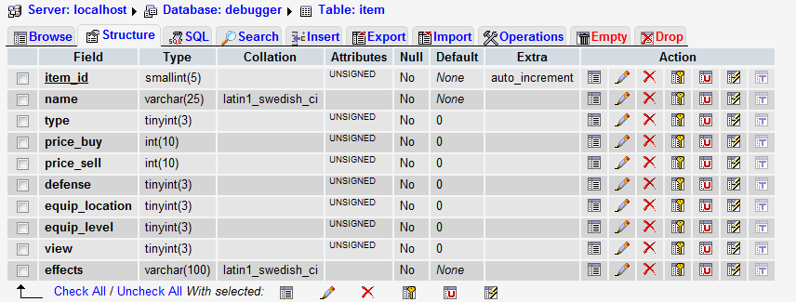
Item_id | It’s the id number of the item.
Name | Item name
Type | Item type ( it will be int amount, like code for e.g. equipable 1, non equipable 0)
Price_buy | Purchase price of item
Price_sell | Selling price of item (this will come into effect if a player wants to sell of his inventory item)
Equip_location | Location of equipable item
Equip_level | Level of the item (level in which it can be used)
View | Item view
Effects | Effects that items can produce.

User table contains following columns. User table is the table from which the user data is confirmed for authentication purpose. Hence this table is essential. It also stores the vital information of the player regarding his last login and log out status.
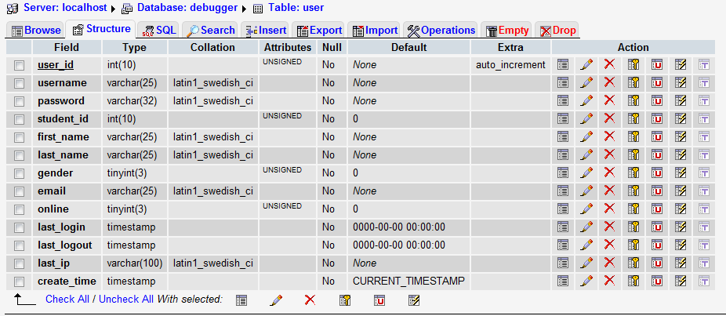
User_id | User id
Username | Username of the player
Password | User password
Student_id | Student SFSU id
First_name | First name of the student
Last_name | Last name of the student
Gender | Gender
Email | Email of the student
Online | Online status of the student
Last_login | Last login time
Last_logout | Last log out time
Last_ip | Last ip address of the user
Create_time

Inventory contains following columns. Inventory keeps track of player’s possessions. He can add/ remove items from his inventory.
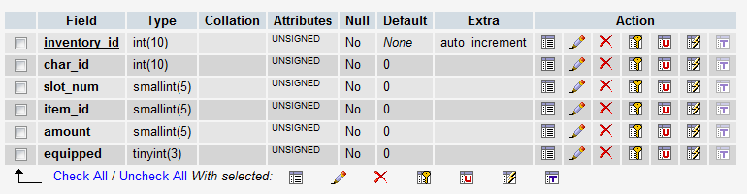
Inventory_id | Id number of inventory
Char_id | Character id of the player
Slot_num | Slot in which the item is to be placed
Item_id | Id number of the item
Amount | Count of the items
Equipped | Equipment status of the item

Game_character table contains the information for character like last x, y, z co-ordinates, user_id, money, health, experience, char_num, move_speed etc. This table is important because it has detailed information about the player which is used in the game frequently.
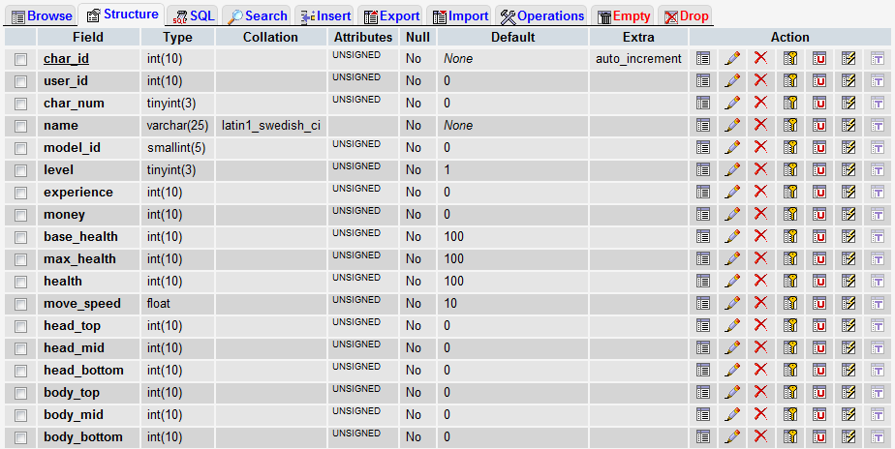
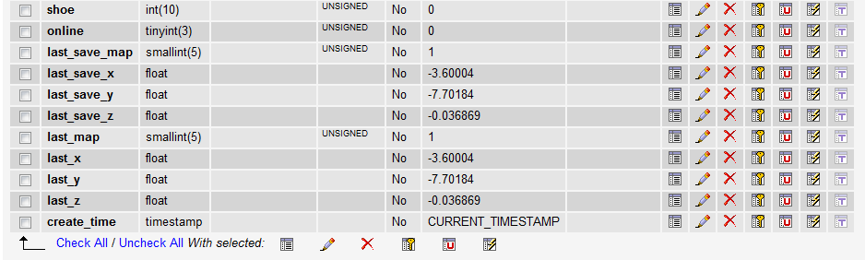
Char_id | Character id
User_id | User id
Char_num | Character number
Name | Name of the character
Model_id | Id number of the character model
Level | Game level of the user
Experience | User experience level
Money | User money
Base_health | User base health (when game starts, its 100)
Max_health | Maximum health capacity (100)
Health | Current user health
Move speed | User moving speed
Head_top | User head-top
Head_bottom | Head bottom of user
Body_top | Body top of user
Body_mid | Body mid of user
Body bottom | Body bottom of user
Shoe | Shoes of user
Online | Online status of user
Last saved map | Last saved map after user exits the game
Last_save_x | Last saved x co-ordinate of user
Last_save_y | Last saved y co-ordinate of user
Last_save_z | Last saved z co-ordinate of user
Last_map | Last map
Last_x | Last saved x co-ordinate
Last_y | Last saved y co-ordinate
Last_z | Last saved z co-ordinate
Create time | timestamp

The bug table contains following columns. The bug table is used with the bug server to get information about the bugs. It stores important information regarding bugs like their move speed, attacking range, drop items id, dropping rate etc. Bug server is like a modified client, which makes bugs as a player in the game. Only difference being they are uncontrollable.

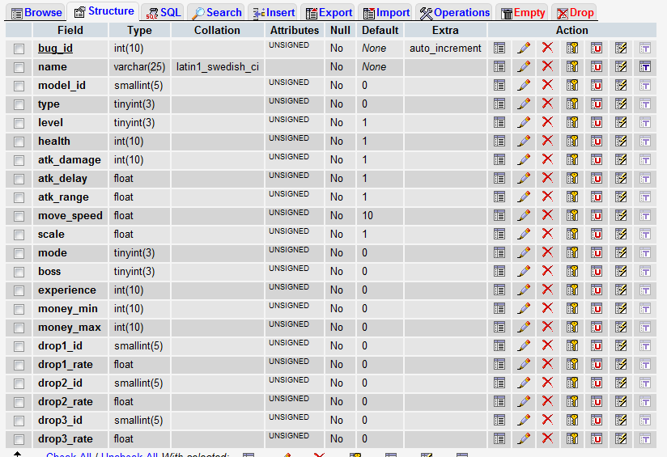
Bug_id | Id num of the bug
Name | Bug name
Model_id | Bug model id
Type | Bug type (aggro, passive etc)
Level | Bug level
Health | Bug health
Atk_damage | Damage on attack
Atk_delay | Attack delay time
Atk_range | Attacking range
Move speed | Bug moving speed
Scale | Bug scale
Mode | Mode of bug
Boss | If bug is boss or not
Experience | Bug experience level
Money_min | Minimum money bug can offer
Money_max | Maximum money bug can offer
DropX_id | Drop item no
DropX_rate | Drop rate

The questions table contains following columns. Questions table contains all the information of the questions like their type, answers, choices, time limit, creation and validation dates etc. This table gets updated when a new question is added via question creator.
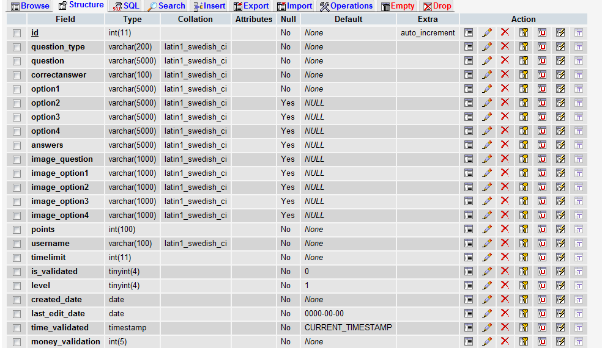
Heartbeat:
A heartbeat is an event that is called by client 10 times every second. Its basic working is updating. This concept comes useful as the Debugger server is not a broadcasting server.
Game Client sends on regular intervals “Heart Beat” signal, indicating on one hand that he is still present and functioning, but on the other hand requesting to be updated. These updates contain all information that Server designated as information that is to be “broadcasted” to the Client. Updates are sent as a response to a Heart Beat request. These Heart Beat requests are sent on average each 15 milliseconds
So using this concept, current as well as other players are updated of the changes happening. Heartbeats are used to poll the server for newly updated information such as chatting, attacking, other players/bugs logging in and out, etc. Heartbeats are sent by both the client and the bug server.
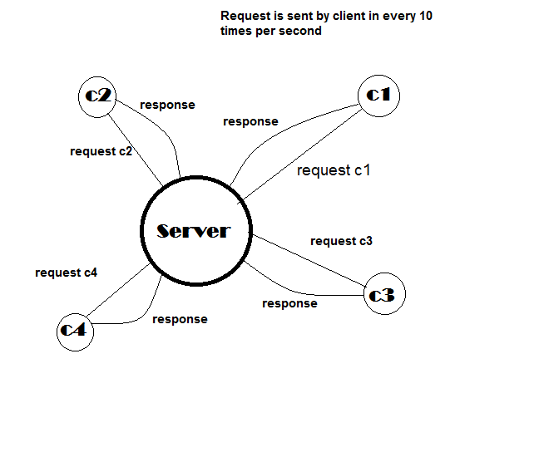
Packet:
Communication between the client and server happens via packets. They are basically protocols for actions/ requests sent by or to be given to the player. Each packet contains the information required to perform the action along with the information of the event or response. For example for login action, the packet would contain protocol code for login and the user info required for authentication.
Question Creator:
The Question Creator is a PHP website that connects to the Database in order to store and modify questions submitted by players. It gives players an easy way to add questions to the game while the game is running, and makes it possible for the game to always be continually updated with questions as they are made. It keeps track of the questions that needs to be approved, and allows the addition of questions from any user with an internet connection.
Basic working of the game:
Debugger works as follows:
- The client starts the game by logging in the game or registering himself followed by logging in.
- Once the player logs in respective scene is loaded with bugs.
- For every action that the player makes there is a request response communication cycle that runs in between the client and server.
- This communication happens via protocols defined for the tasks or actions the player performs such as request/ response attack, request/response chat etc.
- This communication makes use of event handling mechanism by using either an event dictionary at client side or an event hash map at server side.
- The bug server (which is a modified client to handle bugs) also works the same way by using the same mechanism for bugs.

Objective:
The idea of learning the software concepts along with game designing is the motive behind working on this game. This gives an opportunity and a challenge to develop the game more and enhance it, with more features and more knowledge gaining options. Development of MMORPG is considerable challenge, and great opportunity to learn how MMORPG can be shaped so that it serves the needs of perspective users in the way it is planned.
The fundamental objective of this study is to take the game to the next level, enhance it. This means adding new features to the game, so that can create more options for players and keep them engaged, and also work on the current features to make them better.
So the areas of work were decided and prioritized. Apart from the battle system, the one area which was not developed at all was the shop section. So we decided to focus on it and make it available to the player. Also there need to be work done on new features like the quest and the player Vs player mode, so players can fight with each other and acquire/ lose some accessories or health in return.
One more change was to replace the existing bugs with rolling spheres. It is required that every change made should be tested for its use. The major work done in this semester was on the shop section and replacement of existing bugs with a rolling sphere. Following section describes the tasks performed and implemented in the game.

Work Done:
The essence of the game is to gain knowledge by answering question to the bugs. The existing bug server loads all the bugs, but may slow down the game, by introducing lag. So it was decided to replace the existing bugs with some other entity which would have fewer loads, and then test their working with the game.
So first change that was incorporated was addition of rolling spheres in place of existing bugs i.e. spider and panda. There were changes made in the code at following places.

Bug Server:
- A new .egg file named ‘sphere.egg’ was created and was added to bug server under the models\bugs section. New images for texture and color were also added to same section.
- A proper path was added to the bug.py file in order to fetch the sphere.egg file and receive the proper contents along with the textures.
- Spheres needed to be adjusted to their position as by default the z-co-ordinate was taken at the center.
- Also the animation for the older bug was removed and the new animation for the sphere was added to the code.
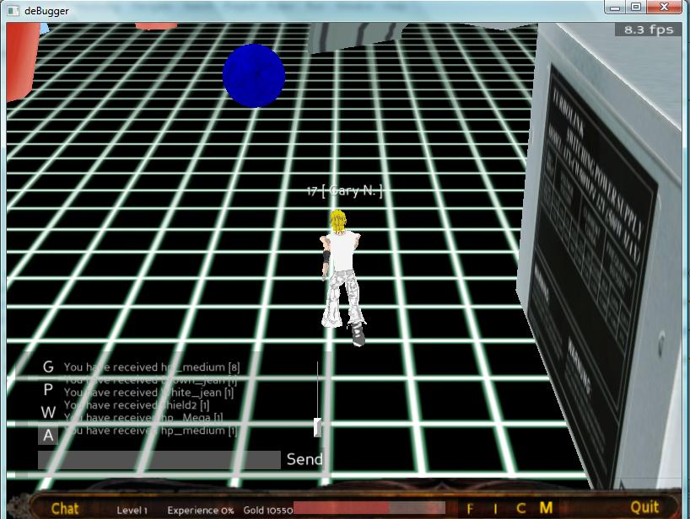

- The sphere is constantly kept rolling and changing colors in order to give a feel of a danger sign or an attacking entity. For this work the rolling animation was added to the existing sphere file and also the color changing intervals were added to the file bug.py. The interval starts as the bug is generated thereby constantly changing the color of the bug after every 2 seconds. The move factor of the sphere was kept 3 as it was getting affected by the scale of the bug.
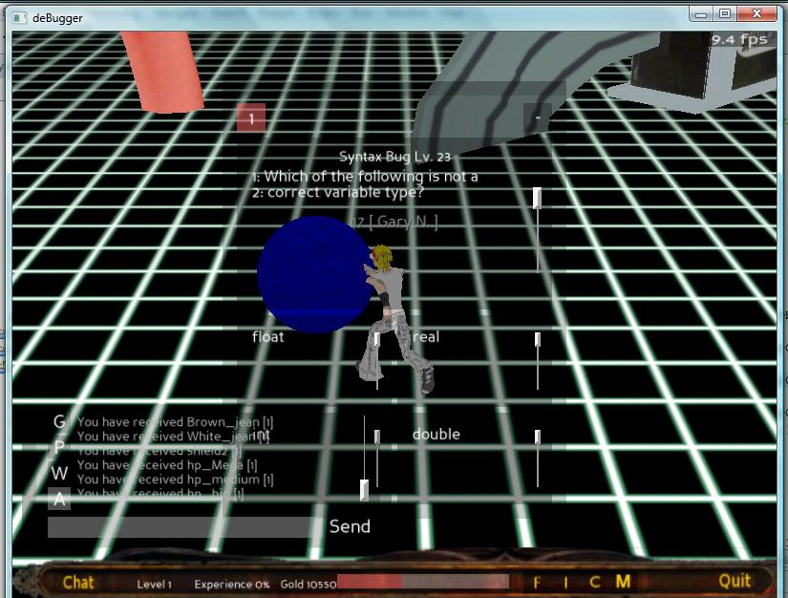

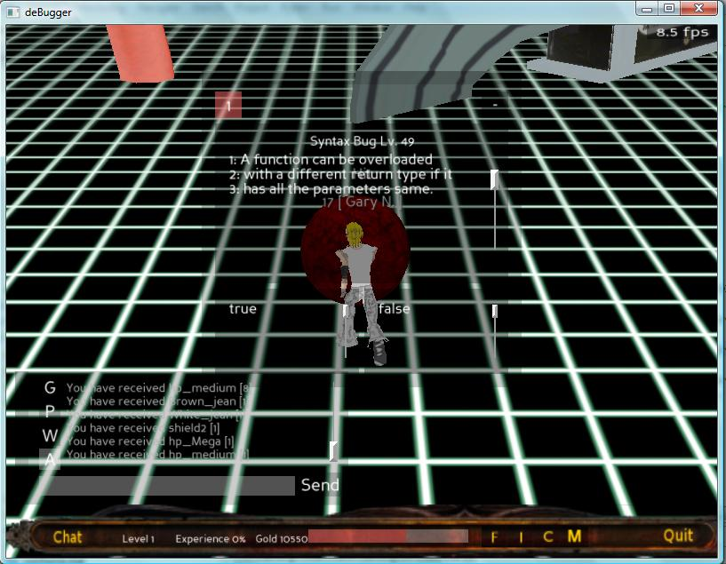
Sphere changing its color
- The sphere also changes its scale upon receiving a correct answer for the question from the user. The sphere starts shrinking on receiving every correct answer. So the scale factor of the sphere is also adjusted in the file bug.py. An interval was added to the function takedamage() to adjust the scale of the bug in bug.py file. Thus for condition (if damage > 0) which implies the player has given correct answer, the interval would start and on every correct answer the scale would be reduced for the bug.

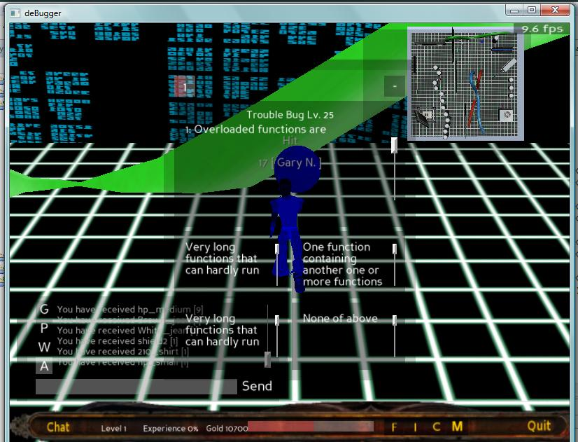
Bug size getting reduced upon receiving correct answer
Database:
- On client side database, in table Bug, new model for sphere was added with its new id and path. So, now with this new model addition in database, spheres can be loaded in the game by selecting its id. As, we need only spheres in the game right now, it is adjusted that only sphere model id will be fetched and loaded.
Testing of the game with spheres was then performed.
The .exe file of the game was generated with this new addition. The .exe file of the game was made using the command : ‘packpanda --dir src --name "Debugger" --bam --rmext egg --pyc --rmext py --rmdir .svn’; where --dir is the directory of the location of the Main.py file.
Now, here launcher.py file was temporarily changed to main.py and the corresponding path was given to packpanda which is a helper application in Panda3D to make .exe file. Also, –bam and –pyc are the compiled versions of the egg and py files, respectively. The --rmext/dir removes the files with the extensions after the –rmext/dir command, so in the command, .egg, .py, and .svn files are removed to lighten the package as well as remove source code and svn files.
The working of the game was then tested to confirm the addition of these spheres. They work fine. Also it was observed that 6-8 players can log in at the same time, and about four players can play simultaneously with a little lag. This lag mainly affects the battle system; hence it is not advisable to have such lag.

The next task was to implement the shop. The current version of the game did not have shop. The need for having shop is important in the game so as to keep the player engaged by giving him/her an option to buy items which he/she can actually use in his game at some point later. As the player is moving in the virtual world, he needs an avatar which can be customizable. Thus, a player can purchase an item from the shop and be able to change his avatar.
Database:
- There was need to add items in the shop and allow player to view and buy them. So at client side database a new table was created named item and the respective path of image files was added.
- Also, in the table avatar new avatars were added with their new respective ids and path.
Client:
- New avatar images were created and added to the models\character images section. Thus a new player can have an option of selecting avatar from a wide range of avatar images.

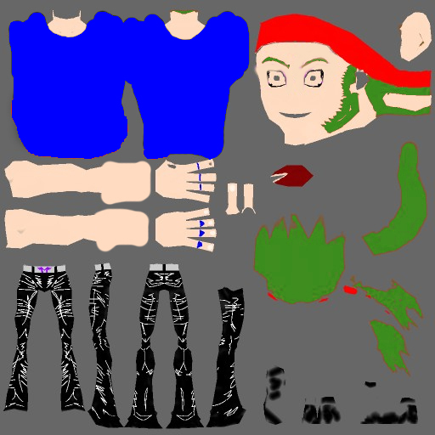

The new avatar and the texture file created.

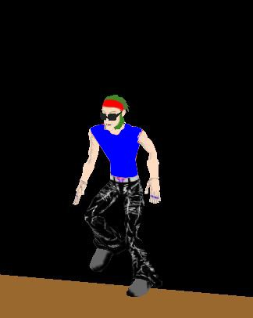
- New .egg files for every new character were created and stored along with respective texture images in the models\characters section. Thus, as the player selects any new avatar its respective file will be called and model will be loaded.
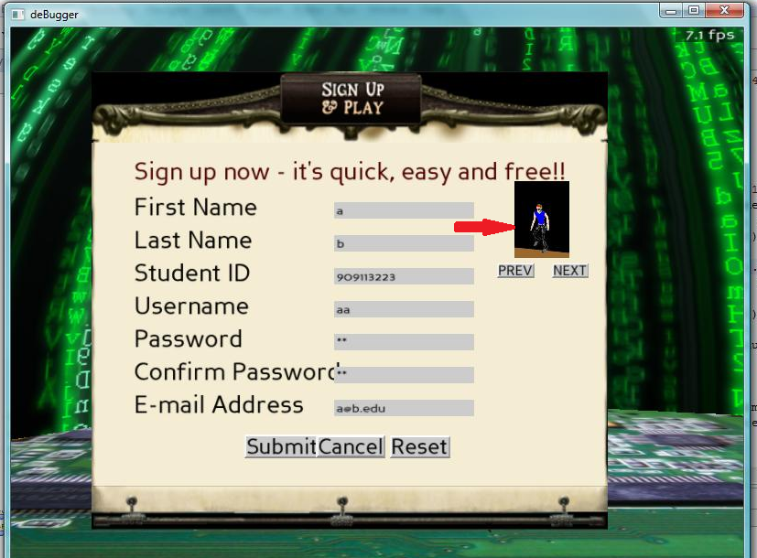
Player can have option of selecting newly added avatar during registration.
- New images of items were added to the section models\ shopimages.
- New codes for client protocols were added for items purchase.
CMSG_REQ_ITEM_FORSHOP = 108
SMSG_REQ_ITEM_FORSHOP = 109
- These images are now called from the file shop.py with the help of following code snippet.

MYDIR = os.path.abspath(sys.path[0])
self.path = MYDIR + '\\models\\shopimages\\'
self.charImageList = os.listdir(self.path)
self.characterImageArray = []
for fname in self.charImageList:
if(fname != '.svn'):
self.characterImageArray.append(fname)

- This code loads and initializes all the images into characterImageArray.
Now, the images can be fetched from the characterimagearray as and when needed.

for i in range(self.numItemsRow):
for j in range(self.numItemsCol):
itemObject = DirectLabel(image= Constants.MYDIR + '/models/shopimages/'+self.characterImageArray[i*self.numItemsCol + j],
relief = None,
image_pos = (0.0, 0.0, 0.0),
image_scale = (0.060, 0.070, 0.065),
frameColor = (0.0, 0.0, 0.0, 0.2),
frameSize = (-0.095, 0.099, -0.095, 0.095),
textMayChange = 1,
pos = (0.0, 0.0, 0.0),
state = DGG.NORMAL )
itemObject.reparentTo(self.itemCell[i * self.numItemsCol + j])
self.itemList.append(itemObject)

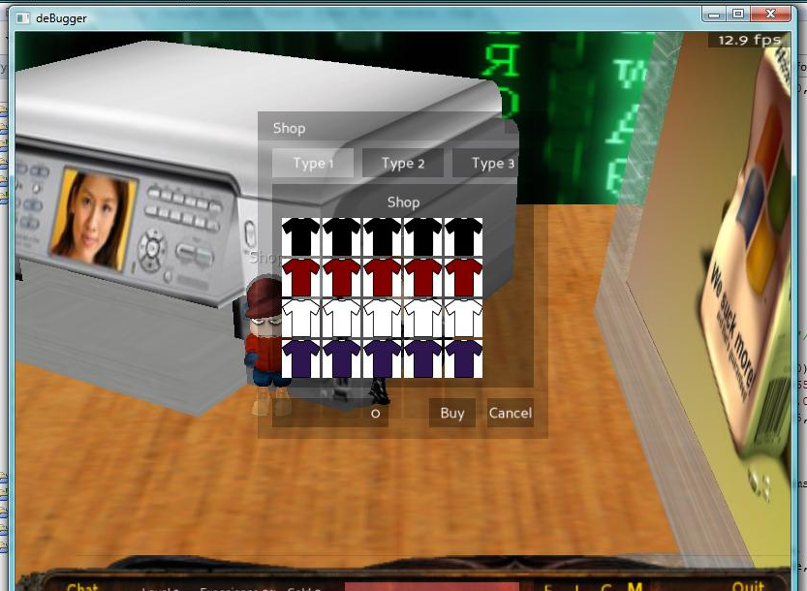
Items displayed in the shop.
- Changes were made in shop.py file in function confirm purchase(), and a call for ‘request to purchase’ an item from the shop was made along with the request code and parameters like item id, item path, user id and level.
Server:
- New codes for item purchase were added on to server side.
CMSG_REQ_ITEM_FORSHOP = 108
SMSG_REQ_ITEM_FORSHOP = 109
- Game.db file was modified. A new function for purchasing items from shop was created.
The function is called as ‘buyitemfromshop’ and it works as follows:
- Check if user has sufficient money by comparing user’s money filed with the item price and also check user level in order to be able to purchase the item, (so three identification codes were generated namely 1: for successful purchase 2: If user does not have sufficient money 3: user’s level is lower than the level in which the item can be purchased.)
- Checking user level is essential as the items displayed in the shop can be according to the level the user in. Some items are available only after reaching a certain level. (Currently only easy level is in function, but levels will be added in future.)
- Get the item count in order to calculate the total count, this count will also be used while updating the inventory.
- After this, deduct the item amount from user account and update the amount field in the user table.
- Go through the table ‘Inventory’ and check if the user exists. If ‘yes’ then add the item to the inventory considering the count of the item. If ‘no’ then add the user info and the item to the inventory. Update user’s inventory on server as well as client side. And notify the client about the same.
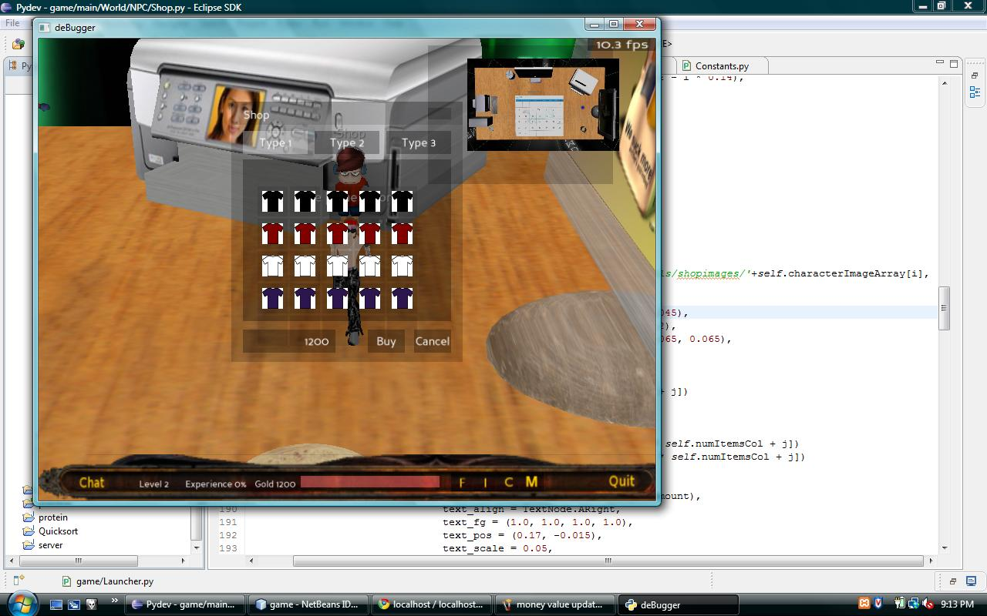
Player’s money value before purchase
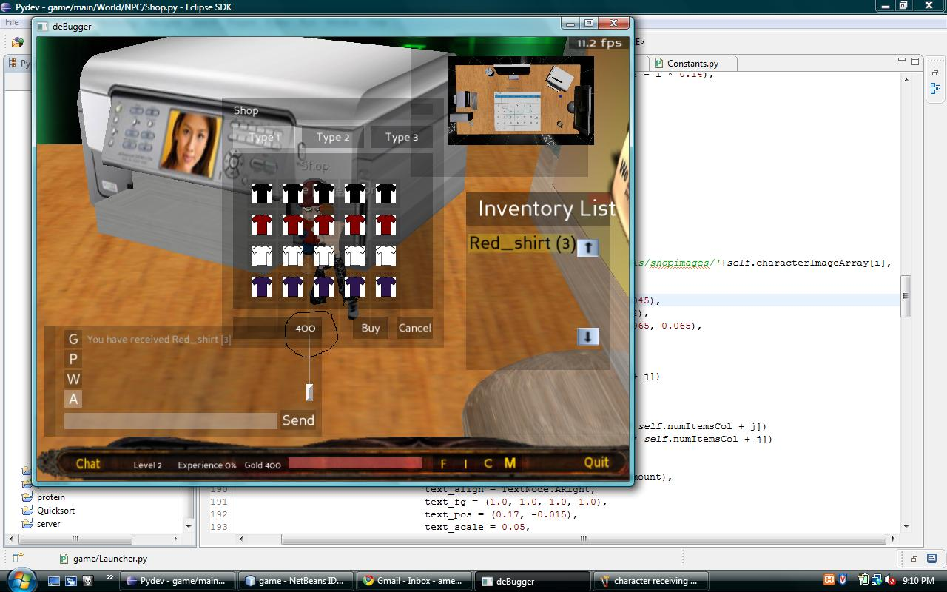
Money value and the inventory getting updated after purchase
Protocols:
- New protocols were written on both client and server side.
- These protocols are basically request for and response of purchase of items from shop.
- These protocols contain information that client sends in order to buy any item from shop such as item id, item path, user id and level along with the purchase request code.
- The request protocol at client side has following structure.
class RequestBuyItem(ServerRequest):
def send(self, args):
try:
pkg = PyDatagram()
pkg.addUint16(Constants.CMSG_REQ_BUYITEM)
pkg.addString(args['item_id'])
pkg.addUint16(args['user_id'])
pkg.addString(args['item_path'])
pkg.addUnit16(args['level'])
self.cWriter.send(pkg, self.connection)
self.log('Sent [' + str(Constants.CMSG_REQ_BUYITEM) + '] Buy Item Request')
except:
self.log('Bad [' + str(Constants.CMSG_REQ_BUYITEM) + '] Buy Item Request')
print_exc()

- The response protocol at client side has following structure.

class ResponseBuyItem(ServerResponse):
def execute(self, data):
try:
if ('World' in self.main.envMap):
#items = data.getString() # will be in the format of 'itemId1:itemName1:quantity1:cost1,itemId2:itemName2:quantity2:cost2'
global item_buy_money
item_buy_status_code = data.getUint16()
item_buy_money = data.getUint16()
self.main.envMap['World'].charHero.updateGold(item_buy_money)
print 'Item bought'
print item_buy_status_code
#0 for success, 1 for failure due to less money, 2 for failure due to high item level
print item_buy_money
self.log('Received [' + str(Constants.SMSG_REQ_BUYITEM) + '] BuyItem Response')
except:
self.log('Bad [' + str(Constants.SMSG_REQ_BUYITEM) + '] BuyItem Response')
print_exc()

- In same way protocols for request and response are written on server side, which takes the input values and process the request from client and then responds back.
- One addition in server response was done which updates the data on client side. Following code snippet which is used in response from the server; updates user’s inventory on the client side, which is visible on the screen.

ResponseItem response = new ResponseItem();
response.set(gameServer);
response.set_item(item);
response.setOut(output);
response.run();

With inclusion of latest code by Gary, all the changes done earlier to the old code were transferred on to the new code and all necessary modifications were done. The shop was recreated with some more changes in the old code, such as major modification was in the shop display. The information about items displayed in the shop is now fetched from the local database.
Database:
- A new field is added to this database namely item_info in the table item which would contain the information necessary to be rendered along with the item such as cost of the item, effect produced by the item.
Client:
- New codes for item purchase were added on to server side.
CMSG_NPC_BUY = 30
SMSG_NPC_BUY = 31
- The function to display the shop in shop.py is also modified in order to switch between the frames so that user can have more items on display. Thus, on selecting a particular tab the content will be displayed accordingly. There are three tabs namely type1, 2 and 3 which are capable of displaying different items on selection of different tabs.
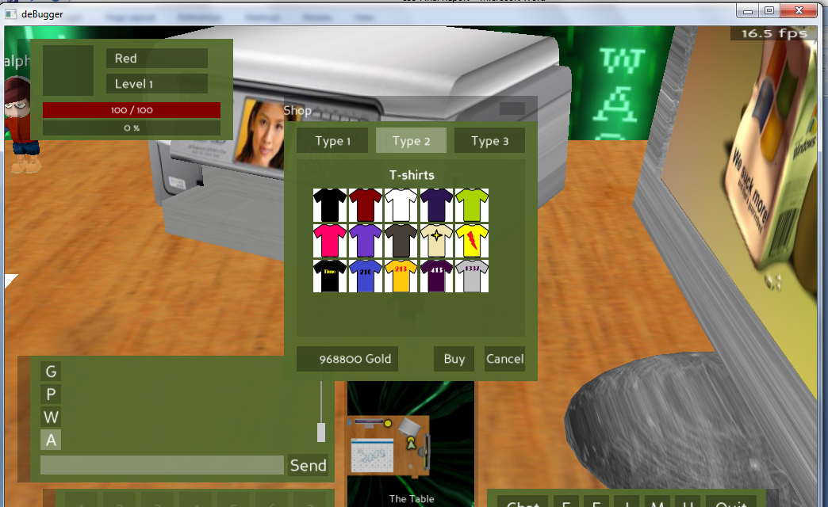
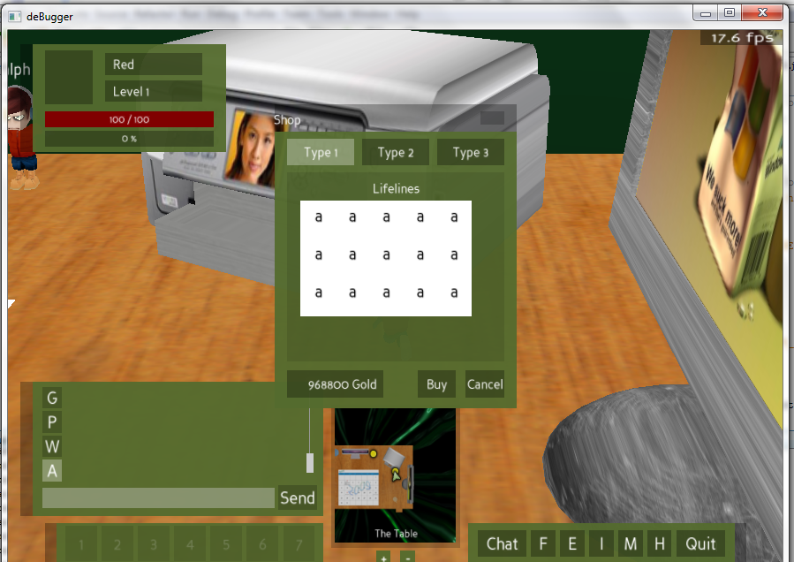
The items displayed vary according to the tab selected. For e.g. if type 2 is selected then it displays T-shirts for type 1 it displays lifelines. (Lifelines are just shown as letters)

- The information about items is displayed on hovering the mouse over the item. This information includes item name, cost and a brief description about the item.) A few items are shown as the ‘items in demand’.

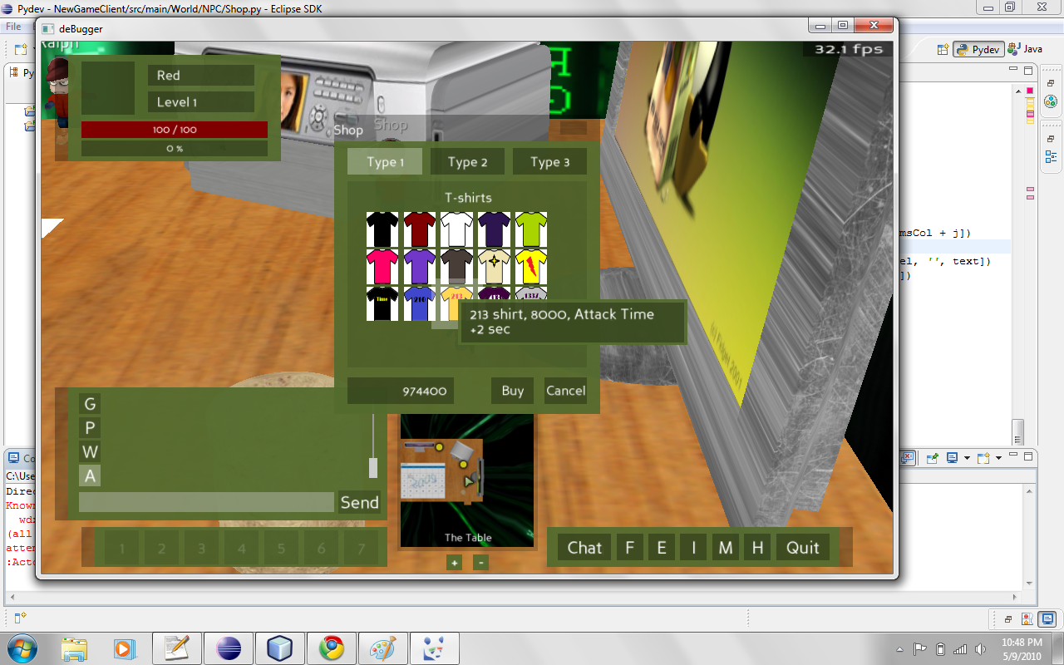
New shop with item info displayed
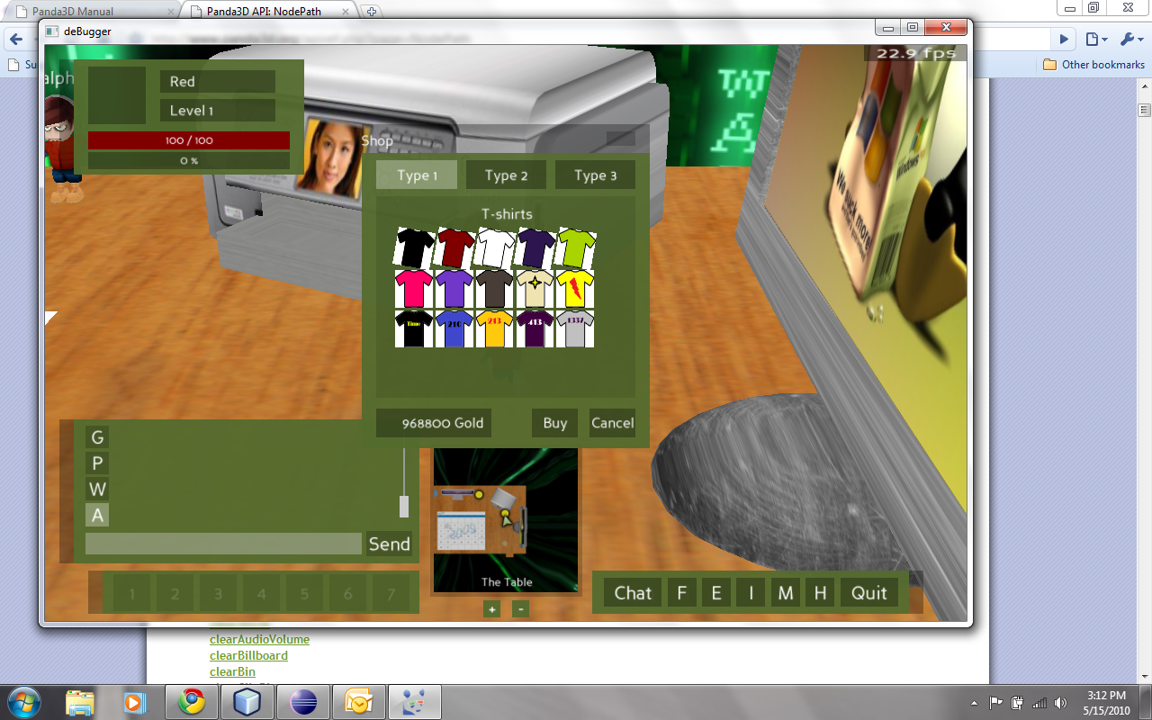
‘Items in demand’ are shown in a different format…

Server:
- New codes for item purchase were added on to server side.
CMSG_NPC_BUY = 30
SMSG_NPC_BUY = 31
- Gamedb.java file from server side is modified by adding a new function ‘buyitemfromshop’ to buy item from the shop. This function is called with the values item_id, npc_type and amount.
- This function works more or less similar to the old function named ‘buyitemfromshop’, which is as follows:
i) Fetch all the information required from the database about the item such as item_id, price, equipable, description etc.
ii) Get user info with the help of char_id.
iii) Check if user has sufficient money by comparing user’s money filed with the item price.
iv) Get the item count in order to calculate the total count, this count will also be used while updating the inventory.
v) After this, deduct the item amount from user account and update the amount field in the user table.
vi) Go through the table ‘Inventory’ and check if the user exists. If ‘yes’; then add the item to the inventory considering the count of the item. If ‘no’ then add the user info and the item to the inventory.
vii) Check for the slot number in order to add the inventory to the correct place. For existing users the slot number will be the previous slot number fetched from the table plus one (Also it should be within the maximum capacity of the slots); for new user the count starts from the first slot.
viii) Check if the item is equipable, if yes then you also add it to the table of equipment. (The code is written but not yet tested.) And update the equipment table. Select the slot for the player already existing in the table and if not; then add the user and update the table entry.
ix) Update user’s inventory on server as well as client side. And notify the client about the same.
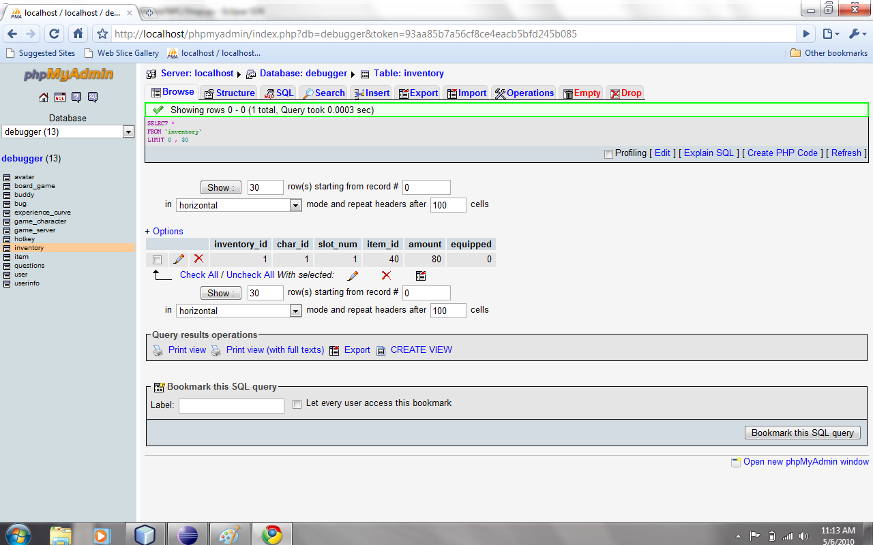
User’s inventory gets updated in database on server side.
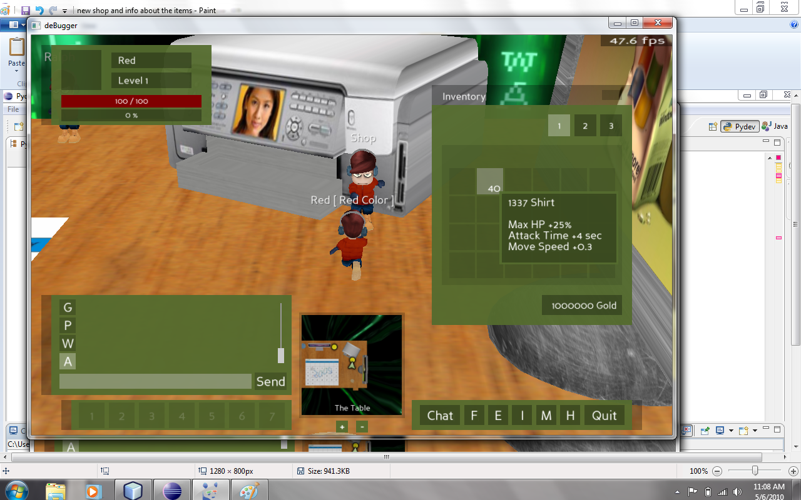
Item info updated in the inventory along with its description.

Addition of “Help” section
- A new help section was added to the game so as to guide the user about the game.
- The help section needs to be simple and easy to understand. Also the information should precise. In order to do that, The complete section is divided into smaller parts which can easily define the different aspects of the game such as board game, shop, equipments and inventory, chat modes, friends and party etc.
- This method works as the player can select the area he needs information on and can easily find it.
- New protocols were added in order to implement which which as discussed as follows:

Client:
- New help package was created under the GUI section, from where the help request can be sent.
- New codes were written to establish the communication
CMSG_HELP = 186
SMSG_HELP = 187
- Initially help was kept simple as all the information was listed in the form of FAQs and displayed, but then it was obvious that a player needs to search the complete list to find the specific information which would take more time.

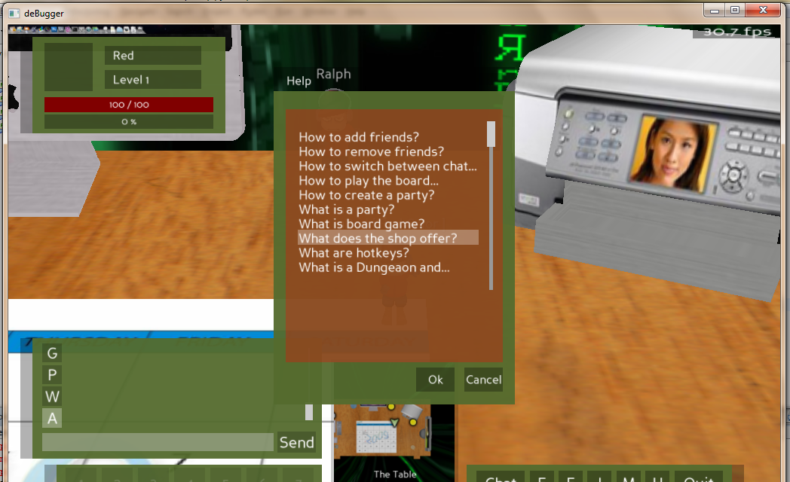
Old Help with all the questions listed
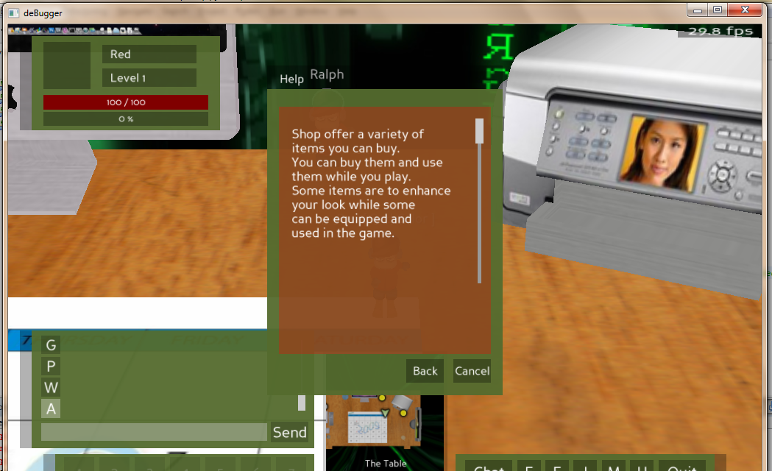
Upon selecting the required question respective answer is shown.

- The display is divided into two sections. The upper section displays the information and the lower section is for options for different information. By selecting the options the respective information is displayed.

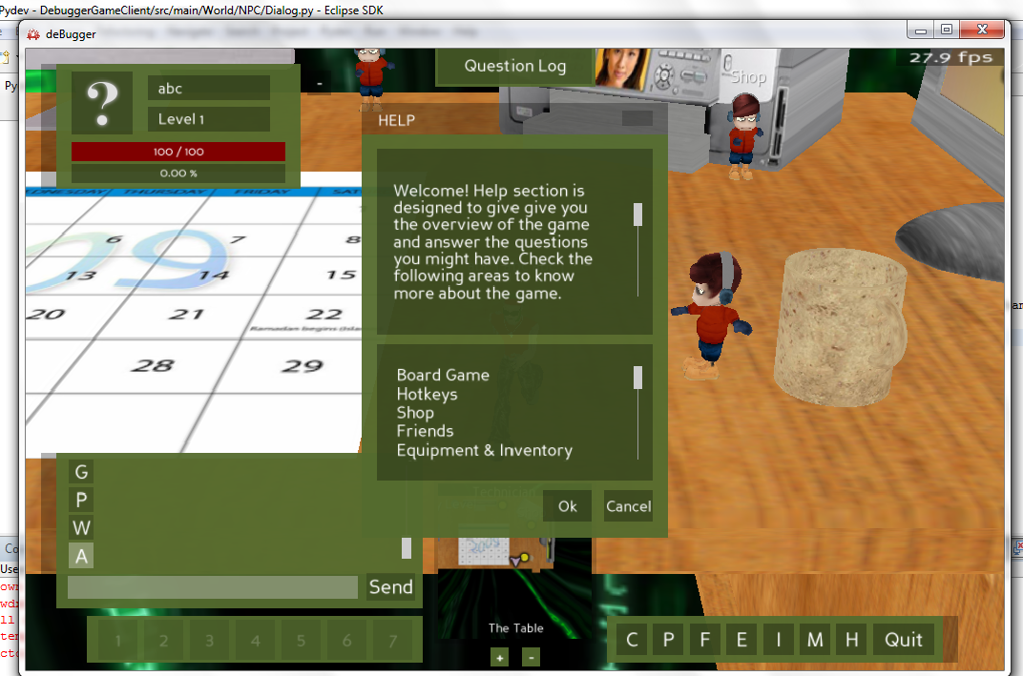
New Help section with the information in the upper box and the options (areas of help categorized) in the lower box.

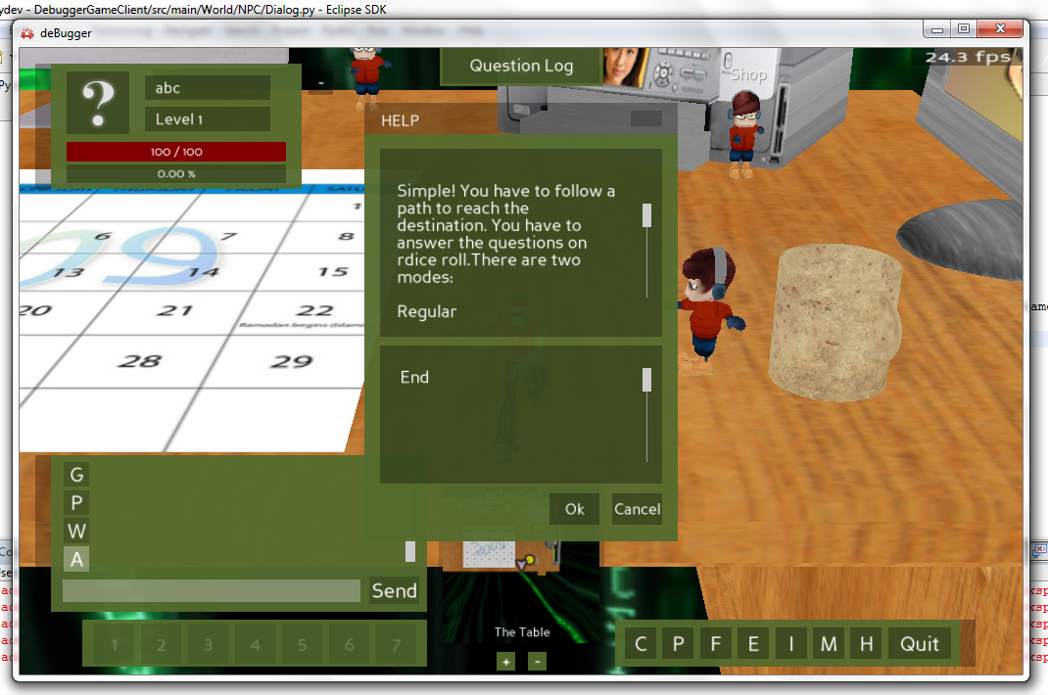
Information displayed on selecting particular option.

Server:
- The server was also modified in order to receive the request from the client. So respective codes were created on server side as well. Initially server was only playing the role of acknowledging the request from the client, when help section was simple question answer format.
- Once the format was channged, there was a text file created namely “help.txt” on the server side for help section to fetch the data required.
- Following are the changes made on server, to add help setion to the game.
- A text file was created on the server which would act like a database for the help information. Data is parsed and provided as per the help request.
- A new class named “GameHelpLoader.java” is created in order to parse the informaion from the text file and temporarily store into a vector. Another class was defined to create all the functions required for the processing of the help information such as sethelpscript(), gethelpscript(), gethelp() etc.

Protocols:
- Request and response protocols were created both at server and client side.
- The request packet from the client contains the selected option and its line number on display along with the request code.
rContents = {'helptopic_id' : self.helptopic_id,
'action' : self.lastOption + 2}
- Request is then made and at the server according to the helptopic and action (which is the line number) the respective information is selected and sent back to the client.
- The request protocol parses the information and stores it temporarily in the vector, it uses a class named script handler (defined by Gary) which evaluates the information and seperates it out into form of message and options and stores them into different vectors.
- The message to be displayed and options can be then easily called using functions getmessage() and getoptions().
- A function named createhelp() creates this script from the help.txt file which is stored in a vector, can be shown as follows:

public GameHelp createHelp(Vector<String> data) {
GameHelp help = null;
help = new GameHelp();
if (data.get(0).trim().equals("{")) {
Vector<String> script = new Vector<String>();
String nextLine;
for (int i = 10; i < data.size(); i++) {
nextLine = data.get(i);
nextLine = nextLine.replace("select(", "select(" + (i - 10) + ", ");
nextLine = nextLine.replace("next(", "next(" + (i - 10));
script.add(nextLine);
}
help.setScript(script);
}
return help;
}
}

- Now this script can be called using getsript() and sent to the client.

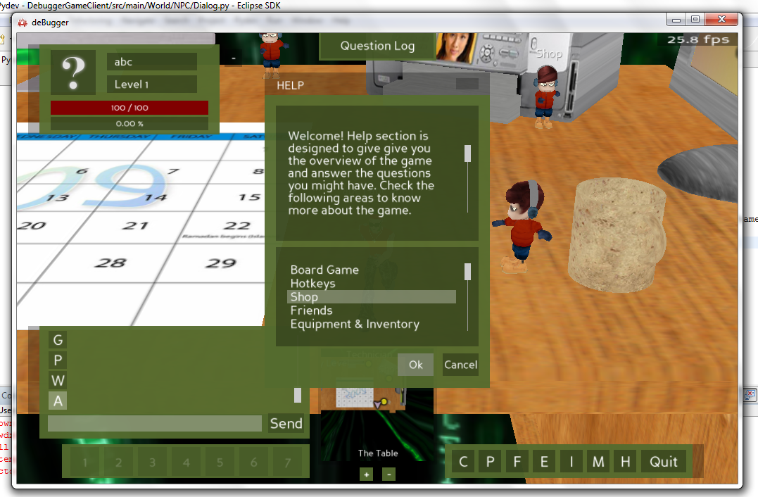
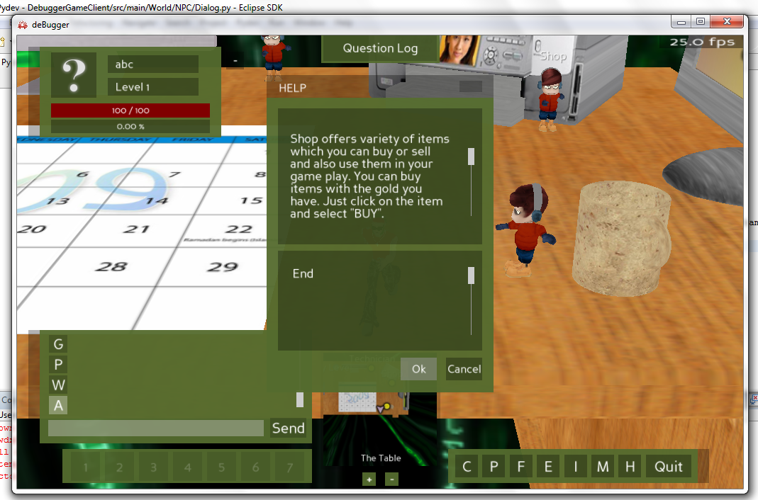

Future Work:
Developing any game is never a complete process. It grows and expands as the time progresses and the player needs and choices change. Debugger also needs more work to be completed. Following are some areas where work is planned in near future.
- Currently a player can only shop the items from the shop, but they cannot make use of them in the game. This functionality is been currently worked upon. Once it is implemented in the game, so that it would encourage players more to buy items and keep the shop in business
- Though, the shop is in working condition, still there is a need for improvement and addition. The shop needs to be bigger in its contents, and also needs to be more dynamic. More work is proposed in this area, so as to let user know the current contents in the shop and how many more items are left.
- Shop needs to keep a track of items and be able to refill them. Also introduce new items over period, and classify the items according to the user or game level. There will be some items called ‘lifelines’, which a player can buy but that won’t be visibly effective on his/her avatar. He can make use of them during the battle.
- Adding wish list for every player, and update and maintain the same as the player gets an item from the shop or bug which also exists in his wish list.
- Work will also be done in order to incorporate player Vs player mode, so that a player can fight other players in the game along with the bugs. This also creates an opportunity for player to create his/her own questions and win an accessory from the shop section of his own choice.
- The quest section. This implies a bug can be handled by more than one player. Any player should be able to form a party and fight the bug. This will also include the questions getting divided among the players in the party at the cost of either health or time.
- Party chat mode. This mode is not implemented yet. This mode is planned to be added.
- A functionality to keep the track of the questions user has answered and his attempts so that the improvement of the user about the knowledge of C++ can be evaluated which is the main purpose behind developing this game.

Conclusion:
Debugger is an evolving educational game. The current work has added some features to it like the sphere and the shop that makes it more engaging. Currently any player can select an item and buy it. So his inventory and money value gets updated. Work is being done in order to make the use of the item in the play along with creating the wish list for every player. The shop will also be having more options and player will have more choice to buy from. This work presented creates an option for player to acquire the accessories and make additions to its inventory.

Reference:
[1] www.wikipedia.org
[2] “Debugger” – documentation by class of CSC631 at San Francisco State University, fall 2009
[3] “The learning guide: MMORPGs as educational environments”- A paper by Dr.Rodney Riegle (Illinois State University) and Mr. Wesley Matejka (Illinois State University), 22nd Annual conference on distance teaching and learning.

